**A Methodological Review of Community-Based Research Related to Intimate Partner Violence**

Rachel Smith-Hunter

Applied Community Psychology Comprehensive Examination

Major Area Paper

Portland State University

25 July 2017

**Contents**

Abstract 1

Part I. Introduction 2

Rationale 4

Guiding Community-Psychology Theoretical Frameworks 7

Part II. Systematic Literature Search & Review Methods 12

Analytic Approach 14

Part III. Literature Synthesis & Review 20

Summative Characteristics of the Included Literature 20

IPV Perpetration Interventions 26

Prevention-Oriented IPV Intervention Programs 37

IPV Research Specifically Inclusive of Sexual Minority Women 41

Part IV. Summative Methodological Critique 47

Part V. Discussion 51

*Epilogue:* *Reflections on the Unique Challenges of Conducting a Community-Psychology-Focused Systematic Literature Reviews* 54

Appendices 55

Appendix A: Referenced Tables & Figures 56

Tables 56

Figures 95

References 107

# Abstract

This systematic methodologically-focused review maps core components of community psychological theory and methodologies to the currently available intimate partner violence intervention and prevention research conducted within community psychological and closely related research disciplines. Community psychological theory values the notion that the communities in which research is taking place and/or affecting (whether directly or indirectly) should be as involved as possible in all phases of the research process, rather than solely as anonymous data points in the analysis. Community psychology thus favors inclusion over exclusion, participant voices equally with researchers' voices, and participatory and/or purposive sampling methods over convenience sampling methods. The reviewed literature will be evaluated and critiqued according to these types of community psychological standards regarding (1) *research methodologies*, (2) *data analytic approaches*, (3) *interpretations of findings*, and (4) *research dissemination.* This review evaluates the extent to which community psychological theory and methodologies are and are not implemented in community-based research related to intimate partner violence. The review specifically follows the methodological evolution and diversity methods and data analytic approaches over time since the origination of Community Psychology as a research discipline, as well as potential trajectories based on the current state of discourse within Community Psychology and closely related research and practice disciplines.

# 

# Part I. Introduction

"... despite our awareness of context for those we study, we do not always apply that understanding to ourselves" (Riger, 1993, p. 279).

The purpose of this review is to provide a systematic methodological overview and critique of the available empirical research related to intimate partner violence (IPV) intervention and prevention efforts through a community psychological lens. As such, this review is specifically focused on the applied methodologies employed within community-based, participatory, and action-oriented research frameworks. The following general research questions were initially formulated to guide the present review's literature search and evaluation methodologies:

* **RQ-1:** What is the state of community-psychology-related IPV interventions research?
  + **RQ-1a:** How has the implementation of community psychological research evolved over time since the origination of the field
  + **RQ-1b:** Based on the current state of discourse within community-psychology and closely related research and practice disciplines, what are the potential research and practice trajectories?
* **RQ-2:** To what extent are community psychological theories and methodologies implemented, or not, in community-based research related to IPV interventions in terms of:
  + **(RQ-2a:)** the research questions and hypotheses that have been posed,
  + **(RQ-2b:)** the sampling methods, data collection methods, and data analytic approaches used to address or test those questions and hypotheses, and
  + **(RQ-2c:)** the ecological levels of analysis involved in each of the latter aspects of the literature?

Underlying the topical foci reflected in the above research questions is the more specific goal of informing IPV intervention and prevention approaches specifically inclusive of, relevant to, and appropriate for addressing same-gender IPV among sexual minority women (SMW). However, while there is currently a burgeoning body of research related to the causes, correlates, and consequences of IPV within the context of women's same-gender relationships, the extensive literature database searches conducted for the present review indicated that there is no currently available empirical research examining interventions specifically implemented to address IPV within such contexts, both within and outside of community-psychological and closely related research disciplines. Thus, one additional research question was formulated over the course of searching for, screening, and selecting the final set of empirical research studies to be formally reviewed:

* **RQ-3:** How do the research questions and hypotheses, sampling and data collection methods, data analytic approaches, and ecological levels of analysis inform IPV-related community-based interventions and research specifically inclusive of sexual minority women and other historically marginalized populations?

# Rationale

Efforts to address violence against women, and in particular intimate partner and sexual violence, in the United States began with an overall focus on treatment (i.e., tertiary-level) intervention approaches, which, understandably, were primarily focused on addressing the immediate needs of victims (Barner & Carney, 2011; Stover, 2005; Stover, Meadows, & Kaufman, 2009). Until IPV perpetration became a crime in all 50 states, these efforts were in large part initiated and sustained on "grassroots" levels, connecting with and building upon one another toward efforts to affect more large-scale changes at the policy and structural levels. The criminalization of IPV perpetration was eventually followed by the enactment and enforcement of mandatory arrest laws across the country, which, while varied in scope and modes of implementation, essentially require that police officers responding to calls deemed characteristic of domestic violence impose some level of punitive action against the accused or immediately evident offender(s) in the situation. These laws were created and continue to be enforced under the goal of ensuring victims' safety. The U.S. 1994 Violence Against Women Act shared a similarly victim-safety-centered purpose and, among a plethora of policy implications, was the first national-level policy providing at least a minimal amount of federal and state-level funding allocations specifically for developing and sustaining services for victims of IPV in each U.S. state (Fine, 1998).

During the same time period described above, work was also done to address the issue of IPV perpetration, which ultimately led to the emergence of various programs across the country focused on tertiary and secondary levels of IPV prevention (Tolman & Edleson, 1995). Overarching approaches to IPV perpetrator interventions in the U.S. varied substantially throughout the late 1980s and through the early 2000s, and a majority of programs today tend to follow a combination of approaches. For instance, cognitive behavioral therapy is often combined with the Duluth curriculum, which primarily targets intervention recipients' endorsement and internalization of patriarchal ideologies that value and promote, particularly male-identified, individuals and groups gaining and maintaining power and control over others (Pence, 1983; Price & Rosenbaum, 2009).

A particularly relevant common thread across the various approaches to IPV perpetrator interventions is the IPV-related research and intervention foci of the late 1900s and early 2000s, which is generally well-aligned with the values and rhetoric of the mainstream second-wave feminist movement in the U.S. Consequently, IPV perpetrator intervention approaches, such as the Duluth curriculum (Pence, 1983), primarily target heterosexual men and are therefore tailored to men's experiences, behaviors, and attitudes. An important consequences of this historical context is the continued dearth in currently available IPV interventions research, both within and outside of community-psychology and related disciplines. Thus, while the underlying purpose of this review remains to inform IPV intervention and prevention efforts inclusive of and relevant to sexual minority women, this critical gap in the available literature does not allow for any meaningful analysis of interventions with this specific population.

However, the lack of IPV-related interventions and research inclusive of or specific to sexual minority women *does* necessitate a research approach that takes into account the unique historical and individually-experienced contexts of this systematically marginalized population. Community Psychology offers one such especially relevant and appropriate research framework for comprehensive, innovative, and actionable investigations of these complex contexts. Central to community-psychological theory and underlying values is the notion that the communities in which research is taking place and which, whether directly or indirectly, are affected by such research should be, ideally, as involved as possible in all phases of the research process. This contrasts with more traditional research paradigms, in which the extent of communities' or individuals' involvement in the research is, ultimately, as anonymous data points in the analysis (Maguire, 1987; Senn, 2005). Community psychological values, theories, and methods thus favor inclusion over exclusion, participant voices considered equally with researchers' voices, and participatory or purposive sampling methods employed based on the research questions or hypotheses at hand over sampling methods employed out of convenience or primarily employed toward the goal of generating large sample sizes (Balcazar et al., 2004; Maguire, 1987; Senn, 2005). The action-oriented and values-transparent community psychological research approach was in fact born out of a resistance to traditional psychology research methodologies, social policies, and program and policy implementation practices that ultimately served to reinforce and/or strengthen social and economic inequalities (Balcazar et al., 2004; Fine et al., 2003; Senn, 2005). This foundation promotes vigilance in critical reflexivity throughout and beyond the research process.

**Intersecting Community-Psychology Theory & Research Methodology.** The present critical methodologically-focused review is intended to serve the above-described key characteristics of community psychology through a critical evaluation of the community-psychology-related empirical literature focused on intimate partner violence intervention and prevention. This review specifically examines the intersections that exist across the core theoretical and methodological domains of community psychological research in terms of their applications and manifestations in various settings and at varying levels of ecological analysis. Thus, the literature presented here is evaluated according to core community psychological values and standards regarding (1) research methodologies, (2) data analytic approaches, (3) interpretations of findings, and (4) research dissemination.

# Guiding Community-Psychology Theoretical Frameworks

"... community scientists study domestic violence using methods and theories that are consistent with the view that domestic violence is not just an individual behavior, but a complex process shaped by historical, social, financial, and legal contexts". (Luke, 2005, p. 185)

The present systematic review is situated within an ecological framework and posits that individuals are both affecting and affected by their environmental settings (Espino & Trickett, 2008; Kelly, Snowden, & Munoz, 1977). This review is further grounded in an action-oriented theoretical and methodological framework (Brydon-Miller, Greenwood, & Maguire, 2003; Chandler & Torbert, 2003; Friedman-Nimz et al., 2006; Kelly et al., 2004; Noffke, 1997; Prilleltensky, 1997, 2001; Seidman, 2012), as well as social scientific theories related to IPV and sexual minority women (Meyer, 1995, 2003, 2015). These frameworks collectively incorporate the community-psychological concepts described below.

**Ecological systems theory and the Social Ecological Model.**

"... community scientists have put context front and center as one of the core values of community psychology". (Luke, 2005, p. 185)

*Ecological analysis* provides a framework for observing, describing, and evaluating individuals' development, experiences, or behaviors in terms of each individual’s multilevel and dynamic environment, or *ecology*, and the transactional relationships among the individual and one or more structural levels comprising the ecological system (Barker, 1964; Bronfenbrenner, 1977; National Center for Injury Prevention and Control, 2015; Sarason, 1972). *Ecological Systems Theory* is based on the *The Ecological Model of Human Development* originally developed by Bronfenbrenner (1979), which is comprised of five nested systems: (1) the *microsystem*, representing individuals and their interpersonal relationships; (2) the *mesosystem*, containing the settings in which two or more individuals' micro-systems interact (e.g., an individual's community); (3) the *exosystem*, representing the settings to which individuals have *indirect* contact such as a child's parent's workplace; (4) the *macrosystem*, comprising the structural elements of a society, such as legislative and state-sponsored bureaucratic institutions; and (5) the *chronosystem*, representing changes over time within and among each of the former four nested systems. Each of these ecological systems represent multiple levels of analysis to which research questions, hypotheses, and interventions can be applied. *Ecological Systems Theory* and Bronfenbrenner (1979)'s *Ecological Model* are cornerstones of Community Psychology, as these theoretical configurations facilitate research that looks beyond an individual in order to better capture and analyze the complexities that both influence and are influenced by individuals (Lounsbury & Mitchell, 2009).

Ecological analysis is especially important to the design, implementation, and evaluation of community-based interventions (Heise, 1998; Lounsbury & Mitchell, 2009; Trickett, 2009a, 2009b, 2011), including IPV-focused and related interventions and prevention approaches (Baker, Buick, Kim, Moniz, & Nava, 2013; Centers for Disease Control and Prevention, 2013; National Center for Injury Prevention and Control, 2015). In particular, IPV has been somewhat well documented over the past few decades as a social and public health issue with causes, correlates, and consequences that span multiple levels of ecological analysis (Dahlberg & Krug, 2002; Krug, Dahlberg, Mercy, Zwi, & Lozano, 2002; National Center for Injury Prevention and Control, 2015). In the early 2000s, the U.S. Centers for Disease Control and Prevention (CDC)'s Division of Violence and Injury Prevention developed and began utilizing a *Social-Ecological Model* as a guiding framework for intimate partner and sexual violence prevention efforts (Dahlberg & Krug, 2002; National Center for Injury Prevention and Control, 2015). CDC's *Social-Ecological Model* is a four-level adaptation of Bronfenbrenner (1979)'s five-system *Ecological Model of Human Development*, and is specifically conceptualized to evaluate and explain the causal factors of IPV, as well as a framework for mapping IPV intervention and prevention approaches to the *individual*, *relationship*, *community*, and *societal* levels of analysis (Dahlberg & Krug, 2002; National Center for Injury Prevention and Control, 2015).

Within the social-ecological analytic framework for IPV, the *individual level* involves factors such as a person's family of origin, past trauma experiences, and personality characteristics that may influence the individual's behaviors and experiences with IPV. At the *relationship* level are, of course, romantic or intimate relationships, but also the influences of individuals' close interpersonal interactions and relationships with family, friends, peers, coworkers, mentors (etc.) on their identities, experiences, and behaviors. An individual's *community* is comprised of the contextual factors existing within or directly influenced by or influencing the settings in which interpersonal relationships and interactions among individuals occur, such as the economic structures and status of one's local community, the stability, or instability, of community members and settings, and the availability, accessibility, and quality of community-based services and communal spaces. Additional components of the *community* context include the organizations and institutions to which an individual belongs or is affiliated with, such as sports teams, professional organizations (e.g., the *Society for Community Research and Action*, *American Psychological Association, etc.*), schools, and workplaces. An individual's *community* can be further parsed according to the sub-groups and sub-communities existing within larger settings, such as the department within which an individual works at a multi-departmental organization, communities of individuals sharing the same college major, special interest groups within professional organizations (etc.). Finally, at the *societal level* are the broad cultural and socio-political structures and climates constructed and maintained by a society's economic, health, education, social policies, traditions, and rituals (see Figure 1).

**Protective (versus risk) Factors.** Whereas risk factors represent, often compounding or intersecting, characteristics and circumstances that *increase* the likelihood of an negative outcomes among individuals, *protective factors* are those which have an opposite effect by *decreasing* the likelihood of negative outcomes. Traditional psychological inquiry (e.g., Clinical Psychology research) has focused on identifying and assessing *risk factors* for negative outcomes on indicators for various psychological and behavioral phenomena at a primarily individual level of analysis. The field of Community Psychology emerged, in large part, in resistance to the individual- and deficit-focused frameworks of traditional psychology (Kloos, Hill, Thomas, Wandersman, & Elias, 2012, Chapter 2; Maton et al., 2006; Toro, 2005). This foundation necessitated a focal shift toward factors, at any given level of analysis, that decrease the probability or prevalence of a given behavioral, social, or public health problem (i.e., *protective factors*). Protective factors can be further conceptualized and evaluated as factors that promote, or even facilitate, positive health, behavioral, and social outcomes.

Thus, a focus on protective, rather than on risk, factors among community scientists is inherently tied to several core values of community-based and action research frameworks including the above-described focus on ecological contexts including and beyond the individual level of analysis. Specifically, community science research that focuses on protective factors prioritizes (primary and secondary) prevention of social and public health problems rather than tertiary prevention/intervention, and emphasizes strengths and resilience rather than deficits across levels of analysis (Anderies, Janssen, & Ostrom, 2004; Berkes & Turner, 2006; Espino & Trickett, 2008; Folke, 2006; Hughes & DuMont, 2002; Lounsbury & Mitchell, 2009; Norris, Stevens, Pfefferbaum, Wyche, & Pfefferbaum, 2008; Whitaker, 2014). Despite this foundation, risk remains a prominent focus when it comes to analysis of the causes, correlates, and consequences of a given phenomenon within community scientific research (Browning, 2002; Hegarty, Sheehan, & Schonfeld, 1999; Whitaker, 2014). IPV-related research, within and outside of community-based research disciplines and settings, especially tends to primarily examine risk factors for IPV perpetration and/or victimization, while protective factors, if at all considered in a given research inquiry, are often secondary considerations (Heise, 1998; Whitaker, 2014).

**'The inextricable relationship of empowerment and politics'.** **(Riger, 1993, p. 283)**.

"... psychology's emphasis on the cognitive processes of the individual lead us to study individuals' **sense of** empowerment rather than actual increases in power, thereby making the political personal". (Riger, 1993, p. 280, **emph. in orig.**)

As Riger (1993) details, *empowerment*, as both a generalized theory and a specific psychological construct, has played an increasingly key role in community-based and action-oriented research. Yet embedded within this role are several problematic features inherent within empowerment as a construct and its implementation in intervention and prevention research. The problematic aspects of empowerment are especially relevant with regards to intimate partner and sexual violence, as both phenomena are inherently tied to power, but, supposedly, in opposing ways. Empowerment, as it has historically been defined and intended within community-psychological contexts, refers to the extent to which "people, organizations, and communities gain mastery over their affairs" (Rappaport, 1987, p. 122). Embedded within this definition are an individual's, organization's, or community's sense or perception of its own autonomy, as well as its actual exertion or application of that autonomy. From a not-so-positive perspective, an empowered individual, for instance, can come to an psychological sense of empowerment that may in turn lead the individual to feeling justified within her or his own empowered right to exert that power against another individual or group of individuals (e.g., through abusive control and manipulation, bullying, physical violence, etc.). On another level, an organization may gain a sufficient sense of collective empowerment to determine that the organization, or its executive leadership, is equipped to decide what is best for the organization's constituency, which could potentially result in the disempowerment of the individuals served by or within the organization (Riger, 1993).

# Part II. Systematic Literature Search & Review Methods

Six separate literature searches were conducted using the PsycINFO (PI) and Web of Science (WoS) online citation indexing databases via the Portland State University library website:

1. ***IPV - General***
2. *IPV Interventions*
3. *IPV Intervention Evaluations*
4. ***Female Same-Sex/Same-Gender IPV (FSSIPV) - General***
5. *FSSIPV Interventions*
6. *FSSIPV Intervention Evaluations*

Because this review is not intended to provide a cross-national examination of IPV interventions research, I restricted each of the above literature searches to empirical studies conducted within the United States and published between 1965 and 2017 (i.e., the year of the [Swampscott conference](http://www.scra27.org/publications/tcp/tcp-past-issues/tcpsummer2014/remembering-swampscott/) and the present year; Fryer, 2008). In addition, to focus the review around community psychology theoretical and methodological frameworks, I initially confined the search results to articles published in scholarly peer-reviewed journals specific to Community Psychology. The list of Community Psychology journals, provided in Table 2, included *The American Journal of Community Psychology* and additional publications endorsed by the *Society for Community Research and Action (SCRA)* as closely related to community psychological research (The Society for Community Research and Action (SCRA), 2017). This restriction yielded a limited number of empirical articles specific to intimate partner violence interventions in general, and yielded zero (0) IPV intervention-related studies specifically inclusive of sexual minority women. In response to this initial finding, I re-ran the first database search listed above (labeled as *"IPV - General"*) using the same keywords, publication year range, and location restrictions as before, but omitting the previously-imposed constraints on the journal title parameter. Then, taking advantage of of the various data points provided along with the primary sources returned from a given search in the both PsycINFO and Web of Science databases, I extracted tabulated data comprised of the journal title of each article in the results list and the total number of articles returned from each of those journals for the latter database search's results.

Based on (a) the volume of IPV-related literature published by each journal and (b) the alignment of the topical and methodological foci with community psychological principles and values, I selected the following four violence-related journals to be added to the list of specified publications in the database searches: (1) *Journal of Interpersonal Violence*, (2) *Journal of Family Violence*, (3) *Violence Against Women*, and (4) *Violence and Victims*. I then re-ran each of the six database searches with the publication title parameter restricted to any of the community-psychology-specific journal titles listed in Table 2 or any of these four violence-specific publications (see Table 3).

Collectively, the six database searches yielded 106 journal articles after removing duplicates (see Table 1). This selection of empirical research constitutes a community-psychology-focused subset of the available U.S.-based IPV-related literature. Among the initial set of 106 articles, ~ 35.8% (38) present IPV-related research focused on intervention and/or prevention approaches, programs, and evaluations; however, the majority of this research is not inclusive of sexual minority women. Conversely, the remaining 66 articles consist of IPV-related research specifically inclusive of sexual minority women; however, does not directly concern IPV intervention or prevention approaches. Rather, this latter category of research primarily focuses on the prevalence, causal antecedents, risk factors, correlates, and/or consequences of IPV among sexual minority women and LGBTQ populations in general.

# Analytic Approach

The six database searches were intentionally designed to successively narrow the search results from IPV-related research in general (regardless of focal population(s)) to IPV-related intervention and/or prevention research specific to sexual minority women. Correspondingly, the literature obtained from these database searches was reviewed through a deductive analytic procedure conducted in two phases: (1) initial screening, assessment, and data organization to determine which articles to include in the formal review; and (2) systematic review and methodological evaluation of the literature retained from the first analytic phase of the literature. Both analytic phases were achieved using the *R Statistical Programming Language and Environment*, the *RQDA* and RSQLite *R* packages, and relational databases built and managed using Structured Query Language (SQL; details regarding specific *R* packages used in conducting analyses and presenting this review are provided in *Appendix C*; R Core Team, 2016).

## Initial Literature Screening, Assessment, & Organization

Each of the 106 articles returned from the database searches was assessed according to three successive levels of inclusion criteria. The first and most basic inclusion criterion is that the articles must present U.S.-based empirical research. Second, the content of each article should be directly applicable to intimate partner violence interventions (e.g., intervention program development, implementation, and evaluation research; applied community-based research methods; etc.). To assess the second criterion, I coded each article using keywords from the authors' description of substantive research topics covered. This information was obtained by first examining each article's title and, if available, abstract or keywords list; and then reviewing the stated purposes, research questions, or hypotheses provided in the main body of each article. The latter step was done to ensure that the coding of each article's focal research topics was both accurate and comprehensive, as this coding was subsequently used as a "filter" for excluding articles not relevant to IPV interventions. Specifically, I examined the list of codes generated from this process (see codes listed under the "*Research Topic*" category in Table 5) and selected the following codes that fit within the scope of this review's previously-described goals and research questions: *Macro Contexts of IPV*, *Coordinated Community Response to IPV* , *Community Capacity*, *Key Stakeholders' Perspectives*, *Measures*, *System Response*, *IPV Intervention Evaluation*, *IPV Intervention Efficacy*, *IPV Intervention Proposal*, *IPV Intervention Development*, *Public/Program Policy*, *Research/Evaluation Methods*, *IPV Intervention Description*, *Approach Evaluation*, *Practitioners' Perspectives*, *IPV Perpetrator Interventions*, *IPV Victimization Intervention*, *Prevention*, *Intervention*, and *Bystander Intervention*

Finally, a particularly crucial inclusion criteria for literature obtained from the fourth through sixth database searches (see Table 1) is that the presented research must include sexual minority women as a focal population. For example, among the two empirical research articles returned from the fifth and sixth literature searches, which targeted SMW-specific IPV intervention and prevention research (see Table 1), one examined male and female college students' perceptions of the prevalence of IPV perpetration among their peers (Witte, Mulla, & Weaver, 2015), and the other detailed an item-response theory approach to measuring teens' attitudes about dating violence among heterosexual adolescents (Edelen, McCaffrey, Marshall, & Jaycox, 2009). While both of these studies somewhat reflect research aligned with community psychological values and methods, their substantive foci failed to meet this review's inclusion criteria for articles returned from the three database searches specific to sexual minority women.

Any articles not meeting the above-described three levels of inclusion criteria were excluded from remainder of analyses conducted for this review. This initial assessment and filtering analytic phase yielded a final set of 29 empirical studies included in the below-described analyses and later-provided synthesis and methodological critique. Among these studies, 22 are exclusively focused on or applicable only to heterosexual, and typically male-identified, populations; whereas 7 studies are specifically inclusive of female-identified lesbian, gay, bisexual, transgender, and/or queer (LGBTQ) groups and individuals (i.e., sexual minority women ["SMW"]).

## Synthesis & Methodological Evaluation

The second phase of deductive analysis served to examine the similarities, differences, and anomalies among the set of included articles according to the above-described two categories determined in the previous data reduction and organization process. Following a qualitative comparative analytic (QCA) approach (Leech & Onwuegbuzie, 2007; Onwuegbuzie & Weinbaum, 2017; Onwuegbuzie, Dickinson, Leech, & Zoran, 2009), I first reviewed each article in its entirety using a literature description and data extraction form (provided in *Appendix B* and [available online](https://eccriley.github.io/CommPsy-SysLitRvw/attachments/TEMPLATE-LitDesc.png) ) that I created for this project. I developed this form with specific guidance from the systematic literature review and data extraction standards, protocols, templates, and guidelines provided by *The PRIMSA Group* (Moher, Liberati, Tetzlaff, Altman, & The PRISMA Group, 2009) and the *Cochrane Collaboration's* resources library and handbook for systematic reviews and meta-analyses (Higgins & Green, 2011). The literature description form consists of sections for recording each reviewed study's substantive research topic(s) (determined by the stated purpose(s), research question(s), and/or hypotheses, as provided in each article), target population(s)), target population(s), sampling frame setting(s), sampling frame(s), sampling methods, research design (e.g., experimental, cross-sectional, descriptive, etc.), overarching methodology (i.e., qualitative, quantitative, or mixed-methods), specific data collection methods (e.g., measures, interview questions, archival data sources, etc.), data analytic approaches and procedures, and key findings. The final piece of information included in the form is the ecological levels of analysis involved in a study's design, methods, and analysis. The ecological levels of analysis section was intentionally placed at the end of the description form so that the author could determine which levels of analysis were involved in each study based on the characteristics of the full array of information and study characteristics recorded in the prior sections of the form. That is, the ecological levels of analysis involved in each of the reviewed studies were inferred based on the other data points recorded in the literature description form for each reviewed study, all of which were directly extracted from the information provided in each article. The summative data across the reviewed studies were then compiled and restructured to form a methodologically-focused codebook, presented in Table 5, consisting of (1) *information categories* corresponding to the research design and methods-related sections covered in the literature description form, and (2) the *codes* generated in each information category from the discrete characteristics recorded in the description form across the reviewed studies.

Research conducted within the subset of community psychology focused around intimate partner violence was initially evaluated according to the level of inclusion and exclusion of the historically marginalized population of particular interest for the purposes of this review: sexual minority women (SMW). The implementation of action-oriented community-psychology methodologies and analytic approaches was then reviewed within each of these categories (i.e., inclusion or exclusion of SMW) in terms of (1) the appropriateness of the methods to the research question(s), (2) how the methods facilitated the inclusion or exclusion of sexual minority women, and (3) whether and how (where applicable) exclusion of sexual minority women is justified.

**Defining and Evaluating Methodological Rigor.** The notion of "scientific rigor" is particularly important in evaluating a set of applied social science research studies employing varying methodologies. This is because "rigor" is not necessarily clearly defined across methodologies, and some research philosophies do not consider certain methodologies as capable of achieving scientific rigor at all (Anderson, 2016; Jason & Glenwick, 2016). For the purposes of this review, methodological rigor is broadly defined as the extent to which a given study employs research methods that best address the overarching research question(s) and/or hypothesis/hypotheses, and the quality of the implementation of those methods (Anderson, 2016; Connell, 2016; Luke, 2005). This definition of methodological rigor therefore does not prioritize a particular method nor category of methods (e.g., quantitative over qualitative, mixed-methods over single-methods, etc.), but rather prioritizes the choice and implementation of methods employed to address a given study's purposes (Jason & Glenwick, 2016; Kloos, 2005; Luke, 2005). In addition, this definition of methodological rigor allows for more specific and in-depth consideration of the limitations presented, and not presented, in each study's report.

Rigor in action-oriented community-based research methods was evaluated according to the choice, description, justification, appropriateness, and execution of each reviewed study's design (i.e., experimental or cross-sectional) and overarching methodology (i.e., quantitative, qualitative, or mixed-methods, Christens et al., 2016; Kral & Allen, 2016). Each of these aspects of the reviewed literature was identified in terms of each evaluated study's purpose, hypotheses, and/or research questions description, sampling frame definition, sampling and data collection methods, analytic approach(es), and description of findings and limitations. Because the underlying goals of this systematic review are motivated by the continued relative absence of sexual minority women in the larger body of IPV-related empirical research literature, especially in terms of IPV perpetrator interventions research, particular attention was given to the sampling frame definitions and sampling methods employed among the empirical studies reviewed here. That is, the evaluated research included in the present review was specifically evaluated in terms of how the methods facilitate the inclusion or exclusion of specific populations, particularly sexual minority women, and whether and how the exclusion of specific populations is justified in each empirical study's report.

In addition, to assess transparency and reproducibility of the research methods and findings, the overall presentation, dissemination mechanism(s), application, and accessibility of the research was noted where available or applicable. These latter assessments of research transparency and reproducibility also incorporated considerations regarding the incorporation of key and/or distal stakeholders' input. The accessibility of the research to primary and distal stakeholders would be reflected according to whether and how stakeholders are provided information about and access to reports of a given project's progress and findings. The role of stakeholder input in the evaluated community-psychology literature was noted in terms of the extent to which efforts made to ensure that *all available* stakeholders' and informants' voices are considered throughout the research process, and that certain voices are not unjustifiably privileged over others. These considerations include evaluation of whether feedback is explicitly solicited, or at least accepted when offered, from key stakeholders and informants to the research, and whether such feedback is genuinely considered by the primary researchers of a given investigation.

# Part III. Literature Synthesis & Review

# Summative Characteristics of the Included Literature

As is shown in Figures 2 and 3, the literature reviewed here spans a timeline beginning in 1991, which aligns with the political and legislative history of U.S. domestic violence policy and social movement(s) discussed in earlier sections. For instance, the original Violence Against Women Act (VAWA), passed in 1994, imposed provisions to enforce the illegality of family violence perpetration and gave way to more funding allocations for IPV-related research across multiple scientific disciplines (Fine, 1998; LeGates, 2001, Ch. 3; Modi, Palmer, & Armstrong, 2014; The White House, Office of the Vice President, & Biden, 2014). The two-fold implications of the legislative passing of the 1994 VAWA are of particular import to the present review, as the combination of (a) acknowledgement of IPV as a public health issue at the federal level and (b) widespread public and government attention and funding being directed toward addressing IPV across multiple levels of analysis and disciplines could provide a nearly ideal landscape for conducting and cultivating innovative community-based and action-oriented research. Indeed, the IPV-related literature included in this review spans a substantially diverse and multilevel array of target populations and sampling frames (see Figure 6 and Tables 8 and 9). Similarly diverse are the settings within which research participants are recruited and research activities conducted, the sampling and participant recruitment methods (see Table 10, Table 11, and Figure 7, respectively), and the data analytic approaches implemented (see Figures 8 and 9) among the present subset of IPV literature.

## Sampling Frame Definitions and Sampling Methods

The present review systematically sought out the subset of community-psychology-related IPV research specifically inclusive of sexual minority women. The database searches described earlier in this paper, yielded five empirical research studies covering topics related to IPV intervention and prevention and in which sexual minority women were specifically included in the sampling frame definitions (Edwards, Littleton, Sylaska, Crossman, & Craig, 2016; Gillum & DiFulvio, 2012; Glass et al., 2008; Pattavina, Hirschel, Buzawa, Faggiani, & Bentley, 2007; Younglove, Kerr, & Vitello, 2002). Only one of these studies also included women who had perpetrated IPV toward a same-gender romantic partner (Glass et al., 2008), but did not specifically describe nor evaluate a proposed, newly implemented, nor existing perpetrator intervention program. Rather, similar to most other articles in this category, Glass et al. (2008) focus on identifying risk factors for IPV among sexual minority women and developing more sensitive and appropriate research methods and tools for assessing such risk factors within this population. The one exception to this overarching trend is Foshee et al. (2004)'s randomized control trial evaluation of the Safe Dates program among adolescents, in which the sampling frame was defined according to geography, age, and school type (i.e., 8th grade students enrolled in a selection of public schools located in multiple North Carolina counties), and was therefore not explicitly exclusive of sexual minorities, but also not *specifically inclusive* of LGBTQ adolescents.

## Methodologies & Methods Utilized

The majority of the reviewed studies utilize only quantitative methodologies ($n=19; 66$), whereas six ($21$) of the reviewed studies employed only qualitative methods, and the remaining four ($14$) studies utilized mixed-methodological approaches. Just over half of the reviewed studies followed experimental designs (n = $17; 59$), of which six ($21$) were randomized control trials utilizing either pre-/post-test designs ( $n=3; 10$ of all studies) or longitudinal designs with three or more time-points ( $n=3; 10$ of all studies; see Tables 16 and 17).

All but four of the 19 quantitatively-based studies used self-report survey measures as the primary datasource, while the six qualitatively-based studies employed a relatively wider variety of data collection methods including one-on-one interviews ($n=4$), group interviews ($n=4$), focus groups ($n=2$), or multi-modal qualitative data collection approaches ($n=1$). The four studies following mixed-methodological designs also utilized a variety of data collection methods, including self-report surveys comprised of open- and closed-ended questions ($n=4$), one-on-one interviews ($n=1$), focus groups ($n=4$), or closed-ended self-report survey questions combined with in-depth qualitative interviews or focus groups ($n=2$).

## Ecological Levels of Analysis Reflected in the Literature

There is somewhat less diversity among the included studies in terms of the ecological levels of analysis within which the specific substantive research topics covered are situated across this review's two principal research domains (i.e., general IPV-related interventions research and SMW-specific IPV research). Specifically, although, the overarching research topics across the literature reviewed here (see Figure 5, Table 6, and Table 7) *collectively* span the individual, organizational, community, and societal levels of social-ecological analysis (Dahlberg & Krug, 2002; National Center for Injury Prevention and Control, 2015), the literature in fact primarily converges on the individual and community levels of analysis, with substantially less attention paid to the close interpersonal relationships among individuals involved in IPV intervention and prevention programs that might influence the effectiveness of various community-based responses to IPV. An even smaller level of attention is given to the more macro-level ecological contexts that may directly and indirectly affect the efficacy and sustainability of a given IPV intervention.

The distribution of the ecological levels of analysis, and particularly the extent of cross-level investigations involved in the included literature, is evident in Figure 10. This adjacency matrix plot was generated using a clustering algorithm which maximizes modularity, or distinctness, across all possible partitions of the data in order to calculate the optimal cluster structure for the graph (Brandes et al., 2008). The data used to for this graph was generated from the coding of each study in terms of the ecological level(s) of analysis collectively reflected in each study's substantive research topics, research questions, hypotheses, sampling frame definitions and sampling methods, data collection methods, and analytic approaches. Thus the adjacency matrix visualization provided in Figure 10 represents the distinct and cross-level intersections existing across each of the four levels of ecological analysis (i.e., individual, relationship, community, and societal) according to which level(s) of analysis each study was coded as reflecting. As the figure shows, the largest area is comprised of a single group, "*Group-2*", which involves only the individual and relationship levels of analysis, whereas the relationship and societal levels of analysis make up their own distinctive clusters with little cross-level interaction (represented in the light-gray areas at each level).

**Substantive Research Topics at Varying Levels of Ecological Analysis.** The primary topics covered at the societal and structural levels of analysis include (1) public policy related to IPV and (2) cultural attitudes and norms (e.g., gender roles, homophobia and heterosexism, etc.) that may directly or indirectly relate to IPV. Specific topics at the community level of analysis include (1) development, improvement, and/or evaluations of coordinated community responses to IPV and (2) communities' capacities to address IPV. Organizational level topics include (1) evaluation of IPV perpetration and/or victimization intervention or prevention programs, (2) evaluation of intervention program policies, and (3) interventions implemented in Non-IPV specific community-based service provider settings (e.g., hospitals). Focal topics, research questions, and hypotheses at the individual level include investigations of (1) individual risk factors for IPV victimization or perpetration, (2) perspectives about or perceptions of IPV among individuals characterized as either (a) having no history of IPV experiences or (b) who are outside of an intervention's target population, (3) help-seeking behaviors among IPV victims, and (4) consequences of IPV for individual victims or perpetrators.

In the sections that follow, the above-described topical and methodological components of the reviewed literature are described through a critical community-psychological lens. The review is divided into three major categories of research: (1) tertiary-level IPV perpetrator intervention evaluation research, (2) secondary and primary prevention-oriented IPV research, and (3) Feasibility and community capacity IPV intervention program evaluations. These categories were determined through applying first a hierarchical and then K-Means clustering algorithm to the coding data generated from the previously described analytic coding procedure (see *"Analytic Approach" in the previous chapter*, Forgey, 1965; Hartigan & Wong, 1979; Jain, Murty, & Flynn, 1999; Steinbach, Karypis, Kumar, & others, 2000; Team & worldwide, 2017). This analysis was conducted using a data matrix constructed with columns consisting of the 22 codes listed under the "Topics" section of the codebook provided in Table 5 and rows consisting of the 29 cases included in the forma review. The data matrix cells contained dichotomous data points with "1" indicating a code had been applied to a case and "0" indicating the opposite. This same data matrix is provided in Table 7, with " $⋅$" representing "0's" and " $✓$" representing "1's". The K-Means cluster analysis revealed that the simplest and most distinguishing, and therefore most informative, clustering solution for these data was a three-cluster solution (see Figure 11), and evaluation of the topical codes applied to cases in each group indicated that the distinguishing characteristics between these groups was the type of IPV intervention evaluation described in or most relevant to each study.

The above-described structure distinguishes between (1) tertiary-level interventions evaluation research (i.e., immediate response and treatment of an existing problem, Krug et al., 2002), (2) secondary and primary prevention interventions evaluation research, and (3) IPV-related research specifically inclusive of sexual minority women. Interestingly, the latter category of research is comprised entirely of studies specifically inclusive of sexual minority women, whereas the latter two categories are comprised of either research focused on the "general" population. but not specifically inclusive of sexual minority groups, or research that is explicitly exclusive to heterosexual male populations. Hence, as is evident in Figure 11, the first two categories are in fact part of a nested structure in that the prevention-oriented studies are mostly nested within the larger IPV perpetration interventions category. There is one exception to this categorization, which is that one component of Potter & Stapleton (2011)'s evaluation study in fact specifically targets LGBTQ respondents; however, the overall focal population for the particular intervention evaluated by Potter & Stapleton (2011), as described in a later section, remains focused on college campus populations in general.

# IPV Perpetration Interventions

The below-described evaluation research focuses on tertiary level IPV perpetrator interventions. That is, each evaluated program primarily works with individuals who have perpetrated IPV at least once in their lifetimes and the primary purpose each intervention is to prevent these individuals' future IPV perpetration.

## Perpetrator Intervention Programs' Efficacy

Using naturalistic observations of program practices and key informant (i.e., program participants' current romantic partners) reports of IPV perpetrators' reassault rates over the course of 15 months following their initial intake into the intervention program, Gondolf (1999) provides a foundational comparative evaluation of four IPV perpetrator intervention systems in four U.S. cities: Pittsburg, PA; Houston, TX; Dallas, TX; and Denver, CO. Findings from this study are, however, somewhat mixed in that comparisons to evaluate differences in reassault rates across the four study sites, representing a continuum of least-to-most comprehensive IPV perpetration intervention systems, showed few meaningful differences across intervention sites. Distinctions across the four sites are, however, more evident when individual perpetrator characteristics (e.g., psychopathology, substance abuse, previous arrests, etc.) and referral sources (i.e., court-mandated versus referral sources outside the court system) are also taken into account. Further, while there was no significant effect of intervention site on reassault rates, the effect of the most comprehensive intervention system among the four included in the study does tend toward significance, particularly when this site's effect is compared with the least comprehensive intervention system included in this evaluation.

Overall, the total recidivism rate observed across all four programs evaluated in Gondolf (1999)'s investigation ($n_{total}=656$) was 32% for physical abuse and 43-70% for non-physical abuse (i.e., controlling behaviors, 45%; verbal abuse, 70%; and threats, 43%). In addition, 72% of partner respondents reported that they "feel 'very safe'" and 66% indicated that they were "'very unlikely' to be hit". However, only 12% rated their overall quality of life following their partners' completion of the intervention as "better", another 12% rated their quality of life as "worse", and 22% rated their quality of life as the "same" as it was prior to their partners' intervention participation (p. 53).

Despite these mixed findings, Gondolf (1999)'s early investigation into the possible differential effects of IPV perpetrator intervention systems representing four distinct points along a continuum from least-to-most comprehensive systems informs questions regarding program-, dyadic-, and individual-level factors that may influence these systems' efficacy at reducing reassault among men who have perpetrated IPV toward one or more female intimate partners. In particular, Gondolf (1999)'s findings regarding differences across the four interventions were most informative to understanding the effectiveness of IPV perpetrator programs when multiple levels of analysis are considered. That is, the effects of intervention characteristics (i.e., comprehensiveness of services and intervention program length) on reassault rates appears rather sensitive to the inclusion of system-level variables not specific to the intervention itself (e.g., referral sources) and dyadic- and individual-level variables in each analysis, such as victim-perpetrator contact during the 15-month study period, perpetrators' IPV-related and non-IPV-related criminal backgrounds, perpetrators' substance use or abuse (etc.).

The primary data sources for Gondolf (1999)'s study's outcome variables are key informant reports provided by participating IPV perpetrators' current romantic partners, regardless of whether those partners were the original victims leading to the men's intervention program participation. This sampling and data collection method is an interesting approach to evaluating IPV perpetrator interventions, and the use of key informant reports (e.g., victims', current and/or past romantic partners', and intervention program facilitators' perspectives used as primary or secondary reports of program participants' behavior) is somewhat thematic across a subset of subsequently-published literature included in this review (Gregory & Erez, 2002; Silvergleid & Mankowski, 2006). An additionally notable characteristic of Gondolf (1999)'s evaluation report is the transparency with which the study's results are presented. While the evaluation ultimately provided, at best, mixed support for more the effect of more comprehensive IPV perpetration intervention systems, the results are presented such a way that acknowledge the state of this field, which, at the time of the study's publication, is best characterized as disjointed and in need of a more concrete and consistent evidence-base.

In a separate effort to inform the question of IPV perpetrator intervention effectiveness from the victims'/survivors' perspectives, Gregory & Erez (2002) conducted in-depth one-on-one interviews with 33 women identified via police reports as having experienced IPV victimization perpetrated by men referred to a local IPV perpetrator intervention program in a rural Ohio county. Interview questions sought information from the survivors' perspectives regarding the offenders' behaviors before, during, and after their participation in the intervention. Survivors' accounts of offenders' behaviors prior to being referred to the intervention indicate that many of the men entering the intervention had also been physically violent with past romantic partners, close relatives, and male friends. In addition, a substantial proportion of survivor respondents indicated that jealousy, substance abuse, and family-related issues (e.g., issues related to children, finances, household chores, etc.) were apparent causes of conflict leading to the perpetrators' use of physical violence. Survivors' also provided insights into their assessments of more underlying causes of abuse, including issues related to power and control, their partners' low self-esteem, and conflict related to sexual and intimacy issues and the perpetrators' infidelity in the relationship. Regarding program participants' partners' accounts of the intervention's effectiveness, the majority of the 33 respondents in Gregory & Erez (2002)'s evaluation indicated either a decrease or complete elimination of violence in their relationships, while one-third of the partners reported that the intervention program in fact became a new source of conflict in their relationship, and 19% reported abuse during or following the offenders' program completion.

A particularly notable descriptive finding from Gregory & Erez (2002)'s investigation is that, on average, over seven years lapsed between the first occurrence of IPV in the relationships accounted for by the study's survivor respondents and the IPV incident resulting in the perpetrators' referrals to the intervention program. Although not explicitly connected in the study's findings report nor discussion, this finding may inform survivor respondents' apparent consensus that jail time should be an immediate and/or unconditional sanction imposed against individuals found guilty and/or under investigation for IPV perpetration. Further, an average time-lapse of this magnitude indicates a potentially critical flaw in the implantation of any form of a coordinated community response to IPV (Hart, 1995).

Gregory & Erez (2002)'s evaluation is restricted to female survivors' accounts of male IPV perpetrators court-mandated, either as part of post-sentencing probationary requirements or deferred-sentencing conditions, to complete the intervention, and therefore does not include accounts of the intervention programs' participants who are not referred to the program by the courts. Gregory & Erez (2002)'s sample further excludes accounts of same-gender IPV perpetration or victimization, as well as IPV perpetrated by female-identified individuals toward male-identified partners. This sampling frame is similar to that defined in Gondolf (1999)'s investigation (summarized above) both in terms of the specific included and excluded populations, as well as the fact that the sampling restrictions in both studies are, at least to some degree, a function of the populations served by the study sites themselves. That is, at the time the studies were conducted, the intervention programs evaluated in both investigations provided IPV perpetrator intervention services only to male-identified individuals who perpetrated IPV toward female-identified partners.

Hendricks, Werner, Shipway, & Turinetti (2006) conducted a comparative evaluation of two IPV perpetrator intervention programs in a small metropolitan Wisconsin county (Ingram & Franco, 2012). Although Hendricks et al. (2006) describe the programs evaluated their investigation as two independent interventions, one of the programs, *"Reasoning & Rehabilitation (R&R)"* is in fact evaluated as a sort of nested intervention within the county's larger IPV perpetrator intervention system, *"Stopping Abuse for Everyone (SAFE)"* (p. 704). That is, individuals are referred to the *R&R* program if they are determined as in need of greater levels of supervision based on a clinical assessment administered during the *SAFE* program's intake process. Such individuals are expected to return to and complete the *SAFE* program's intervention after completing the additional *R&R* program. Hendricks et al. (2006)'s investigation also included an evaluation of the predictive validity of the *Level of Service Inventory–Revised* (*LSI-R*; Andrews & Bonta, 1995), which is the assessment administered to determine intervention participants' levels of risk and need at intake for the *SAFE* program. Regarding the latter, results from logistic regression analyses provided minimal support for the LSI-R scale's accuracy, sensitivity, and specificity in correctly classifying recidivating intervention participants (overall classification accuracy = 66% correct). However, while formal logistic regression analysis was not similarly conducted to examine the measure's predictive accuracy regarding program placement, comparisons via cross-tabulations and chi-square ($χ^{2}$) analyses revealed significant differences in both LSI-R scores and recidivism rates among intervention participants. Specifically, participants who completed the *SAFE* program without referral to the *R&R* program (14.4% recidivated) had significantly lower recidivism rates than those who completed both interventions (32.4% recidivated; $χ^{2}(1)=6.26, p<.05$). As Hendricks et al. (2006) note, because participants were referred to the *R&R* program on the basis of their LSI-R scores, these differences in recidivism rates do not necessarily inform comparisons regarding each intervention program's individual effectiveness at reducing or preventing future violence perpetration among participants. However, a possibly missing point in Hendricks et al. (2006)'s report and analytic conclusions is that these observed differences may provide support for the discriminant validity of the LSI-R as a measure effective in determining the relative risk and needs levels of IPV perpetration intervention participants.

In general, research on the effectiveness of IPV perpetrator intervention programs in the late 1990s and early 2000s, including the above-reviewed research, provides a mixture of evidence in favor and not in favor of these programs' effectiveness (Feder & Wilson, 2005). The above-reviewed subset of the IPV-related literature reiterates the general ambiguity regarding effective approaches to IPV interventions (Dutton & Corvo, 2006, 2007; Gelles, 2001; Gondolf, 2007). Unfortunately, this ambiguity has persisted, as is evidenced by the continued mixed findings presented throughout the overall body of IPV-interventions-related literature (Arias, Arce, & Vilariño, 2013; Babcock et al., 2016; Eckhardt et al., 2013). This ambiguity has often been interpreted over the years as an ultimately adverse outcome such that the overall efficacy of IPV perpetrator interventions to prevent program participants' future IPV perpetration remains, at best, in question, and in some views non-existent (Dutton & Corvo, 2006, 2007).

However, such conclusions neglect attention to the full extent of the available evidence. It is crucial to consider that these interventions are in fact quite varied in terms of the underlying program theories, overall program structures, treatment modalities, and implementation (Gelles, 2001). Further, the empirical community-psychology related literature reviewed above does provide some evidence that certain approaches to and components of IPV perpetrator interventions may be more effective than others (Gondolf, 1999; Hendricks et al., 2006).

## Processes of Change

It is, therefore, important to explore the processes underlying successful outcomes (e.g., reduced or eliminated recidivism among participants) in these interventions. Silvergleid & Mankowski (2006) provide one such exploration of the key processes facilitating positive change among men who successfully completed an IPV perpetrator intervention program in Portland, Oregon. Silvergleid & Mankowski (2006) conducted in-depth, semi-structured, one-on-one interviews with ten intervention group facilitators and nine men who were within two-weeks of having completed their participation in the intervention and who were nominated by group facilitators. Four levels of change processes were identified through inductive thematic analysis of the interview data: (1) "community and extratherapeutic influences", (2) "organizational influences", (3) "group processes", and (4) "individual psychological development" (p. 144). The group-level processes seem especially influential in terms of facilitating a *process* of change, in that this level of influence is further categorized into three sub-processes that appear to build from one another: (1) balancing support and confrontation, (2) sharing and hearing stories, and (3) modeling and mentoring. Facilitators' accounts further emphasized the group-level influences as instrumental in the process underlying intervention participants' "'resocialization' into a new manhood" (Silvergleid & Mankowski, 2006, p. 151).

Contrino, Dermen, Nochajski, Wieczorek, & Navratil (2007) quantitatively examined intervention program participants' levels of compliance with program requirements (e.g., attendance, engagement with the program, maintaining sobriety, nonviolence, etc.) and the extent to which participants retain key components of the intervention's content (e.g., power and control dynamics versus non-controlling behaviors). This investigation's focus aligns with Silvergleid & Mankowski (2006)'s qualitative findings regarding key influences underlying and facilitating IPV perpetrator intervention program participants' change processes. Specifically, both program participant and facilitator interviewees in Silvergleid & Mankowski (2006)'s sample emphasized the importance of learning new skills (e.g., taking a 'time-out') and engagement with program activities (e.g., reading required texts, journaling, acknowledging their past violent behaviors and the impact of those behaviors on others, etc.) in the change processes experienced by program participants:

"The most emphasized aspect of awareness was the participant’s new understanding of the effects of their abuse on others. For many men, truly sit- ting with that understanding, the devastating impact of their actions on those around them, was a strong impetus for change" (Silvergleid & Mankowski, 2006, p. 153).

Findings from Contrino et al. (2007)'s process evaluation somewhat reiterate the above-described processes and corresponding outcomes among intervention participants. For instance, Contrino et al. (2007) examined the differential effects of intervention participants' levels of compliance (high versus low) with program expectation domains on the extent of participants' intake and internalization of the intervention, operationalized in Contrino et al. (2007)'s analysis as recall of key components of the intervention's content (e.g., forms power and control). Participants' recall of power and control forms was found to vary as a function of four out of the ten assessed program expectation domains including (1) using techniques to avoid violence, (2) process-consciousness and communication skills, (3) self-disclosure and non-defensiveness, and (4) use of respectful or sensitive language. However, domains including participants' sustained sobriety and nonviolence throughout their enrollment in the intervention, help-seeking, consistent program attendance, and active engagement in group sessions were not associated with the sustained intake of the intervention's content. The lack of effect of the latter two domains (i.e., program attendance and active engagement with the program) on participants' recall of intervention content is particularly interesting in light of the four domains for which such an effect was evident.

At a conceptual level, the above-listed four program expectation domains shown to influence intervention intake and internalization appear thematically grouped as representing processes of change via internalization and application of the intervention. It seems logical that such change processes would coincide with being both physically and mentally present during the intervention itself. That no relationship was found among the attendance and engagement program expectations and participants' intake and internalization of the intervention is contradictory to these conceptual themes. The measure used to assess program expectation compliance is described in Contrino et al. (2007)'s report as an adaptation of Edward Gondolf's "discharge criteria" (Contrino et al., 2007, p. 1559). The description provides limited information beyond the list of program expectation domains assessed, description of the 5-point likert-type response scale, and brief scoring information. Unfortunately, no sample items are provided for the original discharge criteria nor the adapted measure used in Contrino et al. (2007)'s investigation, and the web address provided in the citation for Gondolf's original discharge criteria[1] does not appear to provide the original measure itself nor additional information regarding the measure's content. However, a "discharge criteria" measure is provided by Gondolf & Wernik (2009), along with details regarding its development, content, and usage examples, which includes a reference to its use in Contrino et al. (2007)'s investigation. The *Discharge Criteria Form* as published in Gondolf & Wernik (2009) is provided in *Appendix C*. The measure assesses intervention participants' level of compliance with the previously mentioned program expectation domains via a single question per domain. This structure limits the assessment tool in terms of its ability to capture the range of qualities and behaviors it is intended to measure. For instance, the item assessing the active engagement domain is written in such a way that, most likely, could only reliably capture explicit behavioral displays of engagement, thereby potentially missing information regarding active engagement among participants whose expressions of engagement in the program may be less extraverted or more introspective. This limitation may help explain the above-described conceptual discrepancies apparent in Contrino et al. (2007)'s reported findings. The measure itself could be improved in terms of its general applicability and sensitivity to the diversities that may exist among IPV intervention participants adding additional items assessing varying forms of the target behaviors for each of the assessed domains.

## Public Policy & Program Practices

Boal & Mankowski (2014b) and Boal & Mankowski (2014a) evaluate two facets of the implementation of legislative policies guiding IPV perpetrator intervention program practices: (1) the statewide *impact* of such policies on perpetrator intervention programs' practices (Boal & Mankowski, 2014b) and (2) the *barriers* faced by programs in meeting the standards prescribed in these legislative policies (Boal & Mankowski, 2014a). Boal & Mankowski (2014b)'s investigation mirrors the earlier IPV perpetrator interventions literature published in violence-specific journals reviewed in the previous section in that the authors' evaluation spanned multiple levels of analysis (i.e., structural/policy- and organizational). The overarching research design employed in Boal & Mankowski (2014b)'s longitudinal investigation of the implementation of standards for IPV perpetrator programs reflects a careful examination of the multiple factors influencing these programs' overall and day-to-day practices. However, similar to the earlier perpetrator interventions literature, Boal & Mankowski (2014b)'s analysis is bound by the limits of the policy and programs under evaluation, as is reflected in the evaluated policy's focus on program practices as they relate to intervention with male-identified individuals who have perpetrated abuse toward female-identified intimate partners.

Importantly, the target treatment population for each IPV perpetrator intervention program described above is restricted to adult men who have perpetrated abuse toward a female-identified intimate partner. Interestingly, however, Price & Rosenbaum (2009)'s findings from a national survey of 276 IPV perpetrator intervention programs ( $N=45$ U.S. states represented in the sample) suggest that the *target* population restrictions of the IPV intervention programs evaluated in the above-reviewed literature may not be representative of the typical *target* population(s) across the U.S. Specifically, $74$ of respondents to Price & Rosenbaum (2009)'s survey indicated that they do *offer* programming for non-male-identified perpetrators, and 78% *offer* programming for homosexual IPV perpetrators. Yet, the survey also observed a 9:1 ratio of male-identified to female-identified IPV perpetrators actually *served* by perpetrator intervention programs. These findings at the national level suggest that, while perpetrator intervention services may exist for individuals not within the 'typical' heterosexual and male-identified population of IPV perpetrator intervention program participants, the underrepresentation of such populations in these programs may likely be due to contextual factors and circumstances outside of the programs themselves.

# Prevention-Oriented IPV Intervention Programs

A small group of evaluation studies ( $n=5; 17$ of all included studies) focus on evaluations of intervention programs targeting secondary or primary levels of intimate partner violence prevention (Enriquez et al., 2010; Foshee et al., 2004; Kan & Feinberg, 2014; Portwood, Lambert, Abrams, & Nelson, 2011; Potter & Stapleton, 2011). Of these prevention-oriented studies () describe secondary prevention programs designed primarily for parents considered to be "at-risk" for IPV perpetration or victimization [@]. Despite this specificity, however, only one of these studies' focal population was restricted to heterosexual parents (Kan & Feinberg, 2014), whereas the remaining two, three, four, five, six, seven, eight, nine parent-focused interventions were not explicitly described in the reviewed articles as being exclusive to or of a particularly sexual orientation.

Foshee et al. (2004) implement and evaluate a multi-site, multi-wave teen dating violence prevention program, the *"Safe Dates Project"*, which targets 8th-grade (at baseline) adolescents enrolled in ten public schools in North Carolina. The *Safe Dates* program was designed at both the secondary and primary levels of prevention, and is comprised of a 10-session treatment curriculum, a student-performed theatre production, a treatment booster in the form of an 11-page newsletter mailed to intervention recipients' homes three years after the initial treatment, and a telephone follow-up from a health educator shortly after the booster was mailed. It is somewhat difficult to evaluate the implementation and evaluation of the *Safe Dates* program using only information provided in Foshee et al. (2004)'s relatively brief report. This is troublesome primarily because the treatment booster was found to be associated with *increased* post-intervention psychological abuse perpetration among adolescents with high baseline psychological abuse scores. Details regarding the content of the booster are not available in the report, most likely due to space restrictions imposed by the publishing journal (*American Journal of Public Health*), yet such details would provide far better and more readily applicable insight regarding (a) the key characteristics of intervention components, not including the treatment booster, that were effective at preventing future violence perpetration among this sample of adolescents, and (b) the possible specific mechanisms by which the treatment booster was associated with increases in teen dating violence perpetration.

Conversely, Portwood et al. (2011) present a particularly promising evaluation of an intervention and prevention approach designed to be adaptive to cultural, group, and individual differences. This program is also the only prevention-oriented program that falls under both secondary and *primary* IPV prevention categories, as the authors emphasize that intervention recipients were only targeted on the basis of their engagement with existing community-based parent programming services, rather than whether they had or were at higher risk of perpetrating intimate partner or child abuse. While this intervention's primary goal is preventing child maltreatment, the program's content and more distal outcomes include IPV-related topics and behaviors such as conflict management and social support engagement. Portwood et al. (2011)'s systematic, comprehensive, reflexive, and adaptive evaluation research methods are particularly notable for the present review's methodological focus. For instance, the authors not only document the psychometric and face validity evidence for the survey measures used at each time-point, as is generally expected in published research reports, but also provide details regarding the authors' specific measurement selection criteria as they directly relate to (1) the underlying motivations and goals of the evaluation and (2) the research questions and hypotheses posed for this investigation. Of particular interest to the underlying motivations for the present review is Portwood et al. (2011)'s assessment of each measure's "... appropriateness of use with diverse populations" (p. 151) as a key criterion for each measure's inclusion in the study. In addition, the authors provide a statistical walk-through of their initial multi-level modeling analyses in order to explain and justify their ultimate analytic decision to test multiple analysis of variance (ANOVA) models comparing differences in individuals and groups across and within the study's three time-points.

Portwood et al. (2011)'s overall analytic approach and procedure is somewhat unique in that their analysis deductively adapts to, rather than seeks to elucidate, the real-world context of the data. That is, Portwood et al. (2011)'s initial analytic methods (i.e., testing multilevel models with intervention recipient groups nested within facilitators and intervention sites) are far better suited for comprehensively assessing the effects, if any, of complex contextual factors over time and across multiple sites than are statistical methods, such as ANOVA, that assess change at more singular, and therefore inherently less contextual, levels (Luke, 2005). Further, a common analytic trajectory begins with the latter single-level approach (i.e., testing differences between groups using T-Tests and ANOVA) and builds up to more contextually-adept analyses such as hierarchical, multi-level, mixed-effects, and structural equation modeling. However, by starting with a comprehensive analysis of several factors relevant to the contexts of the evaluated intervention (e.g., differences across sites and individual facilitators) *and* its recipients (e.g., demographic, personality, and personal history differences among individual participants, etc.), the authors were able to tailor their analyses to best fit the observed characteristics of and variability within the data collected, both within and across individual, organizational, and community levels of analysis. Importantly, however, such an analytic approach can only be appropriate and successful in accurately addressing a given set of research questions or hypotheses when coupled with a systematic, meticulous, and reflexive overarching research methodology. Portwood et al. (2011)'s detailed, clear, and reflexive report and description of the design, implementation, and findings of their evaluation study constitutes a model example of such circumstances and research practices.

## IPV Prevention Program Implementation & Evaluation Methods

Potter & Stapleton (2011) document the development and implementation of a secondary prevention social marketing campaign, the "*The Know Your Power™*" campaign, designed to educate college campus audiences about bystander intervention in situations of sexual and intimate partner violence (Potter & Stapleton, 2011; see also Potter, Moynihan, & Stapleton, 2011; Potter, Moynihan, Stapleton, & Banyard, 2009; Potter, Stapleton, & Moynihan, 2008). Potter & Stapleton (2011)'s evaluation is unique in relation to other articles included in this review, in that their report is as much focused evaluation of the focal intervention's development, implementation, and outcomes as it is a reflective description and evaluation of the author's evaluation and research methods. Specifically, Potter & Stapleton (2011) highlight the importance of seeking feedback from past and current intervention participants’/recipients, as well as local community members at large whose perspectives could further inform the design, content, and implementation of an intervention.

As previously mentioned, Potter & Stapleton (2011)'s evaluation is exceptional for a second reason in that it is the only study among the included literature evaluating an existing intervention program wherein sexual minorities were specifically targeted in the evaluation's overarching sampling frame. The inclusion of sexual minority populations in this study was through focus groups conducted by the researchers that intentionally sought the perspectives of minoritized voices on the campus in which the social marketing campaign intervention was implemented. Importantly, the researchers conducted these focus groups in an effort to evaluate responses to and effects of the campaign across a comprehensive array of perspectives. The authors in fact emphasize the importance of including and appreciating the diversity of community members' perspectives when evaluating an intervention, particularly one designed toward secondary and primary levels of prevention. For example, the authors gained important information regarding the extent to which images used in the marketing campaign were perceived as realistic from the perspectives of the campus' LGBTQ community members, which later influenced the media designs for the next wave of the campaign in order to ensure the intervention reached the entirety of its target audience, thereby potentially increasing its efficacy on a campus-wide level.

# IPV Research Specifically Inclusive of Sexual Minority Women

Beyond Potter & Stapleton (2011)'s reflexive and instructional evaluation report, the remaining set of empirical studies included in the present review are specifically inclusive of sexual minority women. In addition, this set of research is unique from those reviewed thus far in that (1) no existing intervention programs nor strategies, aside from police responses to IPV, specific to this population are evaluated and (2) the literature in this category focuses on the perspectives of potential intervention recipients and primary stakeholders (e.g., LGBTQ individuals and groups with current or past IPV perpetration and/or victimization experiences), as well as the dynamics and socio-political climates of communities within which potential interventions might be implemented. Specific topics covered within this category of research include (1) research methods and measurement tools for assessing IPV among sexual minority women (Glass et al., 2008), (2) characteristics of dating violence among sexual minority youth (Gillum & DiFulvio, 2012), (3) community capacity and readiness for responding to IPV among sexual minority groups (Edwards et al., 2016), and (4) police responses to instances of same-gender IPV in comparison to (a) instances of heterosexual IPV and (b) LGBTQ community members perceptions or assumptions regarding police responses to same-gender IPV (Pattavina et al., 2007; Younglove et al., 2002).

## Assessing Risk of IPV among Sexual Minority Women

Methodologically speaking, Glass et al. (2008) provide another model example of well-designed and well-implemented community-based and ecologically-valid research. Specifically, the authors describe a multi-phase mixed-methods research investigation conducted to evaluate and subsequently modify the "*Danger Assessment*" ("*DA*"), an existing IPV risk assessment tool used widely by researchers and practitioners in fields directly and indirectly related to intimate partner violence (e.g., IPV-specific crisis line, emergency shelter, and legal advocates; batterer intervention providers; nurses; social workers; mental healthcare providers; public health and psychology researchers; etc.). Although this measure has been available since the mid-1980s (Campbell, 1986, 1993; see also Campbell, Webster, & Glass, 2009; Campbell et al., 1985, 1985), Glass et al. (2008) is the first, and only, known study conducted specifically to evaluate the measure's efficacy in accurately assessing and predicting the immediate and short-term IPV victimization risk among sexual minority women. Responding to the increasingly apparent need for a valid and reliable measure assessing IPV victimization risk outside of heterosexual contexts, Glass et al. (2008) first conducted a semi-structured focus groups and interviews with 52 women, the majority ($n=47; 90.4$) of whom indicated they had experienced IPV victimization from a current or former female partner within the past year, while the remaining five ($9.6$) reported having perpetrated same-gender IPV toward a current or former partner in the past year.

Participants in Glass et al. (2008)'s research were recruited throughout the state of Oregon using multiple purposive sampling methods (e.g., advertisements in LGBTQ-specific and non-specific local newspapers, magazines, websites, and radio stations; flyers distributed at LGBTQ-specific bars and community events; face-to-face recruitment in collaboration with LGBTQ-inclusive victim services agencies; etc.). The sampling frame was expanded to the national level in the second, quantitative, phase of Glass et al. (2008)'s investigation, for which advertisements were distributed via media outlets that reached national LGBTQ audiences. This sampling frame definition and the recruitment procedures employed for this study allowed a diverse range of perspectives that is not typically well-captured in other research studies wherein the sampling frame definition is often restricted to (a) *either* urban *or* rural, but rarely both, locales, (b) university undergraduate sampling pools, or, more recently, (c) online participant pools such as Amazon's MTurk (Casler, Bickel, & Hackett, 2013). The latter sampling frame definitions are often poorly suited for recruiting participants from "hard to reach" populations, especially systematically marginalized populations such as sexual minority women with current or recent experiences of IPV victimization or perpetration. Although Glass et al. (2008) describe their own difficulties in achieving an adequate sample size for both the qualitative and quantitative components of their mixed-methods study, the sampling and recruitment methods employed throughout the study's two phases ultimately result in one of the more representative and diverse samples of sexual minority women in IPV-related research.

Applying findings from thematic analysis of the qualitative narratives generated from the semi-structured focus groups and interviews, Glass et al. (2008) developed a modified version of the existing *Danger Assessment*, which was subsequently administered to and evaluated by a second sample of sexual minority women. Participant scores on the *Danger Assessment-Revised* (*DA-R*) and responses to follow-up interview questions were collectively used to determine whether the revised instrument could accurately and reliably identify sexual minority women at risk for IPV from a female-identified partner. The combined qualitative and quantitative data analyses and findings from this multi-phase investigation not only provide strong psychometric and content validity evidence for the revised measure in question, but also provide several insights regarding the experiences of sexual minority women, particularly as they relate to seeking out and receiving community-based services directly or indirectly related to IPV. For instance, the authors highlight a key finding that, despite participants accurately assessing whether they were at any risk for reassault, they also tended to perceive their *level* of risk to be less than what was evidenced in their scores on the *DA-R*. Interestingly, this discrepant perception (i.e., perceived risk as less than actual risk) mirrors participants actual and anticipated experiences with community-based services. That is, participants expect service providers to perceive same-gender violence among sexual minority women as either less serious than violence among heterosexual couples or even non-existent, which incidentally coincides with participants' own assessments of their current risk of IPV from their same-gender partners.

A critical implication of Glass et al. (2008)'s findings is the authors' assertion that "*The DA-R is a collaborative exercise between a domestic violence advocate or a public health, health care, or criminal justice practitioner and the victim herself*" (Glass et al., 2008, p. 1025). Although the authors emphasize this point in relation to the modified IPV risk assessment measure developed from this study, the service model described can also be applied more generally in terms of the interactions that occur between sexual minority individuals with current or past IPV experiences and the community- and government-based organizations from which they may seek IPV-related services or assistance.

**IPV Risk Factors, Causes, & Consequences among Sexual Minority Youth.** In an effort to better understand IPV risk factors, underlying causes, and dynamics, Gillum & DiFulvio (2012) conducted two focus groups with young sexual minority college students recruited from a Northeastern university. The focus groups were gender-segregated such that one was comprised of female-identified youth and the other with male-identified youth. While this study's qualitative findings provide important insights regarding IPV causes and dynamics from the perspectives of sexual minority participants, the study's sample is not inclusive of transgender nor genderqueer individuals and groups. The authors acknowledge this limitation at the beginning of their description of the study's methods and sampling frame and indicate that the sampling limitation is due to a lack of enrollment of transgender, and presumably genderqueer, students in the larger quantitative survey study within which this study is situated. This justification of the sampling limitations is somewhat dissatisfying in that the researchers for this follow-up qualitative study appear to be the same as those for the larger quantitative. Thus, it may be more accurate to attribute this sample limitation to either or both the sampling and recruitment methods employed (i.e., purposive sampling via flyers posted in LGBTQ-specific spaces on campus and face-to-face recruitment at LGBTQ-specific campus events) and/or the enrollment, or lack thereof, of transgender or genderqueer students at the university from which participants were recruited.

Interestingly, participants in this study highlight continued homophobia and heterosexism, as well as issues related to gender role norms on their campus and at the larger societal level as key contextual factors underlying IPV perpetration and victimization among sexual minority youth. Similar, but distinct, issues may contribute to (1) transgender and genderqueer youths' IPV-related experiences and (2) willingness to participate in research studies such as the one described by Gillum & DiFulvio (2012). This potential connection between the study's key limitations and key findings is not presented in the authors' report; however, future research with sexual minority and other dynamic and systematically marginalized populations could benefit from reflecting on possible intersections such as this. Doing so could provide better insights regarding specific and general aspects of the sampling and data collection methods employed in a given study that ultimately failed to include voices and perspectives that are critically important to the researchers' goals.

## Police Responses to Same-Gender IPV

Both Pattavina et al. (2007) and Younglove et al. (2002) seek to elucidate whether, and to what extent, any discrepancy exists between lesbian, gay, bisexual, and transgender (LGBT) individuals' assumptions regarding police responses to IPV within their community and the actual characteristics of police responses to such cases. Younglove et al. (2002) use a vignette experimental design wherein participating police officers ($N=82$) were randomly assigned to receive the description of an IPV incident containing varying levels of information regarding the involved parties' identifying characteristics. The identifying characteristics specifically varied in terms of the amount of cues given regarding each party's gender and sexual orientation. Although the authors highlight face-level mean differences in scores across items on the measure assessing participating officers' perceptions of their potential reactions to the situations depicted in the vignettes shown, these differences are in fact not meaningful even in the most generous statistical sense. For instance, the authors first highlight that, "an eyeball's glance" indicates a greater likelihood of officers' perceiving instances of heterosexual ($m=4.89$), versus homosexual ($m=4.42 (lesbian women) -4.76 (gay men)$), couple violence as actual domestic violence. However, the probability of this mis-perception occurring at random is greater than $30$, thereby rendering the differences in these mean scores statistically meaningless. This is later corroborated by the authors' details regarding the actual statistical tests conducted, which revealed no significant, nor tending toward significant, differences in scores on each of the assessment's items. Despite the problematic reporting of this study's findings, the investigation does prove informative in that police responses to cases of IPV among same-sex couples have been historically assumed as an inherent barrier to the availability of community-based services for LGBTQ individuals who have either perpetrated or experienced victimization from same-sex intimate partner violence.

# Part IV. Summative Methodological Critique

"... although community scientists frequently employ theories, models, and frameworks that take context into account, they seem to be less likely to employ contextual methods in their work" (Luke, 2005, p. 186, **emph.** in orig.).

On the surface, key community-psychological values, theory, and methods are evident throughout the IPV-related literature conducted within community-psychology-specific disciplines and related research frameworks. The implementation of those values, theory, and methods, however, is in less consistently well-carried out. For instance, as is evidenced in Tables 12 and 14, although there is quite a diversity in terms of the number of different data analytic approaches employed across the reviewed literature, that diversity is primarily a function of a small number of the reviewed studies employing a large number of analytic approaches. Further, the majority of studies reviewed here rely only data analytic approaches, as well as data collection methods, that do not necessarily equip the researchers to address complex, cross-level, and intersectional research questions and hypotheses. For instance, only one of the reviewed articles (Lewis, Milletich, Derlega, & Padilla, 2014) employed structural equation modeling, one study (Kan & Feinberg, 2014) used hierarchical linear and mixed-effects modeling, and one conducted path analysis to evaluate a set of individual-level variables. The remaining studies employing quantitative methods utilized more traditional statistical analyses suitable primarily to inform differences among means and proportions, and some studies only report descriptive statistics with no additional analysis beyond those descriptives. Such analytic approaches only allow researchers to determine differences within and between samples, but do not facilitate insights into the contexts nor complexities of those differences. Regarding data collection modalities, as described in the previous section, the majority of studies reviewed here relied on cross-sectional self-report survey data. While such methods are certainly useful for addressing a wide range of research questions and hypotheses, cross-sectional survey data alone do not equip researchers with the level of contextual information necessary for addressing research questions that span multiple levels of ecological analysis (Luke, 2005).

Additional concerns arise in terms of the implementation of community-psychological principles related to stakeholder input and intervention settings. Empirical research wherein the sampling frame and level of analysis is defined as either the intervention setting itself or intervention program staff/volunteers is an inherently community-based participatory evaluation method well suited for research conducted within an action-research cycle framework (Fine et al., 2003; Kelly et al., 2004). However, in reviewing above-described literature, it became increasingly evident that community-based participatory evaluation methods may hinder the action component of an action-research cycle. Results from the the earlier-described literature database searches indicated that *no* empirical research study exists that evaluates on any level (i.e., from formative and descriptive to assessing processes and outcomes) IPV interventions specifically inclusive of sexual minority women. This conclusion relates to research conducted both within and outside of community-psychology and related disciplines.

The available community-psychology-related research literature specific to IPV interventions remains instead almost exclusively focused on IPV occurring among heterosexual couples, and particularly IPV perpetrated by male-identified individuals. Evaluation of the above-reviewed literature indicates that this restriction is often described as primarily a function of the existing structure and practices of the interventions' settings. Thus, it seems that the implementation of certain principles of community-based participatory evaluation methods may in fact constitute a major barrier to conducting action-oriented research. One potential path toward re-starting a stalled action-research cycle such as that described above is to more actively respond to and address limitations existing within a given intervention setting before, during, and especially following the conclusion of research activities within an intervention setting.

## Ecological-Validity

The above-described methodological limitations among the reviewed community-based and action-oriented literature are most clearly reflected in the levels of ecological analysis collectively involved across these studies. A common factor characteristic among the formally reviewed literature is that each of the reviewed studies addressed research questions or hypotheses through multiple ecological levels of analysis (see Figures 12). This commonality is an artifact of the previously-described selection process conducted to determine which studies to include in the community-psychology-focused methodological review presented here (see Figure 4). However, important differences and patterns exist regarding which and how many levels of analysis are involved in each of the reviewed studies. Figure 12 provides a visual description of the levels of analysis involved in each of the reviewed studies, as well as an analytic depiction of the relations among the reviewed studies based on the level(s) of analysis involved in each. That is, this network visualization not only shows that the vast majority of the reviewed literature can be characterized as crossing the individual and community levels of analysis, as reflected in the relative node sizes (determined by the number of studies addressing each level of analysis) for these two levels of the social-ecological model. Figure 13 depicts the analytic approaches employed in each reviewed study in terms of the ecological levels of analysis involved in each study. Importantly, this visualization underscores the previously-discussed limitations among the reviewed literature regarding the data analytic approaches employed. The width of each arc in Figure 13 reflects the strength of the relations among the nodes connected by each arc, which was determined by tabulating the analytic approaches used in each study and computing the frequency with which each study then intersected with each ecological level of analysis. The resulting visualization from this procedure (i.e., Figure 13) shows that approaches involving more contextual and complex analyses (e.g., structural equation modeling, path analysis, multivariate analyses, relative risk analysis, etc.) facilitate investigations that intersect across the four ecological levels of analysis. To further investigate the implementation of ecological analysis among the reviewed studies, the levels of analysis represented in the social-ecological model (i.e., individual, relationship, community, societal) were re-coded according to the ecological systems within which these levels reside, according to Bronfenbrenner (1979)'s definitions of micro-, exo-, meso-, and macro- ecological systems. Specifically, the individual and relationship levels of analysis best fit within the microsystem, while the community social-ecological level fits within both the microsystem and the exosystem (coded as 'Micro-Exo'), and the societal level of analysis intersects across the exosystem and macrosystem (coded as 'Exo-Macro'). This recoding of the social-ecological model's levels within the data generated through the qualitative comparative analyses conducted for this review yielded the simplified network visualization depicted in Figure 14. This depiction of the reviewed literature importantly underscores the overarching micro-level focus across these studies.

# Part V. Discussion

This review aimed to provide a systematic and methodologically-focused overview of the available IPV-related research conducted within Community Psychology and related research disciplines, with a specific focus on such research that is specifically inclusive of sexual minority women. The motivations for this methodological review lie in the author's prior knowledge of an enduring critical gap concerning IPV that is perpetrated and experienced by sexual minority women within the overall body of IPV-related research. This review was consequently further motivated by the author's knowledge of the benefits of a community-psychological research lens in terms of the values-transparent and ecologically-valid research methodologies and data analytic approaches that collectively result from such a perspective.

## Limitations of This Review

The present review is specifically focused on the methodological quality of research conducted within the aforementioned frameworks and the corresponding implications for IPV-related research and intervention practice specific to sexual minority women. The lack of available empirical literature evaluating IPV-related interventions specifically inclusive of sexual minority women at the time this review was conducted posed an inherent limitation to the overall content of the present review. In addition and as previously noted (see *"Systematic Literature Search & Review Methods"*), the present review is confined to IPV-related interventions research conducted (a) in the United States and (b) within Community-Psychological and closely related research frameworks, and therefore does not provide a synthesis nor methodological evaluation of full body of available IPV-related research. The latter limits of this review cause a second limitation, which is that this review does not provide a systematic comparative analysis of U.S.-based IPV-related research conducted within Community Psychological frameworks versus research conducted outside of (a) the United States nor (b) Community Psychological research frameworks.

A key to addressing these limitations is the continued burgeoning of IPV-related research that is specifically inclusive of lesbian, gay, bisexual, transgender, and queer populations. It is crucial that this growing body of research actively works to avoid the same limitations consistently found across research conducted under the goals of alleviating social and public health issues such as intimate partner and sexual violence. Specifically, the growing IPV-related literature, both within and outside of Community Psychology and related disciplines would benefit from more reflexivity in terms of the intersections between the research methods, tools, analytic approaches we learn, adapt, and employ and the populations and contexts that are either over- or under-represented in our research.

## Implications

Collectively, the evaluation of the ecological complexity, or lack thereof, among the reviewed literature reiterates the need for more robust and contextually-valid methods and analytic approaches in community-based and action-oriented IPV-related research. Incorporating methods and analytic approaches that *intersect* across the levels of the ecological model allows for both complex and broad-based investigations of and insights regarding not only a given phenomenon of interest, but also the design and implementation of social and community interventions. In fact, the observed disconnect between the individual, relationship, and societal levels of ecological analysis within the literature included in this analysis is an especially concerning limitation of this set of community-based IPV-related literature. Intimate partner and sexual violence inherently involve the close relationships among individuals, including relationships between the perpetrators and victims or survivors of intimate partner and sexual violence, as well as the close connections each party has with others outside of the immediate perpetrator/victim relationship. The latter group is a critical component the context surrounding an individual's participation in an IPV perpetrator intervention, particularly given that individuals engaged in such programs are often required by either or both the programs themselves or the criminal justice system to have either limited or no contact with the victim(s) during their participation in the intervention. Thus, critically overlooked intersections exist between (a) IPV perpetrator intervention program participants and their peers and mentors within the intervention programs, as well as (b) the structural and cultural practices, institutions, and customs of the societies within which each of the former individuals and close interpersonal relationships exists.

Future research investigations specifically targeting these intersections would not only alleviate this gap in the literature, but also potentially provide important insights regarding intervention recipients' *and* intervention practitioners' experiences within and outside of the intervention programs. Such insights would inform the development, implementation, adaptation, and sustainability of future and existing community-based IPV intervention and, in particular, prevention programs.

Focusing on the ecological validity of the methods we employ to develop, evaluate, and sustain IPV intervention and prevention efforts would not only facilitate the complex levels of analysis necessary for addressing social and public health problems as complex as intimate partner violence, but would also better facilitate inclusivity of marginalized populations (e.g., sexual minority women) within community scientific IPV-related research.

# *Epilogue:* *Reflections on the Unique Challenges of Conducting a Community-Psychology-Focused Systematic Literature Reviews*

"Many topics in community science will never coalesce around one theory because they are complex systems comprising multiple mechanisms of operation and change." (Jason & Glenwick, 2016, p. 1)

The methodologically-focused critical review presented here provides a unique perspective of IPV-related empirical research by restricting the reviewed literature as a whole to only include studies published either in violence-specific journals determined by the primary author as well-aligned with community-psychological or in journals endorsed by the Society for Community Research and Action as closely aligned with or related to community-psychology values, theory, and methods. This perspective therefore inherently incorporates applied research conducted within a range of action-oriented, community-based, participatory, and multilevel frameworks.

The process of conducting this community-psychology-focused systematic review of empirical research related to IPV and sexual minority women was arduous, to say the least. Community Psychological, as a field, is overwhelmingly more multi-disciplinary than most scientific research fields (Maton et al., 2006; Toro, 2005). Further, the field of Community Psychology is more so a methodologically- and values-focused research discipline, rather than a field of study defined around a specific substantive area of research. That is, unlike research fields such as medicine, or sub-fields of medicine such as Oncology, Community Psychology is a primarily a field of social scientific research providing a range of general and specific values-based frameworks and ecologically-relevant methodologies. In addition, although intimate partner violence is increasingly recognized and treated as a public health issue (Dahlberg & Mercy, 2009; Modi et al., 2014), like many of the substantive research topics covered by community scientists, IPV-related research is not exclusive to any one research discipline, such as Public Health, nor is it in and of itself a distinct field of research. Rather, IPV-specific and related research is conducted out of a multitude of research and practice fields, including, but certainly not limited to, Psychology and its various sub-fields (e.g., Community, Social, Clinical, Organizational, and Cognitive Psychology), Sociology, Criminology, Public Policy, Economics, Public Health, Biology, Medicine, etcetera.

Given the multi-disciplinary and complex natures of both community-psychological and IPV-related research, as well as the specificity of the present systematic review's focus, the author was careful to maintain detailed records regarding each decision made throughout the article selection and review process (see Figure 4), as well as the rationale underlying each decision. The criteria and procedures used in the present review to determine the community-psychology relevance of research obtained from the literature database searches documented in *Appendix C* have also been made publicly available in an [online repository](https://eccriley.github.io/CommPsy-SysLitRvw/) owned, built, and maintained by the author for two purposes: (1) to ensure the transparency and reproducibility of the systematic review methods conducted for this review, and (2) as a potentially useful by-product of this process for future efforts to conduct similarly community-psychology-focused systematic literature reviews, including and beyond research related to intimate partner violence and sexual minority women.

# Appendices

*Please note that only* ***Appendix A*** *is provided in this document.* ***Appendices B and C*** *are available online via the publicly available repository and website created as an compendium to this paper (*[*https://eccriley.github.io/CommPsy-SysLitRvw/*](https://eccriley.github.io/CommPsy-SysLitRvw/)*):*

* **Appendix B:** <https://eccriley.github.io/CommPsy-SysLitRvw/attachments/TEMPLATE-LitDesc.png>
* **Appendix C:** <https://eccriley.github.io/CommPsy-SysLitRvw/attachments/bibs.png>

# Appendix A: Referenced Tables & Figures

# Tables

Table 1: Descriptions of database searches conducted with corresponding ranges of the number of results returned

|  |  |  |
| --- | --- | --- |
|  | Database Searcha |  |
| 1. |  | 3,376, 4,386 |
| 2. | --- | 337, 686 |
| 3. | --- | 32, 46 |
| 4. |  | 18, 34 |
| 5. | --- | 0, 4 |
| 6. | --- | 0, 2 |

**Note:**  
a For each database search, multiple search terms were included for the subject/keywords parameters to represent intimate partner violence

Table 2: Community-Psychology-Specific Journal Titles Included in Literature Database Searches with the Corresponding Number of Formally Reviewed Articles per Journal

|  |  |  |
| --- | --- | --- |
|  | Publication Title | $$N_{articles}$$ |
| 1 | American Journal of Community Psychology | 1 |
| 2 | American Journal of Preventive Medicine | 1 |
| 3 | American Journal of Public Health | 2 |
| 6 | Journal of Primary Prevention | 1 |
| 9 | Action Research | 0 |
| 10 | American Journal of Health Promotion | 0 |
| 11 | American Journal of Orthopsychiatry | 0 |
| 12 | Australian Community Psychologist | 0 |
| 13 | Community Development | 0 |
| 14 | Community Development Journal | 0 |
| 15 | Community Mental Health Journal | 0 |
| 16 | Community Psychology in Global Perspective | 0 |
| 17 | Cultural Diversity and Ethnic Minority Psychology | 0 |
| 18 | Global Journal of Community Psychology Practice | 0 |
| 19 | Health Education and Behavior | 0 |
| 20 | Health Promotion Practice | 0 |
| 21 | Journal of Applied Social Psychology | 0 |
| 22 | Journal of Community and Applied Social Psychology | 0 |
| 23 | Journal of Community Practice | 0 |
| 24 | Journal of Community Psychology | 0 |
| 25 | Journal of Health and Social Behavior | 0 |
| 26 | Journal of Prevention and Intervention | 0 |
| 27 | Journal of Rural Community Psychology | 0 |
| 28 | Journal of Social Issues | 0 |
| 29 | Psychiatric Rehabilitation Journal | 0 |
| 30 | Psychology of Women Quarterly | 0 |
| 31 | Social Science and Medicine | 0 |
| 32 | The Community Psychologist | 0 |
| 33 | Transcultural Psychiatry | 0 |
| 34 | Progress in Community Health Partnerships | 0 |

Table 3: Violence-Specific Journal Titles Included in Literature Database Searches with the Corresponding Number of Formally Reviewed Articles per Journal Included

|  |  |  |
| --- | --- | --- |
|  | Publication Title | $$N_{articles}$$ |
| 4 | Journal of Family Violence | 1 |
| 5 | Journal of Interpersonal Violence | 8 |
| 7 | Violence Against Women | 11 |
| 8 | Violence and Victims | 4 |

Table 4: Number of Formally Reviewed Articles per Journal in Each Research Domain Covered in this Review

|  |  |  |  |
| --- | --- | --- | --- |
|  | IPV Interventions Research | SMW-Specific IPV Research | $$N_{Articles_{Total}}$$ |
| American Journal of Community Psychology | - | 1 | **1** |
| American Journal of Preventive Medicine | 1 | - | **1** |
| American Journal of Public Health | 1 | 1 | **2** |
| Journal of Family Violence | 1 | - | **1** |
| Journal of Interpersonal Violence | 6 | 2 | **8** |
| Journal of Primary Prevention | 1 | - | **1** |
| Violence Against Women | 8 | 3 | **11** |
| Violence and Victims | 4 | - | **4** |

Table 5: Codebook Constructed from the Discrete Summative Data Compiled Across the Formally Reviewed Literature

|  |  |
| --- | --- |
| Information Category | Codes |
| **Archival Data Source(s)** | Client Records |
| - | Government-Sponsored Survey |
| - | Police/Court Records |
| **Ecological Level(s) of Analysis** | Community |
| - | Exo-Macro |
| - | Individual |
| - | Meso-Exo |
| - | Micro |
| - | Relationship |
| - | Societal |
| **Experimental Design** | Longitudinal |
| - | Pre-Test/Post-Test |
| - | RCT - Baseline + Follow-Up |
| - | RCT - Longitudinal |
| - | Vignette |
| **Methodology** | Meta-Analysis |
| - | Mixed-Methods |
| - | Not Applicable - Methodology |
| - | QuaLitative |
| - | QuaNTitative |
| - | Systematic Literature Review |
| **Mixed (QL & QNT) Methods** | 1-on-1 Interviews |
| - | Focus Groups |
| - | Multi-Modal |
| - | QuaLitative Survey |
| - | QuaNTitative Survey |
| **Mixed-Methods Resarch Design** | Cross-Sectional |
| - | Experimental |
| - | Longitudinal |
| - | Pre-Test/Post-Test |
| **QuaLitative Analytic Approaches** | Constant Comparative Analysis |
| - | Content Analysis |
| - | Cross-Case Analysis |
| - | Descriptive |
| - | Grounded Theory |
| - | Grouped Thematic Analysis |
| - | Thematic Analysis |
| **QuaLitative Methods (QL)** | 1-on-1 Interviews |
| - | Archival/Secondary Data |
| - | Case Study |
| - | Focus Groups |
| - | Group Interviews |
| - | Multi-Modal |
| - | Participatory Observation |
| - | QuaLitative Survey |
| **QuaLitative Research Design** | Experimental |
| - | Longitudinal |
| - | Narrative |
| - | Phenomenological |
| **QuaNTitative Analytic Approaches** | ANCOVA |
| - | ANOVA |
| - | Boostrapping |
| - | Chi-Square Difference Test |
| - | Chi-Square Goodness of Fit |
| - | Cluster Analysis |
| - | Confirmatory Factor Analysis (CFA) |
| - | Correlations |
| - | Descriptives |
| - | Exploratory Factor Analysis (EFA) |
| - | Factorial Invariance Testing Across Groups |
| - | Full SEM (Measurement + Structural Models) |
| - | Grounded Theory |
| - | Hierarchical Linear Regression |
| - | Indirect-Effects |
| - | Item Response Theory (IRT) |
| - | Latent Variable Modeling |
| - | Likelihood Ratio Tests (LRT) |
| - | Linear Regression |
| - | Logistic Regression |
| - | MANCOVA |
| - | MANOVA |
| - | Maximum Likelihood Estimation (MLE) |
| - | Mediation |
| - | Mixed-Effects Modeling (MEM) |
| - | Moderation/Conditional Process |
| - | Multi-Group Modeling |
| - | Multi-Level Modeling (MLM) |
| - | Multivariate Analyses |
| - | Odds Ratios (OR) |
| - | Ordinary Least Squares Regression |
| - | Path Analysis |
| - | Post-Hoc Comparisons |
| - | Relative Risk Ratios (RRR) |
| - | Repeated-Measures ANOVA/ANCOVA |
| - | Step-Wise Regression |
| - | Structural Equation Modeling (SEM) |
| - | T-Test (Mean Differences) |
| - | Variance Adjusted Estimation |
| - | Weighted Least Squares (WLS) Estimation |
| **QuaNTitative Methods (QNT)** | 1-on-1 Interviews |
| - | Archival/Secondary Data |
| - | Multi-Modal |
| - | QuaNTitative Survey |
| **QuaNTitative Research Design** | Cross-Sectional |
| - | Experimental |
| - | Longitudinal |
| - | Pre-Test/Post-Test |
| - | Quasi-Experimental |
| **Quasi-Experimental Design** | Quasi-Experimental Longitudinal |
| **Remove** | Full Text Not Available |
| - | Non-Empricial |
| - | Non-US |
| - | Not SMW-Inclusive |
| **Research Category** | IPV Interventions Research |
| - | LGBTQ-IPV Research |
| **Research Design** | Cross-Sectional |
| - | Experimental |
| - | Narrative |
| - | Phenomenological |
| - | Quasi-Experimental |
| **Research Topic** | Approach Evaluation |
| - | Bystander Intervention |
| - | Community Capacity |
| - | Coordinated Community Response to IPV |
| - | Help-Seeking |
| - | HIV Intervention/Prevention |
| - | Intervention |
| - | IPV Consequences |
| - | IPV Dynamics |
| - | IPV Intervention Description |
| - | IPV Intervention Development |
| - | IPV Intervention Efficacy |
| - | IPV Intervention Evaluation |
| - | IPV Intervention Proposal |
| - | IPV Perpetrator Interventions |
| - | IPV Prevalance |
| - | IPV Screening |
| - | IPV Victimization Intervention |
| - | Key Stakeholders' Perspectives |
| - | Macro Contexts of IPV |
| - | Measures |
| - | Outsiders' Perspective |
| - | Perpetrator Characteristics |
| - | Practitioners' Perspectives |
| - | Prevention |
| - | Protective Factors |
| - | Public/Program Policy |
| - | Research/Evaluation Methods |
| - | Risk Factors |
| - | System Response |
| - | Victims'/Survivors' Perspectives |
| **Target Population(s) & Sampling Frame** | African Americans |
| - | Asian Americans |
| - | At Risk Populations |
| - | Cis-Genders |
| - | College Students |
| - | Couples |
| - | Disabled-Persons |
| - | Females/Women/Girls |
| - | Gender Minorities |
| - | General Population |
| - | Graduate Students |
| - | Heterosexuals |
| - | IPV Intervention Programs |
| - | IPV Perpetrators |
| - | IPV Victims/Survivors |
| - | IPV-Specific Community-Based Practitioners |
| - | Latina/os |
| - | Males/Men/Boys |
| - | Non-IPV Community-Based Practitioners |
| - | Non-IPV Crime Victims |
| - | Non-IPV System Entities |
| - | Not Applicable - Population |
| - | Parents |
| - | Racial Minorities |
| - | Sexual Minorities |
| - | Sexual Minority Women Only |
| - | SMW as Distinct Group |
| - | Urban-Specific Populations |
| - | Youth/Children |

Table 6: Substantive Research Topics Covered

|  |  |  |  |
| --- | --- | --- | --- |
|  | IPV Interventions | SMW-Specific Research | Total |
| Approach Evaluation | 1 | - | **1** |
| Bystander Intervention | - | 1 | **1** |
| Community Capacity | - | 1 | **1** |
| Coordinated Community Response to IPV | 1 | 1 | **2** |
| HIV Intervention/Prevention | 1 | - | **1** |
| Intervention | 22 | 2 | **24** |
| IPV Intervention Description | 2 | 1 | **3** |
| IPV Intervention Development | 3 | - | **3** |
| IPV Intervention Evaluation | 19 | 1 | **20** |
| IPV Intervention Proposal | 1 | - | **1** |
| IPV Perpetrator Interventions | 11 | - | **11** |
| IPV Screening | 1 | - | **1** |
| IPV Victimization Intervention | 8 | - | **8** |
| Key Stakeholders' Perspectives | - | 1 | **1** |
| Measures | - | 2 | **2** |
| Outsiders' Perspective | - | 2 | **2** |
| Practitioners' Perspectives | 1 | - | **1** |
| Prevention | 4 | 1 | **5** |
| Research/Evaluation Methods | 2 | 1 | **3** |
| Risk Factors | - | 1 | **1** |
| System Response | 2 | 2 | **4** |
| Victims'/Survivors' Perspectives | 2 | - | **2** |

Table 7: Substantive Research Topics by Study (1/2)

|  |  |  |  |  |  |  |  |  |  |  |  |
| --- | --- | --- | --- | --- | --- | --- | --- | --- | --- | --- | --- |
|  | 1 | 2 | 3 | 4 | 5 | 6 | 7 | 8 | 9 | 10 | 11 |
| Contrino et al. (2007) | $$⋅$$ | $$⋅$$ | $$⋅$$ | $$⋅$$ | $$⋅$$ | $$✓$$ | $$⋅$$ | $$⋅$$ | $$✓$$ | $$⋅$$ | $$✓$$ |
| Edelen et al. (2009) ${}^{*}$ | $$⋅$$ | $$⋅$$ | $$⋅$$ | $$⋅$$ | $$⋅$$ | $$✓$$ | $$⋅$$ | $$⋅$$ | $$⋅$$ | $$⋅$$ | $$⋅$$ |
| Edwards et al. (2016) ${}^{*}$ | $$⋅$$ | $$⋅$$ | $$✓$$ | $$✓$$ | $$⋅$$ | $$⋅$$ | $$⋅$$ | $$⋅$$ | $$⋅$$ | $$⋅$$ | $$⋅$$ |
| Enriquez et al. (2010) | $$⋅$$ | $$⋅$$ | $$⋅$$ | $$⋅$$ | $$✓$$ | $$✓$$ | $$⋅$$ | $$✓$$ | $$✓$$ | $$⋅$$ | $$⋅$$ |
| Ermentrout, Rizo, & Macy (2014) | $$⋅$$ | $$⋅$$ | $$⋅$$ | $$⋅$$ | $$⋅$$ | $$✓$$ | $$⋅$$ | $$✓$$ | $$✓$$ | $$⋅$$ | $$⋅$$ |
| Feder et al. (2011) | $$⋅$$ | $$⋅$$ | $$⋅$$ | $$⋅$$ | $$⋅$$ | $$✓$$ | $$⋅$$ | $$⋅$$ | $$✓$$ | $$⋅$$ | $$✓$$ |
| Foshee et al. (2004) | $$⋅$$ | $$⋅$$ | $$⋅$$ | $$⋅$$ | $$⋅$$ | $$✓$$ | $$⋅$$ | $$⋅$$ | $$✓$$ | $$⋅$$ | $$✓$$ |
| Gillum (2008) | $$⋅$$ | $$⋅$$ | $$⋅$$ | $$⋅$$ | $$⋅$$ | $$✓$$ | $$⋅$$ | $$⋅$$ | $$✓$$ | $$⋅$$ | $$⋅$$ |
| Gillum & DiFulvio (2012) ${}^{*}$ | $$⋅$$ | $$⋅$$ | $$⋅$$ | $$⋅$$ | $$⋅$$ | $$⋅$$ | $$⋅$$ | $$⋅$$ | $$⋅$$ | $$⋅$$ | $$⋅$$ |
| Glass et al. (2008) ${}^{*}$ | $$⋅$$ | $$⋅$$ | $$⋅$$ | $$⋅$$ | $$⋅$$ | $$⋅$$ | $$⋅$$ | $$⋅$$ | $$⋅$$ | $$⋅$$ | $$⋅$$ |
| Gondolf (1999) | $$⋅$$ | $$⋅$$ | $$⋅$$ | $$⋅$$ | $$⋅$$ | $$✓$$ | $$⋅$$ | $$⋅$$ | $$✓$$ | $$⋅$$ | $$✓$$ |
| Gregory & Erez (2002) | $$⋅$$ | $$⋅$$ | $$⋅$$ | $$⋅$$ | $$⋅$$ | $$✓$$ | $$⋅$$ | $$⋅$$ | $$✓$$ | $$⋅$$ | $$✓$$ |
| Hendricks et al. (2006) | $$⋅$$ | $$⋅$$ | $$⋅$$ | $$⋅$$ | $$⋅$$ | $$✓$$ | $$⋅$$ | $$⋅$$ | $$✓$$ | $$⋅$$ | $$✓$$ |
| Hovell, Seid, & Liles (2006) | $$⋅$$ | $$⋅$$ | $$⋅$$ | $$⋅$$ | $$⋅$$ | $$✓$$ | $$⋅$$ | $$⋅$$ | $$✓$$ | $$⋅$$ | $$⋅$$ |
| Howell et al. (2015) | $$⋅$$ | $$⋅$$ | $$⋅$$ | $$⋅$$ | $$⋅$$ | $$✓$$ | $$⋅$$ | $$⋅$$ | $$✓$$ | $$⋅$$ | $$⋅$$ |
| Kan & Feinberg (2014) | $$⋅$$ | $$⋅$$ | $$⋅$$ | $$⋅$$ | $$⋅$$ | $$✓$$ | $$⋅$$ | $$⋅$$ | $$✓$$ | $$⋅$$ | $$⋅$$ |
| Mufti $\overset{´}{c}$& Bouffard (2007) | $$✓$$ | $$⋅$$ | $$⋅$$ | $$✓$$ | $$⋅$$ | $$✓$$ | $$⋅$$ | $$⋅$$ | $$⋅$$ | $$⋅$$ | $$✓$$ |
| Pattavina et al. (2007) ${}^{*}$ | $$⋅$$ | $$⋅$$ | $$⋅$$ | $$⋅$$ | $$⋅$$ | $$⋅$$ | $$⋅$$ | $$⋅$$ | $$⋅$$ | $$⋅$$ | $$⋅$$ |
| Portwood et al. (2011) | $$⋅$$ | $$⋅$$ | $$⋅$$ | $$⋅$$ | $$⋅$$ | $$✓$$ | $$⋅$$ | $$⋅$$ | $$✓$$ | $$⋅$$ | $$⋅$$ |
| Potter & Stapleton (2011) ${}^{*}$ | $$⋅$$ | $$✓$$ | $$⋅$$ | $$⋅$$ | $$⋅$$ | $$✓$$ | $$✓$$ | $$⋅$$ | $$✓$$ | $$⋅$$ | $$⋅$$ |
| Price & Rosenbaum (2009) | $$⋅$$ | $$⋅$$ | $$⋅$$ | $$⋅$$ | $$⋅$$ | $$✓$$ | $$✓$$ | $$⋅$$ | $$⋅$$ | $$⋅$$ | $$✓$$ |
| Roffman, Edleson, Neighbors, Mbilinyi, & Walker (2008) | $$⋅$$ | $$⋅$$ | $$⋅$$ | $$⋅$$ | $$⋅$$ | $$✓$$ | $$✓$$ | $$⋅$$ | $$✓$$ | $$⋅$$ | $$✓$$ |
| Rumptz, Sullivan, Davidson, & Basta (1991) | $$⋅$$ | $$⋅$$ | $$⋅$$ | $$⋅$$ | $$⋅$$ | $$✓$$ | $$⋅$$ | $$⋅$$ | $$✓$$ | $$⋅$$ | $$⋅$$ |
| Sargent, McDonald, Vu, & Jouriles (2016) | $$⋅$$ | $$⋅$$ | $$⋅$$ | $$⋅$$ | $$⋅$$ | $$✓$$ | $$⋅$$ | $$⋅$$ | $$✓$$ | $$⋅$$ | $$⋅$$ |
| Silvergleid & Mankowski (2006) | $$⋅$$ | $$⋅$$ | $$⋅$$ | $$⋅$$ | $$⋅$$ | $$✓$$ | $$⋅$$ | $$⋅$$ | $$✓$$ | $$⋅$$ | $$✓$$ |
| Sullivan, Bybee, & Allen (2002) | $$⋅$$ | $$⋅$$ | $$⋅$$ | $$⋅$$ | $$⋅$$ | $$✓$$ | $$⋅$$ | $$⋅$$ | $$✓$$ | $$⋅$$ | $$⋅$$ |
| Thompson et al. (2000) | $$⋅$$ | $$⋅$$ | $$⋅$$ | $$⋅$$ | $$⋅$$ | $$✓$$ | $$⋅$$ | $$⋅$$ | $$✓$$ | $$⋅$$ | $$⋅$$ |
| Welland & Ribner (2010) | $$⋅$$ | $$⋅$$ | $$⋅$$ | $$⋅$$ | $$⋅$$ | $$✓$$ | $$⋅$$ | $$✓$$ | $$⋅$$ | $$✓$$ | $$✓$$ |
| Younglove et al. (2002) ${}^{*}$ | $$⋅$$ | $$⋅$$ | $$⋅$$ | $$⋅$$ | $$⋅$$ | $$⋅$$ | $$⋅$$ | $$⋅$$ | $$⋅$$ | $$⋅$$ | $$⋅$$ |

**Note:**  
* SMW-Inclusive

1 = Approach Evaluation; 2 = Bystander Intervention; 3 = Community Capacity; 4 = Coordinated Community Response to IPV ; 5 = HIV Intervention/Prevention; 6 = Intervention; 7 = IPV Intervention Description; 8 = IPV Intervention Development; 9 = IPV Intervention Evaluation; 10 = IPV Intervention Proposal; 11 = IPV Perpetrator Interventions

Substantive Research Topics by Study (2/2)

|  |  |  |  |  |  |  |  |  |  |  |  |
| --- | --- | --- | --- | --- | --- | --- | --- | --- | --- | --- | --- |
|  | 12 | 13 | 14 | 15 | 16 | 17 | 18 | 19 | 20 | 21 | 22 |
| Contrino et al. (2007) | $$⋅$$ | $$⋅$$ | $$⋅$$ | $$⋅$$ | $$⋅$$ | $$⋅$$ | $$⋅$$ | $$⋅$$ | $$⋅$$ | $$⋅$$ | $$⋅$$ |
| Edelen et al. (2009) ${}^{*}$ | $$⋅$$ | $$⋅$$ | $$⋅$$ | $$✓$$ | $$✓$$ | $$⋅$$ | $$⋅$$ | $$⋅$$ | $$⋅$$ | $$⋅$$ | $$⋅$$ |
| Edwards et al. (2016) ${}^{*}$ | $$⋅$$ | $$⋅$$ | $$⋅$$ | $$⋅$$ | $$⋅$$ | $$⋅$$ | $$⋅$$ | $$⋅$$ | $$⋅$$ | $$⋅$$ | $$⋅$$ |
| Enriquez et al. (2010) | $$⋅$$ | $$⋅$$ | $$⋅$$ | $$⋅$$ | $$⋅$$ | $$⋅$$ | $$✓$$ | $$⋅$$ | $$⋅$$ | $$⋅$$ | $$⋅$$ |
| Ermentrout et al. (2014) | $$⋅$$ | $$✓$$ | $$⋅$$ | $$⋅$$ | $$⋅$$ | $$⋅$$ | $$⋅$$ | $$⋅$$ | $$⋅$$ | $$⋅$$ | $$⋅$$ |
| Feder et al. (2011) | $$⋅$$ | $$⋅$$ | $$⋅$$ | $$⋅$$ | $$⋅$$ | $$⋅$$ | $$⋅$$ | $$✓$$ | $$⋅$$ | $$⋅$$ | $$⋅$$ |
| Foshee et al. (2004) |  |  |  |  |  |  |  |  |  |  |  |
| Gillum (2008) |  |  |  |  |  |  |  |  |  |  |  |
| Gillum & DiFulvio (2012) |  |  |  |  |  |  |  |  |  |  |  |
| Glass et al. (2008) |  |  |  |  |  |  |  |  |  |  |  |
| Gondolf (1999) |  |  |  |  |  |  |  |  |  |  |  |
| Gregory & Erez (2002) |  |  |  |  |  |  |  |  |  |  |  |
| Hendricks et al. (2006) |  |  |  |  |  |  |  |  |  |  |  |
| Hovell et al. (2006) |  |  |  |  |  |  |  |  |  |  |  |
| Howell et al. (2015) |  |  |  |  |  |  |  |  |  |  |  |
| Kan & Feinberg (2014) |  |  |  |  |  |  |  |  |  |  |  |
| Mufti & Bouffard (2007) |  |  |  |  |  |  |  |  |  |  |  |
| Pattavina et al. (2007) |  |  |  |  |  |  |  |  |  |  |  |
| Portwood et al. (2011) |  |  |  |  |  |  |  |  |  |  |  |
| Potter & Stapleton (2011) |  |  |  |  |  |  |  |  |  |  |  |
| Price & Rosenbaum (2009) |  |  |  |  |  |  |  |  |  |  |  |
| Roffman et al. (2008) |  |  |  |  |  |  |  |  |  |  |  |
| Rumptz et al. (1991) |  |  |  |  |  |  |  |  |  |  |  |
| Sargent et al. (2016) |  |  |  |  |  |  |  |  |  |  |  |
| Silvergleid & Mankowski (2006) | $$⋅$$ | $$⋅$$ | $$⋅$$ | $$⋅$$ | $$⋅$$ | $$✓$$ | $$⋅$$ | $$⋅$$ | $$⋅$$ | $$⋅$$ | $$⋅$$ |
| Sullivan et al. (2002) | $$⋅$$ | $$✓$$ | $$⋅$$ | $$⋅$$ | $$⋅$$ | $$⋅$$ | $$⋅$$ | $$⋅$$ | $$⋅$$ | $$⋅$$ | $$⋅$$ |
| Thompson et al. (2000) | $$✓$$ | $$✓$$ | $$⋅$$ | $$⋅$$ | $$⋅$$ | $$⋅$$ | $$⋅$$ | $$⋅$$ | $$⋅$$ | $$✓$$ | $$⋅$$ |
| Welland & Ribner (2010) | $$⋅$$ | $$⋅$$ | $$⋅$$ | $$⋅$$ | $$⋅$$ | $$⋅$$ | $$⋅$$ | $$⋅$$ | $$⋅$$ | $$⋅$$ | $$⋅$$ |
| Younglove et al. (2002) ${}^{*}$ | $$⋅$$ | $$⋅$$ | $$⋅$$ | $$⋅$$ | $$✓$$ | $$⋅$$ | $$⋅$$ | $$⋅$$ | $$⋅$$ | $$✓$$ | $$⋅$$ |

**Note:**  
* SMW-Inclusive

12 = IPV Screening; 13 = IPV Victimization Intervention; 14 = Key Stakeholders' Perspectives; 15 = Measures; 16 = Outsiders' Perspective; 17 = Practitioners' Perspectives; 18 = Prevention; 19 = Research/Evaluation Methods; 20 = Risk Factors; 21 = System Response; 22 = Victims'/Survivors' Perspectives

Table 8: Populations Included in Sampling Frames among the Reviewed Literature

|  |  |  |  |
| --- | --- | --- | --- |
|  | IPV Interventions | SMW-Specific Research | Total |
| African Americans | 1 | - | 1 |
| College Students | - | 1 | 1 |
| Couples | - | 1 | 1 |
| Females/Women/Girls | 9 | 2 | 11 |
| General Population | 1 | 1 | 2 |
| IPV Intervention Programs | 4 | - | 4 |
| IPV Perpetrators | 8 | 1 | 9 |
| IPV Victims/Survivors | 4 | 1 | 5 |
| IPV-Specific Community-Based Practitioners | 1 | - | 1 |
| Latina/os | 1 | - | 1 |
| Males/Men/Boys | 6 | 1 | 7 |
| Non-IPV Community-Based Practitioners | 2 | 1 | 3 |
| Non-IPV System Entities | 1 | 2 | 3 |
| Parents | 3 | - | 3 |
| Sexual Minorities | - | 3 | 3 |
| Sexual Minority Women Only | - | 1 | 1 |
| SMW as Distinct Group | - | 2 | 2 |
| Youth/Children | 3 | 2 | 5 |

Table 9: Sampling Frames by Study (1/2)

|  |  |  |  |  |  |  |  |  |  |
| --- | --- | --- | --- | --- | --- | --- | --- | --- | --- |
|  | 1 | 2 | 3 | 4 | 5 | 6 | 7 | 8 | 9 |
| Contrino et al. (2007) | $$⋅$$ | $$⋅$$ | $$⋅$$ | $$⋅$$ | $$⋅$$ | $$⋅$$ | $$✓$$ | $$⋅$$ | $$⋅$$ |
| Edelen et al. (2009) ${}^{*}$ | $$⋅$$ | $$⋅$$ | $$⋅$$ | $$⋅$$ | $$⋅$$ | $$⋅$$ | $$⋅$$ | $$⋅$$ | $$⋅$$ |
| Edwards et al. (2016) ${}^{*}$ | $$⋅$$ | $$✓$$ | $$⋅$$ | $$✓$$ | $$⋅$$ | $$⋅$$ | $$⋅$$ | $$⋅$$ | $$⋅$$ |
| Enriquez et al. (2010) | $$⋅$$ | $$⋅$$ | $$⋅$$ | $$✓$$ | $$⋅$$ | $$⋅$$ | $$⋅$$ | $$⋅$$ | $$⋅$$ |
| Ermentrout et al. (2014) | $$⋅$$ | $$⋅$$ | $$⋅$$ | $$✓$$ | $$⋅$$ | $$✓$$ | $$⋅$$ | $$⋅$$ | $$⋅$$ |
| Feder et al. (2011) | $$⋅$$ | $$⋅$$ | $$⋅$$ | $$⋅$$ | $$⋅$$ | $$⋅$$ | $$⋅$$ | $$⋅$$ | $$⋅$$ |
| Foshee et al. (2004) |  |  |  |  |  |  |  |  |  |
| Gillum (2008) |  |  |  |  |  |  |  |  |  |
| Gillum & DiFulvio (2012) |  |  |  |  |  |  |  |  |  |
| Glass et al. (2008) |  |  |  |  |  |  |  |  |  |
| Gondolf (1999) |  |  |  |  |  |  |  |  |  |
| Gregory & Erez (2002) |  |  |  |  |  |  |  |  |  |
| Hendricks et al. (2006) |  |  |  |  |  |  |  |  |  |
| Hovell et al. (2006) |  |  |  |  |  |  |  |  |  |
| Howell et al. (2015) |  |  |  |  |  |  |  |  |  |
| Mufti & Bouffard (2007) |  |  |  |  |  |  |  |  |  |
| Pattavina et al. (2007) |  |  |  |  |  |  |  |  |  |
| Portwood et al. (2011) |  |  |  |  |  |  |  |  |  |
| Potter & Stapleton (2011) |  |  |  |  |  |  |  |  |  |
| Price & Rosenbaum (2009) |  |  |  |  |  |  |  |  |  |
| Roffman et al. (2008) |  |  |  |  |  |  |  |  |  |
| Rumptz et al. (1991) |  |  |  |  |  |  |  |  |  |
| Sargent et al. (2016) |  |  |  |  |  |  |  |  |  |
| Silvergleid & Mankowski (2006) | $$⋅$$ | $$⋅$$ | $$⋅$$ | $$⋅$$ | $$⋅$$ | $$✓$$ | $$✓$$ | $$⋅$$ | $$✓$$ |
| Sullivan et al. (2002) | $$⋅$$ | $$⋅$$ | $$⋅$$ | $$✓$$ | $$⋅$$ | $$⋅$$ | $$⋅$$ | $$⋅$$ | $$⋅$$ |
| Thompson et al. (2000) | $$⋅$$ | $$⋅$$ | $$⋅$$ | $$⋅$$ | $$⋅$$ | $$⋅$$ | $$⋅$$ | $$⋅$$ | $$⋅$$ |
| Welland & Ribner (2010) | $$⋅$$ | $$⋅$$ | $$⋅$$ | $$⋅$$ | $$⋅$$ | $$⋅$$ | $$✓$$ | $$⋅$$ | $$⋅$$ |
| Younglove et al. (2002) ${}^{*}$ | $$⋅$$ | $$⋅$$ | $$⋅$$ | $$⋅$$ | $$⋅$$ | $$⋅$$ | $$⋅$$ | $$⋅$$ | $$⋅$$ |

**Note:**  
* SMW-Inclusive

1 = African Americans; 2 = College Students; 3 = Couples; 4 = Females/Women/Girls; 5 = General Population; 6 = IPV Intervention Programs; 7 = IPV Perpetrators; 8 = IPV Victims/Survivors; 9 = IPV-Specific Community-Based Practitioners

Sampling Frames by Study (2/2)

|  |  |  |  |  |  |  |  |  |  |
| --- | --- | --- | --- | --- | --- | --- | --- | --- | --- |
|  | 10 | 11 | 12 | 13 | 14 | 15 | 16 | 17 | 18 |
| Contrino et al. (2007) | $$⋅$$ | $$✓$$ | $$⋅$$ | $$⋅$$ | $$⋅$$ | $$⋅$$ | $$⋅$$ | $$⋅$$ | $$⋅$$ |
| Edelen et al. (2009) ${}^{*}$ | $$⋅$$ | $$⋅$$ | $$⋅$$ | $$⋅$$ | $$⋅$$ | $$⋅$$ | $$⋅$$ | $$⋅$$ | $$✓$$ |
| Edwards et al. (2016) ${}^{*}$ | $$⋅$$ | $$✓$$ | $$⋅$$ | $$⋅$$ | $$⋅$$ | $$✓$$ | $$⋅$$ | $$✓$$ | $$⋅$$ |
| Enriquez et al. (2010) | $$⋅$$ | $$⋅$$ | $$⋅$$ | $$⋅$$ | $$⋅$$ | $$⋅$$ | $$⋅$$ | $$⋅$$ | $$⋅$$ |
| Ermentrout et al. (2014) | $$⋅$$ | $$⋅$$ | $$⋅$$ | $$⋅$$ | $$✓$$ | $$⋅$$ | $$⋅$$ | $$⋅$$ | $$✓$$ |
| Feder et al. (2011) | $$⋅$$ | $$⋅$$ | $$✓$$ | $$⋅$$ | $$⋅$$ | $$⋅$$ | $$⋅$$ | $$⋅$$ | $$⋅$$ |
| Foshee et al. (2004) |  |  |  |  |  |  |  |  |  |
| Gillum (2008) |  |  |  |  |  |  |  |  |  |
| Gillum & DiFulvio (2012) |  |  |  |  |  |  |  |  |  |
| Glass et al. (2008) |  |  |  |  |  |  |  |  |  |
| Gondolf (1999) |  |  |  |  |  |  |  |  |  |
| Gregory & Erez (2002) |  |  |  |  |  |  |  |  |  |
| Hendricks et al. (2006) |  |  |  |  |  |  |  |  |  |
| Hovell et al. (2006) |  |  |  |  |  |  |  |  |  |
| Howell et al. (2015) |  |  |  |  |  |  |  |  |  |
| Mufti & Bouffard (2007) |  |  |  |  |  |  |  |  |  |
| Pattavina et al. (2007) |  |  |  |  |  |  |  |  |  |
| Portwood et al. (2011) |  |  |  |  |  |  |  |  |  |
| Potter & Stapleton (2011) |  |  |  |  |  |  |  |  |  |
| Price & Rosenbaum (2009) |  |  |  |  |  |  |  |  |  |
| Roffman et al. (2008) |  |  |  |  |  |  |  |  |  |
| Rumptz et al. (1991) |  |  |  |  |  |  |  |  |  |
| Sargent et al. (2016) |  |  |  |  |  |  |  |  |  |
| Silvergleid & Mankowski (2006) | $$⋅$$ | $$⋅$$ | $$⋅$$ | $$⋅$$ | $$⋅$$ | $$⋅$$ | $$⋅$$ | $$⋅$$ | $$⋅$$ |
| Sullivan et al. (2002) | $$⋅$$ | $$⋅$$ | $$⋅$$ | $$⋅$$ | $$✓$$ | $$⋅$$ | $$⋅$$ | $$⋅$$ | $$✓$$ |
| Thompson et al. (2000) | $$⋅$$ | $$⋅$$ | $$✓$$ | $$✓$$ | $$⋅$$ | $$⋅$$ | $$⋅$$ | $$⋅$$ | $$⋅$$ |
| Welland & Ribner (2010) | $$✓$$ | $$✓$$ | $$⋅$$ | $$⋅$$ | $$⋅$$ | $$⋅$$ | $$⋅$$ | $$⋅$$ | $$⋅$$ |
| Younglove et al. (2002) ${}^{*}$ | $$⋅$$ | $$⋅$$ | $$✓$$ | $$✓$$ | $$⋅$$ | $$⋅$$ | $$⋅$$ | $$⋅$$ | $$⋅$$ |

**Note:**  
* SMW-Inclusive

10 = Latina/os; 11 = Males/Men/Boys; 12 = Non-IPV Community-Based Practitioners; 13 = Non-IPV System Entities; 14 = Parents; 15 = Sexual Minorities; 16 = Sexual Minority Women Only; 17 = SMW as Distinct Group; 18 = Youth/Children

Table 10: Sampling Settings among the Reviewed Literature

|  |  |  |  |
| --- | --- | --- | --- |
|  | IPV Interventions | SMW-Specific Research | Total |
| Anger Management Programs | 1 | - | 1 |
| Childcare Services | 2 | - | 2 |
| Children's Services | 2 | - | 2 |
| Colleges/Univeresities | 1 | 3 | 4 |
| Community Centers | 1 | - | 1 |
| Community-Based Services | 20 | 1 | 21 |
| Criminal Justice System | 4 | 2 | 6 |
| Drug & Alcohol Abuse Treatment Services | 2 | - | 2 |
| IPV Perpetrator Intervention Programs | 8 | - | 8 |
| IPV-Victim Services | 7 | 1 | 8 |
| Legal-Aid | 1 | - | 1 |
| Mental Health Services | 1 | - | 1 |
| Multi-Site | 4 | 1 | 5 |
| Online Media/Forums | 1 | 2 | 3 |
| Online Media/Forums - Colleges/Universities | - | 1 | 1 |
| Online Media/Forums - LGBT | - | 2 | 2 |
| Parent Education Services | 2 | - | 2 |
| Primary & Emer. Healthcare Services | 6 | - | 6 |
| Primary Schools | 1 | - | 1 |
| Print Media | 1 | - | 1 |
| Print Media - Colleges/Universities | - | 1 | 1 |
| Social Services | 1 | - | 1 |

Table 11: Sampling Settings by Study (1/2)

|  |  |  |  |  |  |  |  |  |  |  |  |  |
| --- | --- | --- | --- | --- | --- | --- | --- | --- | --- | --- | --- | --- |
|  | 1 | 2 | 3 | 4 | 5 | 6 | 7 | 8 | 9 | 10 | 11 | 12 |
| Contrino et al. (2007) | $$⋅$$ | $$⋅$$ | $$⋅$$ | $$⋅$$ | $$⋅$$ | $$⋅$$ | $$✓$$ | $$⋅$$ | $$✓$$ | $$✓$$ | $$⋅$$ | $$⋅$$ |
| Edwards et al. (2016) ${}^{*}$ | $$⋅$$ | $$⋅$$ | $$⋅$$ | $$⋅$$ | $$✓$$ | $$⋅$$ | $$⋅$$ | $$⋅$$ | $$⋅$$ | $$⋅$$ | $$⋅$$ | $$⋅$$ |
| Enriquez et al. (2010) | $$⋅$$ | $$✓$$ | $$⋅$$ | $$⋅$$ | $$⋅$$ | $$⋅$$ | $$✓$$ | $$⋅$$ | $$⋅$$ | $$⋅$$ | $$⋅$$ | $$⋅$$ |
| Ermentrout et al. (2014) | $$⋅$$ | $$✓$$ | $$✓$$ | $$⋅$$ | $$⋅$$ | $$⋅$$ | $$✓$$ | $$⋅$$ | $$⋅$$ | $$⋅$$ | $$✓$$ | $$⋅$$ |
| Feder et al. (2011) | $$⋅$$ | $$⋅$$ | $$⋅$$ | $$⋅$$ | $$⋅$$ | $$⋅$$ | $$✓$$ | $$⋅$$ | $$⋅$$ | $$⋅$$ | $$⋅$$ | $$⋅$$ |
| Foshee et al. (2004) | $$⋅$$ | $$⋅$$ | $$⋅$$ | $$⋅$$ | $$⋅$$ | $$⋅$$ | $$⋅$$ | $$⋅$$ | $$⋅$$ | $$⋅$$ | $$⋅$$ | $$⋅$$ |
| Gillum (2008) |  |  |  |  |  |  |  |  |  |  |  |  |
| Gillum & DiFulvio (2012) |  |  |  |  |  |  |  |  |  |  |  |  |
| Glass et al. (2008) |  |  |  |  |  |  |  |  |  |  |  |  |
| Gondolf (1999) |  |  |  |  |  |  |  |  |  |  |  |  |
| Gregory & Erez (2002) |  |  |  |  |  |  |  |  |  |  |  |  |
| Hendricks et al. (2006) |  |  |  |  |  |  |  |  |  |  |  |  |
| Hovell et al. (2006) |  |  |  |  |  |  |  |  |  |  |  |  |
| Howell et al. (2015) |  |  |  |  |  |  |  |  |  |  |  |  |
| Kan & Feinberg (2014) |  |  |  |  |  |  |  |  |  |  |  |  |
| Mufti & Bouffard (2007) |  |  |  |  |  |  |  |  |  |  |  |  |
| Pattavina et al. (2007) |  |  |  |  |  |  |  |  |  |  |  |  |
| Portwood et al. (2011) |  |  |  |  |  |  |  |  |  |  |  |  |
| Potter & Stapleton (2011) |  |  |  |  |  |  |  |  |  |  |  |  |
| Price & Rosenbaum (2009) |  |  |  |  |  |  |  |  |  |  |  |  |
| Roffman et al. (2008) |  |  |  |  |  |  |  |  |  |  |  |  |
| Rumptz et al. (1991) |  |  |  |  |  |  |  |  |  |  |  |  |
| Sargent et al. (2016) |  |  |  |  |  |  |  |  |  |  |  |  |
| Silvergleid & Mankowski (2006) | $$⋅$$ | $$⋅$$ | $$⋅$$ | $$⋅$$ | $$⋅$$ | $$⋅$$ | $$✓$$ | $$⋅$$ | $$⋅$$ | $$✓$$ | $$⋅$$ | $$⋅$$ |
| Sullivan et al. (2002) | $$⋅$$ | $$⋅$$ | $$⋅$$ | $$⋅$$ | $$⋅$$ | $$⋅$$ | $$✓$$ | $$⋅$$ | $$⋅$$ | $$⋅$$ | $$✓$$ | $$⋅$$ |
| Thompson et al. (2000) | $$⋅$$ | $$⋅$$ | $$⋅$$ | $$⋅$$ | $$⋅$$ | $$⋅$$ | $$✓$$ | $$⋅$$ | $$⋅$$ | $$⋅$$ | $$⋅$$ | $$⋅$$ |
| Welland & Ribner (2010) | $$⋅$$ | $$⋅$$ | $$⋅$$ | $$⋅$$ | $$⋅$$ | $$⋅$$ | $$✓$$ | $$⋅$$ | $$⋅$$ | $$✓$$ | $$⋅$$ | $$⋅$$ |
| Younglove et al. (2002) ${}^{*}$ | $$⋅$$ | $$⋅$$ | $$⋅$$ | $$✓$$ | $$⋅$$ | $$⋅$$ | $$⋅$$ | $$✓$$ | $$⋅$$ | $$⋅$$ | $$⋅$$ | $$⋅$$ |

**Note:**  
* SMW-Inclusive

1 = Anger Management Programs; 2 = Childcare Services; 3 = Children's Services; 4 = CJ - Police; 5 = Colleges/Univeresities; 6 = Community Centers; 7 = Community-Based Services; 8 = Criminal Justice System; 9 = Drug & Alcohol Abuse Treatment Services; 10 = IPV Perpetrator Intervention Programs; 11 = IPV-Victim Services; 12 = Legal-Aid

Sampling Settings by Study (2/2)

|  |  |  |  |  |  |  |  |  |  |  |  |
| --- | --- | --- | --- | --- | --- | --- | --- | --- | --- | --- | --- |
|  | 13 | 14 | 15 | 16 | 17 | 18 | 19 | 20 | 21 | 22 | 23 |
| Contrino et al. (2007) | $$⋅$$ | $$⋅$$ | $$⋅$$ | $$⋅$$ | $$⋅$$ | $$⋅$$ | $$⋅$$ | $$⋅$$ | $$⋅$$ | $$⋅$$ | $$⋅$$ |
| Edwards et al. (2016) ${}^{*}$ | $$⋅$$ | $$⋅$$ | $$✓$$ | $$✓$$ | $$✓$$ | $$⋅$$ | $$⋅$$ | $$⋅$$ | $$⋅$$ | $$⋅$$ | $$⋅$$ |
| Enriquez et al. (2010) | $$⋅$$ | $$⋅$$ | $$⋅$$ | $$⋅$$ | $$⋅$$ | $$⋅$$ | $$⋅$$ | $$⋅$$ | $$⋅$$ | $$⋅$$ | $$⋅$$ |
| Ermentrout et al. (2014) | $$⋅$$ | $$⋅$$ | $$⋅$$ | $$⋅$$ | $$⋅$$ | $$⋅$$ | $$⋅$$ | $$⋅$$ | $$⋅$$ | $$⋅$$ | $$⋅$$ |
| Feder et al. (2011) | $$⋅$$ | $$⋅$$ | $$⋅$$ | $$⋅$$ | $$⋅$$ | $$⋅$$ | $$✓$$ | $$⋅$$ | $$⋅$$ | $$⋅$$ | $$⋅$$ |
| Foshee et al. (2004) | $$⋅$$ | $$✓$$ | $$⋅$$ | $$⋅$$ | $$⋅$$ | $$⋅$$ | $$⋅$$ | $$✓$$ | $$⋅$$ | $$⋅$$ | $$⋅$$ |
| Gillum (2008) |  |  |  |  |  |  |  |  |  |  |  |
| Gillum & DiFulvio (2012) |  |  |  |  |  |  |  |  |  |  |  |
| Glass et al. (2008) |  |  |  |  |  |  |  |  |  |  |  |
| Gondolf (1999) |  |  |  |  |  |  |  |  |  |  |  |
| Gregory & Erez (2002) |  |  |  |  |  |  |  |  |  |  |  |
| Hendricks et al. (2006) |  |  |  |  |  |  |  |  |  |  |  |
| Hovell et al. (2006) |  |  |  |  |  |  |  |  |  |  |  |
| Howell et al. (2015) |  |  |  |  |  |  |  |  |  |  |  |
| Kan & Feinberg (2014) |  |  |  |  |  |  |  |  |  |  |  |
| Mufti & Bouffard (2007) |  |  |  |  |  |  |  |  |  |  |  |
| Pattavina et al. (2007) |  |  |  |  |  |  |  |  |  |  |  |
| Portwood et al. (2011) |  |  |  |  |  |  |  |  |  |  |  |
| Potter & Stapleton (2011) |  |  |  |  |  |  |  |  |  |  |  |
| Price & Rosenbaum (2009) |  |  |  |  |  |  |  |  |  |  |  |
| Roffman et al. (2008) |  |  |  |  |  |  |  |  |  |  |  |
| Rumptz et al. (1991) |  |  |  |  |  |  |  |  |  |  |  |
| Sargent et al. (2016) |  |  |  |  |  |  |  |  |  |  |  |
| Silvergleid & Mankowski (2006) | $$⋅$$ | $$⋅$$ | $$⋅$$ | $$⋅$$ | $$⋅$$ | $$⋅$$ | $$⋅$$ | $$⋅$$ | $$⋅$$ | $$⋅$$ | $$⋅$$ |
| Sullivan et al. (2002) | $$⋅$$ | $$⋅$$ | $$⋅$$ | $$⋅$$ | $$⋅$$ | $$⋅$$ | $$⋅$$ | $$⋅$$ | $$⋅$$ | $$⋅$$ | $$⋅$$ |
| Thompson et al. (2000) | $$⋅$$ | $$⋅$$ | $$⋅$$ | $$⋅$$ | $$⋅$$ | $$⋅$$ | $$✓$$ | $$⋅$$ | $$⋅$$ | $$⋅$$ | $$⋅$$ |
| Welland & Ribner (2010) | $$⋅$$ | $$⋅$$ | $$⋅$$ | $$⋅$$ | $$⋅$$ | $$⋅$$ | $$⋅$$ | $$⋅$$ | $$⋅$$ | $$⋅$$ | $$⋅$$ |
| Younglove et al. (2002) ${}^{*}$ | $$⋅$$ | $$⋅$$ | $$⋅$$ | $$⋅$$ | $$⋅$$ | $$⋅$$ | $$⋅$$ | $$⋅$$ | $$⋅$$ | $$⋅$$ | $$⋅$$ |

**Note:**  
* SMW-Inclusive

13 = Mental Health Services; 14 = Multi-Site; 15 = Online Media/Forums; 16 = Online Media/Forums - Colleges/Universities; 17 = Online Media/Forums - LGBT; 18 = Parent Education Services; 19 = Primary & Emer. Healthcare Services; 20 = Primary Schools; 21 = Print Media; 22 = Print Media - Colleges/Universities; 23 = Social Services

Table 12: QuaLitative Analytic Approaches Employed across the Reviewed Literature

|  |  |  |  |
| --- | --- | --- | --- |
|  | IPV Interventions | SMW-Specific Research | Total |
| Constant Comparative Analysis | 1 | - | **1** |
| Content Analysis | 2 | 1 | **3** |
| Cross-Case Analysis | 1 | - | **1** |
| Descriptive | - | 2 | **2** |
| Grounded Theory | 3 | 1 | **4** |
| Thematic Analysis | 6 | 2 | **8** |

Table 13: Qua**L**itative Analytic Approaches by Study

|  |  |  |  |  |  |  |
| --- | --- | --- | --- | --- | --- | --- |
|  | 1 | 2 | 3 | 4 | 5 | 6 |
| Enriquez et al. (2010) | $$⋅$$ | $$⋅$$ | $$⋅$$ | $$⋅$$ | $$⋅$$ | $$✓$$ |
| Ermentrout et al. (2014) | $$⋅$$ | $$⋅$$ | $$⋅$$ | $$⋅$$ | $$✓$$ | $$✓$$ |
| Gillum (2008) | $$⋅$$ | $$✓$$ | $$✓$$ | $$⋅$$ | $$✓$$ | $$✓$$ |
| Gillum & DiFulvio (2012) ${}^{*}$ | $$⋅$$ | $$⋅$$ | $$⋅$$ | $$✓$$ | $$⋅$$ | $$✓$$ |
| Glass et al. (2008) ${}^{*}$ | $$⋅$$ | $$⋅$$ | $$⋅$$ | $$✓$$ | $$✓$$ | $$✓$$ |
| Gregory & Erez (2002) | $$⋅$$ | $$✓$$ | $$⋅$$ | $$⋅$$ | $$⋅$$ | $$⋅$$ |
| Portwood et al. (2011) | $$⋅$$ | $$⋅$$ | $$⋅$$ | $$⋅$$ | $$⋅$$ | $$✓$$ |
| Potter & Stapleton (2011) ${}^{*}$ | $$⋅$$ | $$✓$$ | $$⋅$$ | $$⋅$$ | $$⋅$$ | $$⋅$$ |
| Silvergleid & Mankowski (2006) | $$⋅$$ | $$⋅$$ | $$⋅$$ | $$⋅$$ | $$✓$$ | $$✓$$ |
| Welland & Ribner (2010) | $$✓$$ | $$⋅$$ | $$⋅$$ | $$⋅$$ | $$⋅$$ | $$✓$$ |

**Note:**  
* SMW-Specific

1 = Constant Comparative Analysis; 2 = Content Analysis; 3 = Cross-Case Analysis; 4 = Descriptive; 5 = Grounded Theory; 6 = Thematic Analysis

Table 14: QuaNTitative Analytic Approaches Employed across the Reviewed Literature

|  |  |  |  |
| --- | --- | --- | --- |
|  | IPV Interventions | SMW-Specific Research | Total |
| ANCOVA | 1 | - | **1** |
| ANOVA | 4 | 3 | **7** |
| Chi-Square Difference Test | 7 | 2 | **9** |
| Correlations | 4 | 2 | **6** |
| Descriptives | 15 | 6 | **21** |
| Linear Regression | 2 | - | **2** |
| Logistic Regression | 4 | 2 | **6** |
| MANCOVA | 1 | - | **1** |
| Mixed-Effects Modeling (MEM) | 1 | - | **1** |
| Moderation/Conditional Process | 3 | - | **3** |
| Multi-Level Modeling (MLM) | 2 | - | **2** |
| Multivariate Analyses | 3 | 1 | **4** |
| Odds Ratios (OR) | 3 | - | **3** |
| Ordinary Least Squares Regression | - | 1 | **1** |
| Post-Hoc Comparisons | 1 | 1 | **2** |
| Relative Risk Ratios (RRR) | - | 1 | **1** |
| Repeated-Measures ANOVA/ANCOVA | 1 | - | **1** |
| T-Test (Mean Differences) | 7 | 2 | **9** |

Table 15: Qua**NT**itative Analytic Approaches by Study

|  |  |  |  |  |  |  |  |  |  |  |  |  |  |  |  |  |  |  |
| --- | --- | --- | --- | --- | --- | --- | --- | --- | --- | --- | --- | --- | --- | --- | --- | --- | --- | --- |
|  | 1 | 2 | 3 | 4 | 5 | 6 | 7 | 8 | 9 | 10 | 11 | 12 | 13 | 14 | 15 | 16 | 17 | 18 |
| Contrino et al. (2007) | $$⋅$$ | $$⋅$$ | $$⋅$$ | $$✓$$ | $$✓$$ | $$⋅$$ | $$⋅$$ | $$⋅$$ | $$⋅$$ | $$⋅$$ | $$⋅$$ | $$⋅$$ | $$⋅$$ | $$⋅$$ | $$⋅$$ | $$⋅$$ | $$⋅$$ | $$✓$$ |
| Edwards et al. (2016) ${}^{*}$ | $$⋅$$ | $$✓$$ | $$✓$$ | $$✓$$ | $$✓$$ | $$⋅$$ | $$⋅$$ | $$⋅$$ | $$⋅$$ | $$⋅$$ | $$⋅$$ | $$⋅$$ | $$⋅$$ | $$⋅$$ | $$✓$$ | $$⋅$$ | $$⋅$$ | $$⋅$$ |
| Enriquez et al. (2010) | $$⋅$$ | $$⋅$$ | $$⋅$$ | $$⋅$$ | $$✓$$ | $$⋅$$ | $$⋅$$ | $$⋅$$ | $$⋅$$ | $$⋅$$ | $$⋅$$ | $$⋅$$ | $$⋅$$ | $$⋅$$ | $$⋅$$ | $$⋅$$ | $$⋅$$ | $$✓$$ |
| Foshee et al. (2004) | $$⋅$$ | $$⋅$$ | $$⋅$$ | $$✓$$ | $$⋅$$ | $$⋅$$ | $$✓$$ | $$⋅$$ | $$⋅$$ | $$✓$$ | $$⋅$$ | $$✓$$ | $$✓$$ | $$⋅$$ | $$⋅$$ | $$⋅$$ | $$⋅$$ | $$⋅$$ |
| Gillum & DiFulvio (2012) ${}^{*}$ | $$⋅$$ | $$⋅$$ | $$⋅$$ | $$⋅$$ | $$✓$$ | $$⋅$$ | $$⋅$$ | $$⋅$$ | $$⋅$$ | $$⋅$$ | $$⋅$$ | $$⋅$$ | $$⋅$$ | $$⋅$$ | $$⋅$$ | $$⋅$$ | $$⋅$$ | $$⋅$$ |
| Glass et al. (2008) ${}^{*}$ | $$⋅$$ | $$⋅$$ | $$⋅$$ | $$✓$$ | $$✓$$ | $$⋅$$ | $$✓$$ | $$⋅$$ | $$⋅$$ | $$⋅$$ | $$⋅$$ | $$⋅$$ | $$⋅$$ | $$⋅$$ | $$⋅$$ | $$✓$$ | $$⋅$$ | $$⋅$$ |
| Gondolf (1999) | $$⋅$$ | $$⋅$$ | $$✓$$ | $$⋅$$ | $$✓$$ | $$⋅$$ | $$✓$$ | $$⋅$$ | $$⋅$$ | $$⋅$$ | $$⋅$$ | $$⋅$$ | $$⋅$$ | $$⋅$$ | $$⋅$$ | $$⋅$$ | $$⋅$$ | $$⋅$$ |
| Hendricks et al. (2006) | $$⋅$$ | $$✓$$ | $$✓$$ | $$⋅$$ | $$✓$$ | $$⋅$$ | $$⋅$$ | $$⋅$$ | $$⋅$$ | $$⋅$$ | $$⋅$$ | $$⋅$$ | $$⋅$$ | $$⋅$$ | $$⋅$$ | $$⋅$$ | $$⋅$$ | $$✓$$ |
| Hovell et al. (2006) | $$⋅$$ | $$⋅$$ | $$✓$$ | $$⋅$$ | $$✓$$ | $$⋅$$ | $$⋅$$ | $$⋅$$ | $$⋅$$ | $$⋅$$ | $$⋅$$ | $$⋅$$ | $$✓$$ | $$⋅$$ | $$⋅$$ | $$⋅$$ | $$⋅$$ | $$⋅$$ |
| Howell et al. (2015) | $$⋅$$ | $$⋅$$ | $$⋅$$ | $$✓$$ | $$✓$$ | $$✓$$ | $$⋅$$ | $$⋅$$ | $$⋅$$ | $$⋅$$ | $$⋅$$ | $$⋅$$ | $$⋅$$ | $$⋅$$ | $$⋅$$ | $$⋅$$ | $$⋅$$ | $$⋅$$ |
| Kan & Feinberg (2014) | $$⋅$$ | $$⋅$$ | $$⋅$$ | $$⋅$$ | $$⋅$$ | $$⋅$$ | $$⋅$$ | $$⋅$$ | $$✓$$ | $$✓$$ | $$✓$$ | $$✓$$ | $$⋅$$ | $$⋅$$ | $$⋅$$ | $$⋅$$ | $$⋅$$ | $$⋅$$ |
| Mufti $\overset{´}{c}$& Bouffard (2007) | $$⋅$$ | $$⋅$$ | $$✓$$ | $$⋅$$ | $$✓$$ | $$⋅$$ | $$✓$$ | $$⋅$$ | $$⋅$$ | $$⋅$$ | $$⋅$$ | $$⋅$$ | $$⋅$$ | $$⋅$$ | $$⋅$$ | $$⋅$$ | $$⋅$$ | $$✓$$ |
| Pattavina et al. (2007) ${}^{*}$ | $$⋅$$ | $$⋅$$ | $$⋅$$ | $$⋅$$ | $$✓$$ | $$⋅$$ | $$✓$$ | $$⋅$$ | $$⋅$$ | $$⋅$$ | $$⋅$$ | $$✓$$ | $$⋅$$ | $$⋅$$ | $$⋅$$ | $$⋅$$ | $$⋅$$ | $$⋅$$ |
| Portwood et al. (2011) | $$⋅$$ | $$✓$$ | $$⋅$$ | $$⋅$$ | $$✓$$ | $$⋅$$ | $$⋅$$ | $$⋅$$ | $$⋅$$ | $$⋅$$ | $$✓$$ | $$⋅$$ | $$⋅$$ | $$⋅$$ | $$✓$$ | $$⋅$$ | $$⋅$$ | $$⋅$$ |
| Potter & Stapleton (2011) ${}^{*}$ | $$⋅$$ | $$✓$$ | $$✓$$ | $$⋅$$ | $$✓$$ | $$⋅$$ | $$⋅$$ | $$⋅$$ | $$⋅$$ | $$⋅$$ | $$⋅$$ | $$⋅$$ | $$⋅$$ | $$✓$$ | $$⋅$$ | $$⋅$$ | $$⋅$$ | $$✓$$ |
| Price & Rosenbaum (2009) | $$⋅$$ | $$⋅$$ | $$⋅$$ | $$⋅$$ | $$✓$$ | $$⋅$$ | $$⋅$$ | $$⋅$$ | $$⋅$$ | $$⋅$$ | $$⋅$$ | $$⋅$$ | $$⋅$$ | $$⋅$$ | $$⋅$$ | $$⋅$$ | $$⋅$$ | $$⋅$$ |
| Roffman et al. (2008) | $$⋅$$ | $$⋅$$ | $$⋅$$ | $$⋅$$ | $$✓$$ | $$⋅$$ | $$⋅$$ | $$⋅$$ | $$⋅$$ | $$⋅$$ | $$⋅$$ | $$⋅$$ | $$⋅$$ | $$⋅$$ | $$⋅$$ | $$⋅$$ | $$⋅$$ | $$⋅$$ |
| Rumptz et al. (1991) | $$⋅$$ | $$⋅$$ | $$⋅$$ | $$⋅$$ | $$✓$$ | $$⋅$$ | $$⋅$$ | $$⋅$$ | $$⋅$$ | $$⋅$$ | $$⋅$$ | $$⋅$$ | $$⋅$$ | $$⋅$$ | $$⋅$$ | $$⋅$$ | $$⋅$$ | $$⋅$$ |
| Sargent et al. (2016) | $$⋅$$ | $$✓$$ | $$✓$$ | $$⋅$$ | $$✓$$ | $$⋅$$ | $$⋅$$ | $$⋅$$ | $$⋅$$ | $$✓$$ | $$⋅$$ | $$⋅$$ | $$⋅$$ | $$⋅$$ | $$⋅$$ | $$⋅$$ | $$⋅$$ | $$✓$$ |
| Sullivan et al. (2002) | $$✓$$ | $$⋅$$ | $$✓$$ | $$⋅$$ | $$✓$$ | $$⋅$$ | $$⋅$$ | $$✓$$ | $$⋅$$ | $$⋅$$ | $$⋅$$ | $$✓$$ | $$⋅$$ | $$⋅$$ | $$⋅$$ | $$⋅$$ | $$✓$$ | $$✓$$ |
| Thompson et al. (2000) | $$⋅$$ | $$✓$$ | $$✓$$ | $$✓$$ | $$✓$$ | $$✓$$ | $$✓$$ | $$⋅$$ | $$⋅$$ | $$⋅$$ | $$⋅$$ | $$⋅$$ | $$✓$$ | $$⋅$$ | $$⋅$$ | $$⋅$$ | $$⋅$$ | $$✓$$ |
| Welland & Ribner (2010) | $$⋅$$ | $$⋅$$ | $$⋅$$ | $$⋅$$ | $$✓$$ | $$⋅$$ | $$⋅$$ | $$⋅$$ | $$⋅$$ | $$⋅$$ | $$⋅$$ | $$⋅$$ | $$⋅$$ | $$⋅$$ | $$⋅$$ | $$⋅$$ | $$⋅$$ | $$⋅$$ |
| Younglove et al. (2002) ${}^{*}$ | $$⋅$$ | $$✓$$ | $$⋅$$ | $$⋅$$ | $$✓$$ | $$⋅$$ | $$⋅$$ | $$⋅$$ | $$⋅$$ | $$⋅$$ | $$⋅$$ | $$⋅$$ | $$⋅$$ | $$⋅$$ | $$⋅$$ | $$⋅$$ | $$⋅$$ | $$✓$$ |

**Note:**  
* SMW-Specific

1 = ANCOVA; 2 = ANOVA; 3 = Chi-Square Difference Test; 4 = Correlations; 5 = Descriptives; 6 = Linear Regression; 7 = Logistic Regression; 8 = MANCOVA; 9 = Mixed-Effects Modeling (MEM); 10 = Moderation/Conditional Process; 11 = Multi-Level Modeling (MLM); 12 = Multivariate Analyses; 13 = Odds Ratios (OR); 14 = Ordinary Least Squares Regression; 15 = Post-Hoc Comparisons; 16 = Relative Risk Ratios (RRR); 17 = Repeated-Measures ANOVA/ANCOVA; 18 = T-Test (Mean Differences)

Table 16: Experimental Research Designs

|  |  |  |  |
| --- | --- | --- | --- |
|  | IPV Interventions | SMW-Specific Research | Total |
| Longitudinal | 11 | 1 | **12** |
| Pre-Test/Post-Test | 1 | 2 | **3** |
| RCT - Baseline + Follow-Up | 3 | - | **3** |
| RCT - Longitudinal | 3 | - | **3** |
| Vignette | - | 1 | **1** |

Table 17: Experimental Designs by Study

|  |  |  |  |  |  |
| --- | --- | --- | --- | --- | --- |
|  | 1 | 2 | 3 | 4 | 5 |
| Enriquez et al. (2010) | $$⋅$$ | $$✓$$ | $$⋅$$ | $$⋅$$ | $$⋅$$ |
| Feder et al. (2011) | $$✓$$ | $$⋅$$ | $$⋅$$ | $$✓$$ | $$⋅$$ |
| Foshee et al. (2004) | $$✓$$ | $$⋅$$ | $$⋅$$ | $$✓$$ | $$⋅$$ |
| Glass et al. (2008) ${}^{*}$ | $$⋅$$ | $$✓$$ | $$⋅$$ | $$⋅$$ | $$⋅$$ |
| Gondolf (1999) | $$✓$$ | $$⋅$$ | $$⋅$$ | $$⋅$$ | $$⋅$$ |
| Hendricks et al. (2006) | $$✓$$ | $$⋅$$ | $$⋅$$ | $$⋅$$ | $$⋅$$ |
| Howell et al. (2015) | $$✓$$ | $$⋅$$ | $$✓$$ | $$⋅$$ | $$⋅$$ |
| Kan & Feinberg (2014) | $$⋅$$ | $$⋅$$ | $$✓$$ | $$⋅$$ | $$⋅$$ |
| Mufti $\overset{´}{c}$& Bouffard (2007) | $$✓$$ | $$⋅$$ | $$⋅$$ | $$⋅$$ | $$⋅$$ |
| Portwood et al. (2011) | $$⋅$$ | $$⋅$$ | $$⋅$$ | $$✓$$ | $$⋅$$ |
| Potter & Stapleton (2011) ${}^{*}$ | $$✓$$ | $$✓$$ | $$⋅$$ | $$⋅$$ | $$⋅$$ |
| Roffman et al. (2008) | $$✓$$ | $$⋅$$ | $$⋅$$ | $$⋅$$ | $$⋅$$ |
| Rumptz et al. (1991) | $$✓$$ | $$⋅$$ | $$⋅$$ | $$⋅$$ | $$⋅$$ |
| Sargent et al. (2016) | $$✓$$ | $$⋅$$ | $$✓$$ | $$⋅$$ | $$⋅$$ |
| Sullivan et al. (2002) | $$✓$$ | $$⋅$$ | $$⋅$$ | $$⋅$$ | $$⋅$$ |
| Thompson et al. (2000) | $$✓$$ | $$⋅$$ | $$⋅$$ | $$⋅$$ | $$⋅$$ |
| Younglove et al. (2002) ${}^{*}$ | $$⋅$$ | $$⋅$$ | $$⋅$$ | $$⋅$$ | $$✓$$ |

**Note:**  
* SMW-Specific

1 = Longitudinal; 2 = Pre-Test/Post-Test; 3 = RCT - Baseline + Follow-Up; 4 = RCT - Longitudinal; 5 = Vignette

# Figures

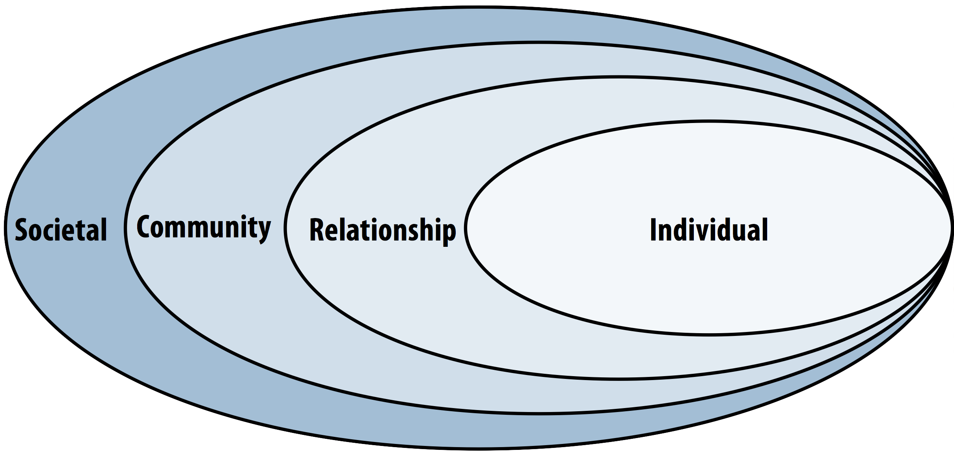

Figure 1: Social-Ecological Model

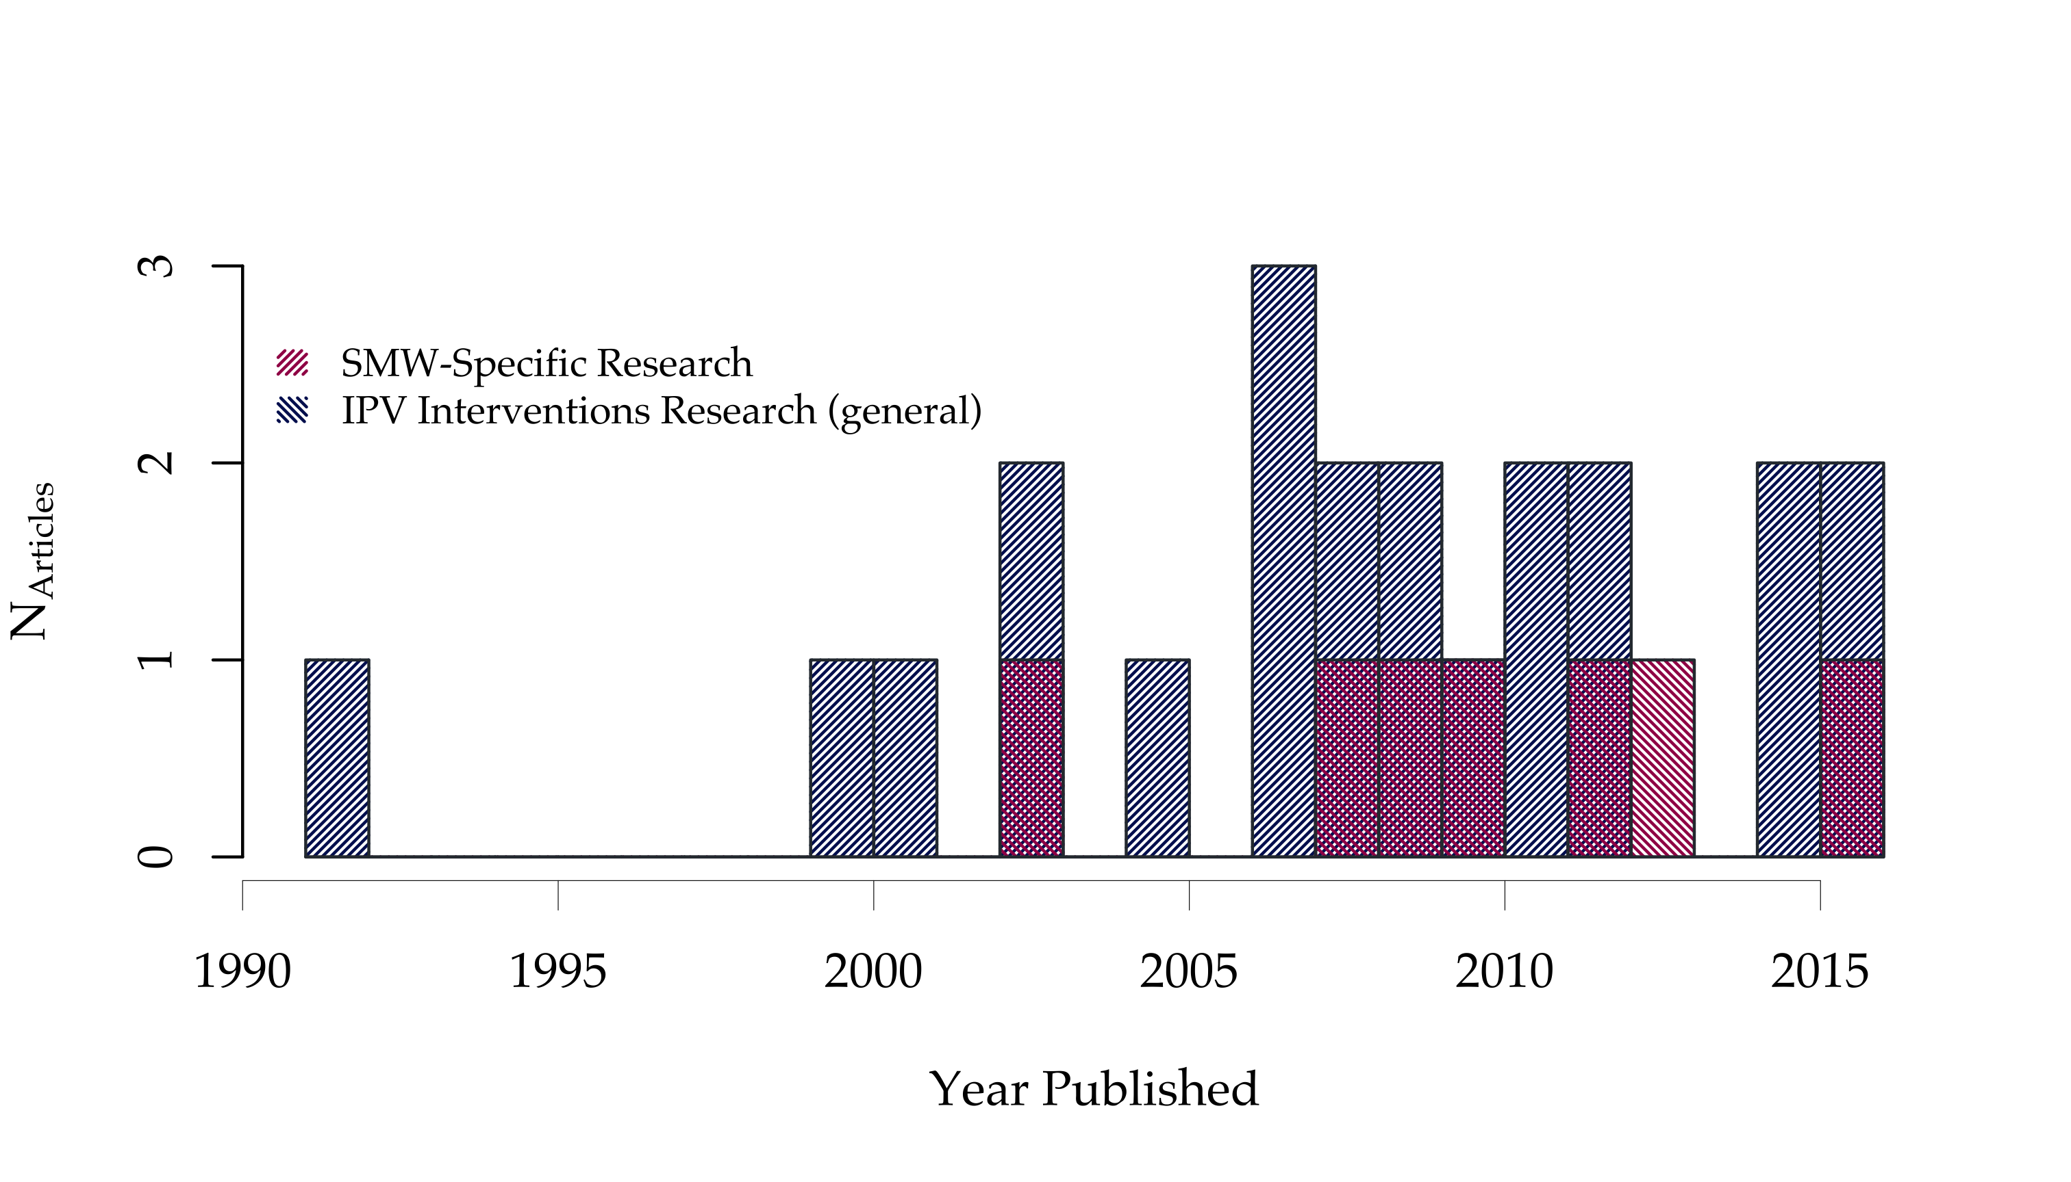

Figure 2: Timeline of publication years of the reviewed literature

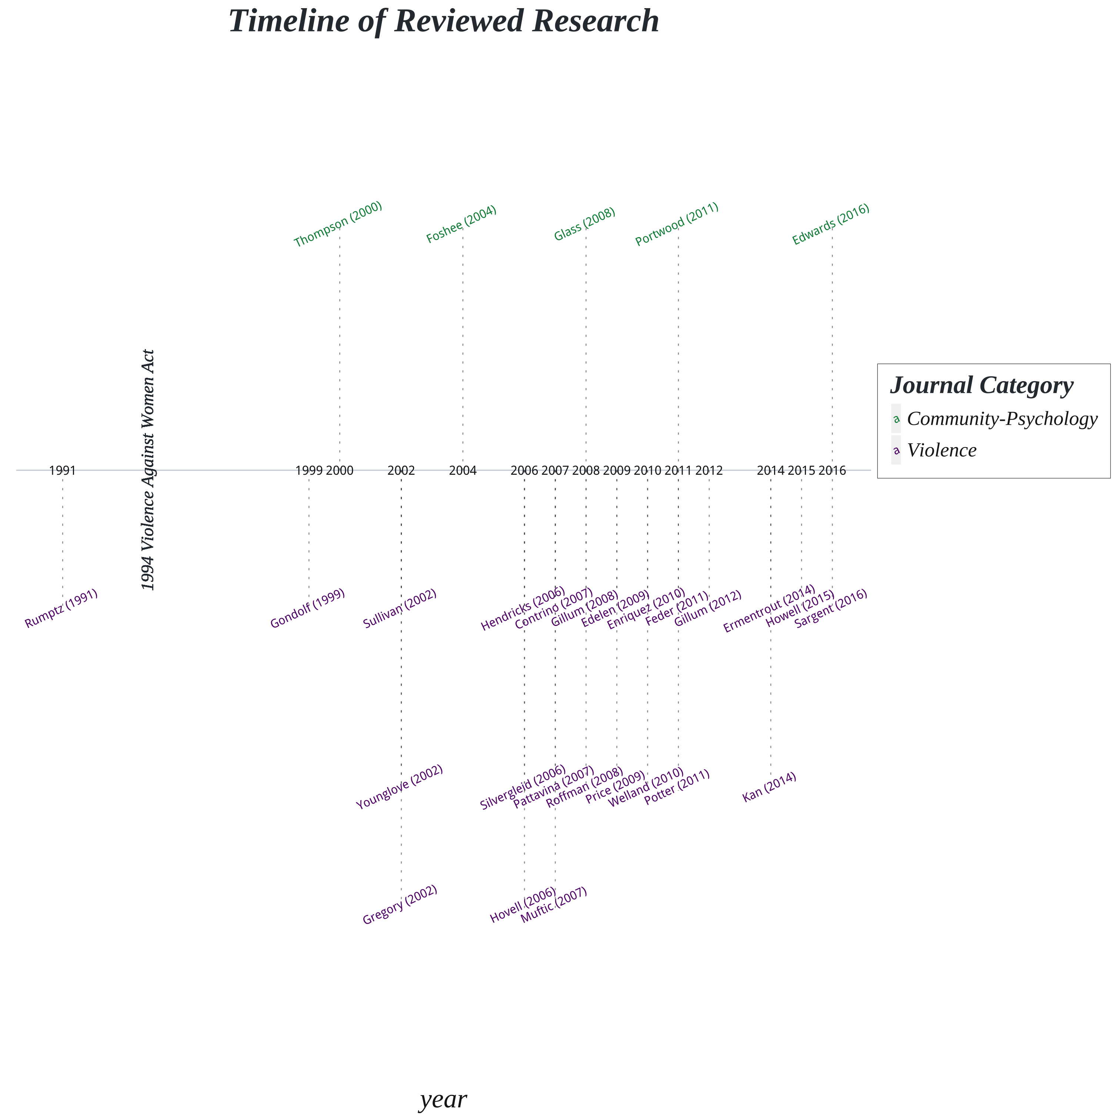

Figure 3: Publication Year by Study

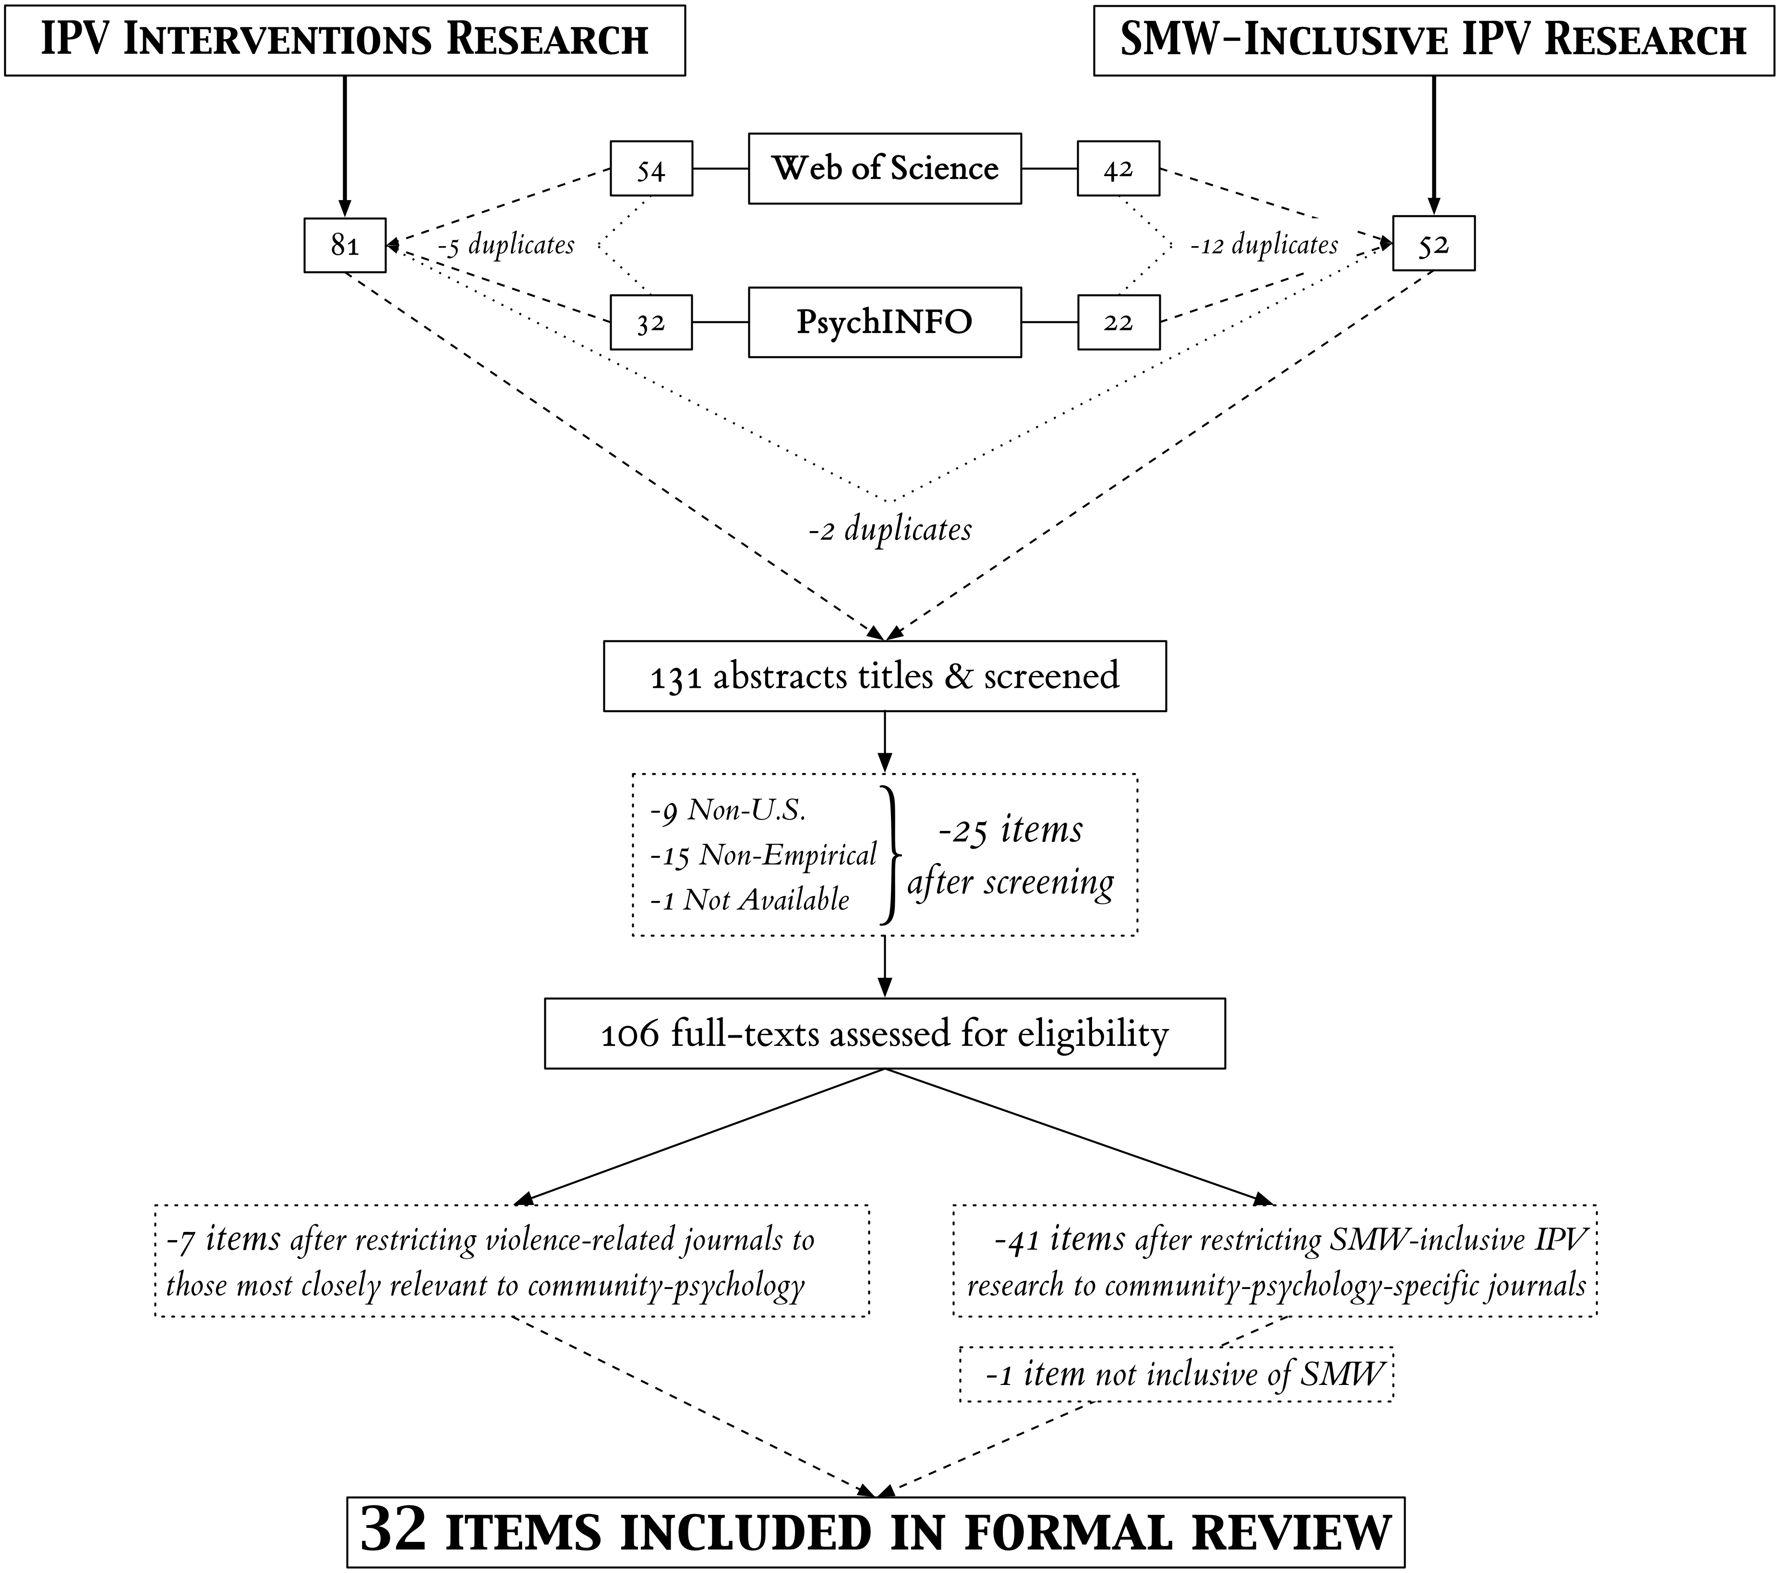

Figure 4: Systematic Literature Search and Inclusion Flow-Chart

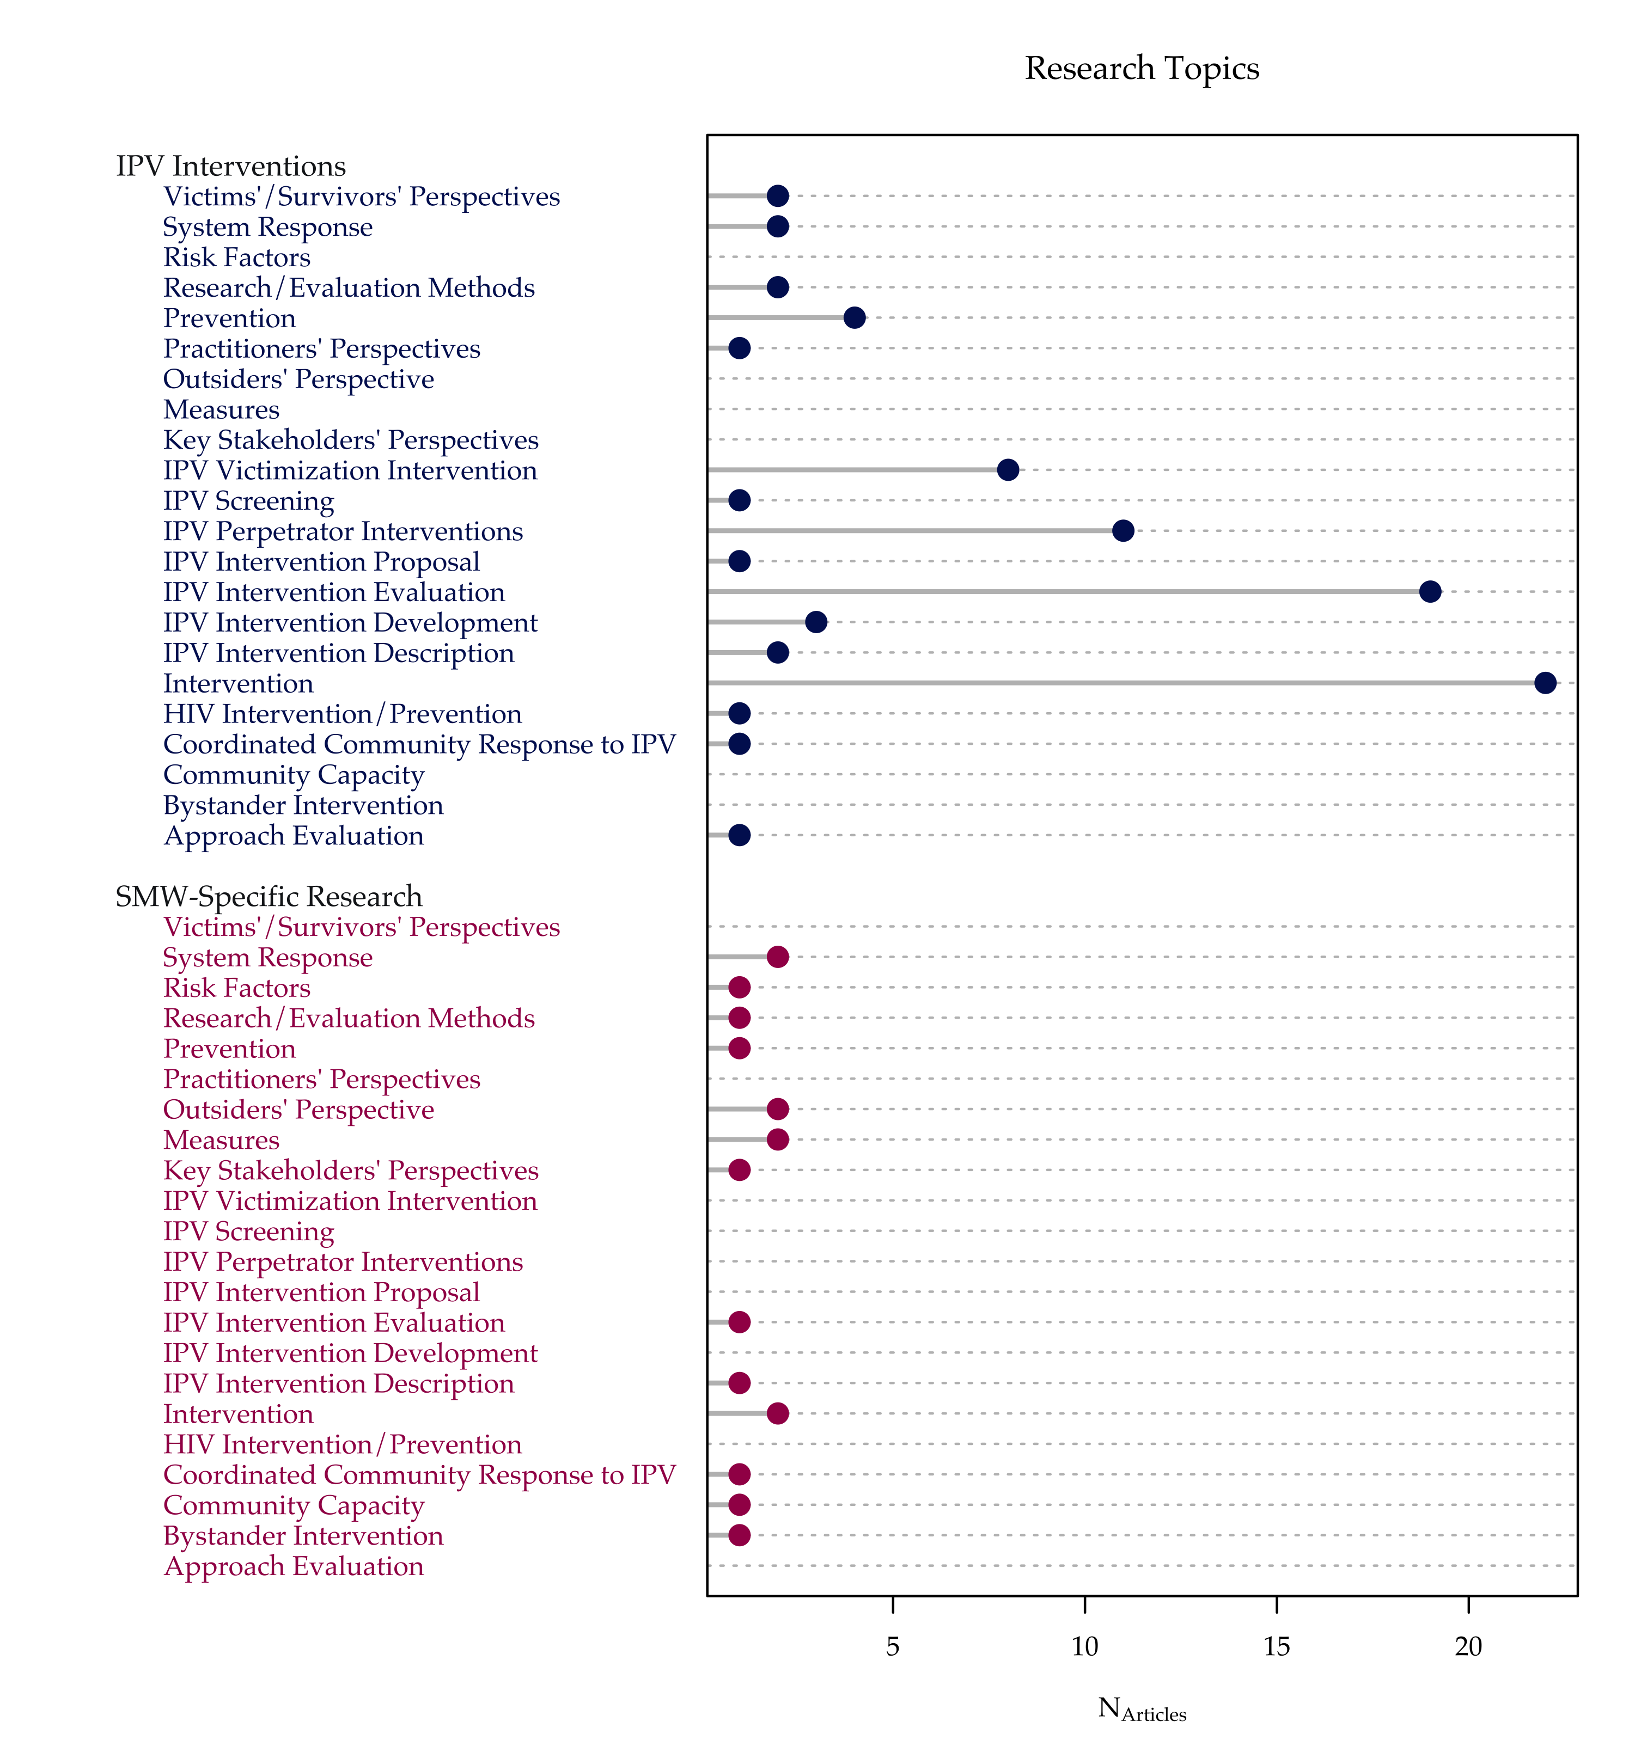

Figure 5: Substantive Research Topics Covered across the Reviewed Empirical Research

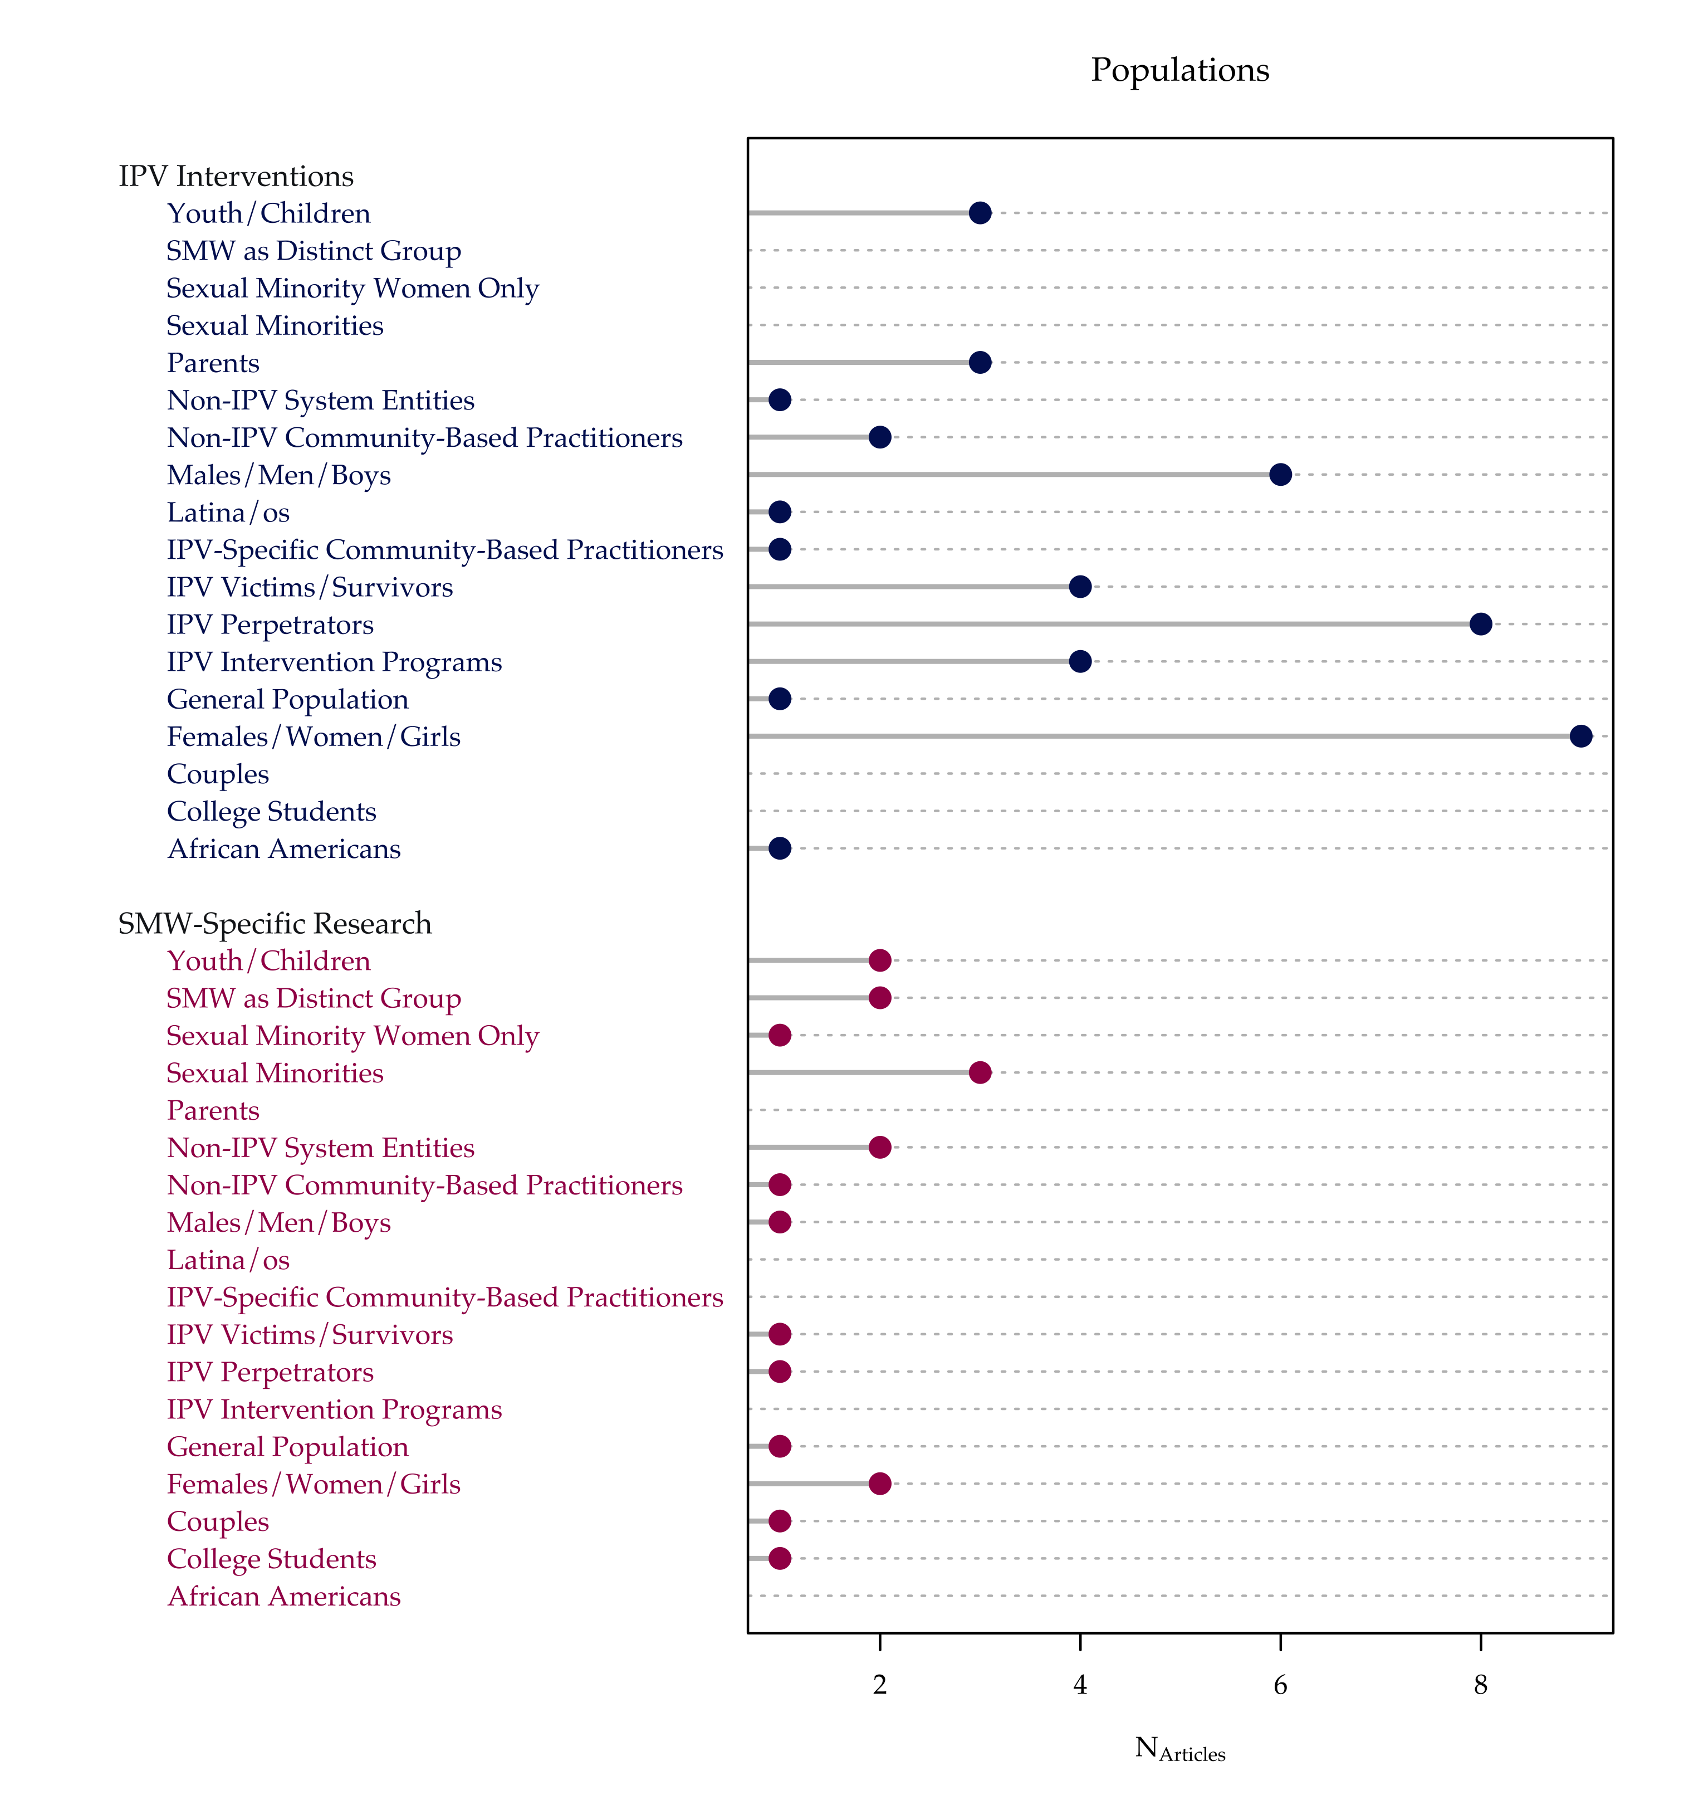

Figure 6: Target Populations Included in the Sampling Frames among the Review Literature in Each Substantive Research Category

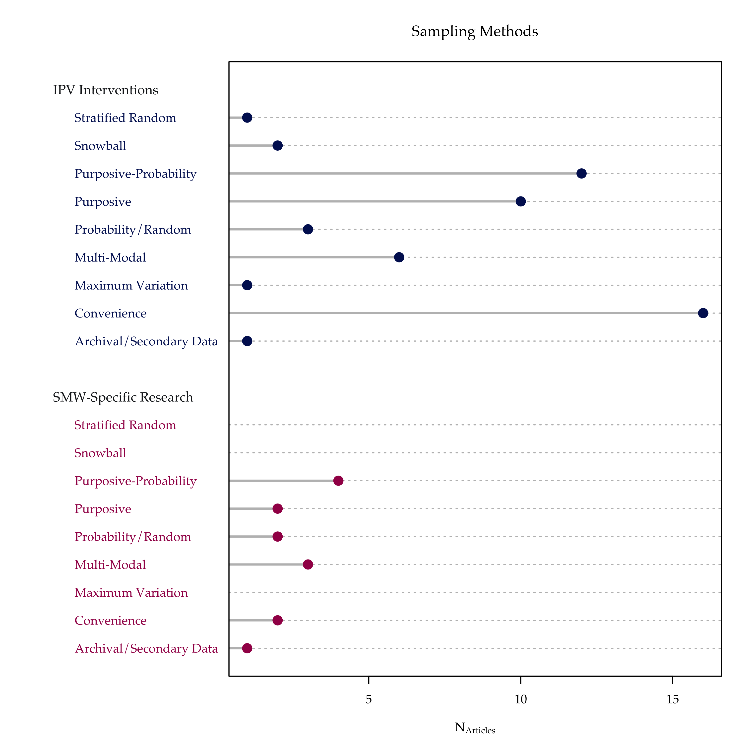

Figure 7: Sampling Methods Employed among the Review Literature in Each Substantive Research Category

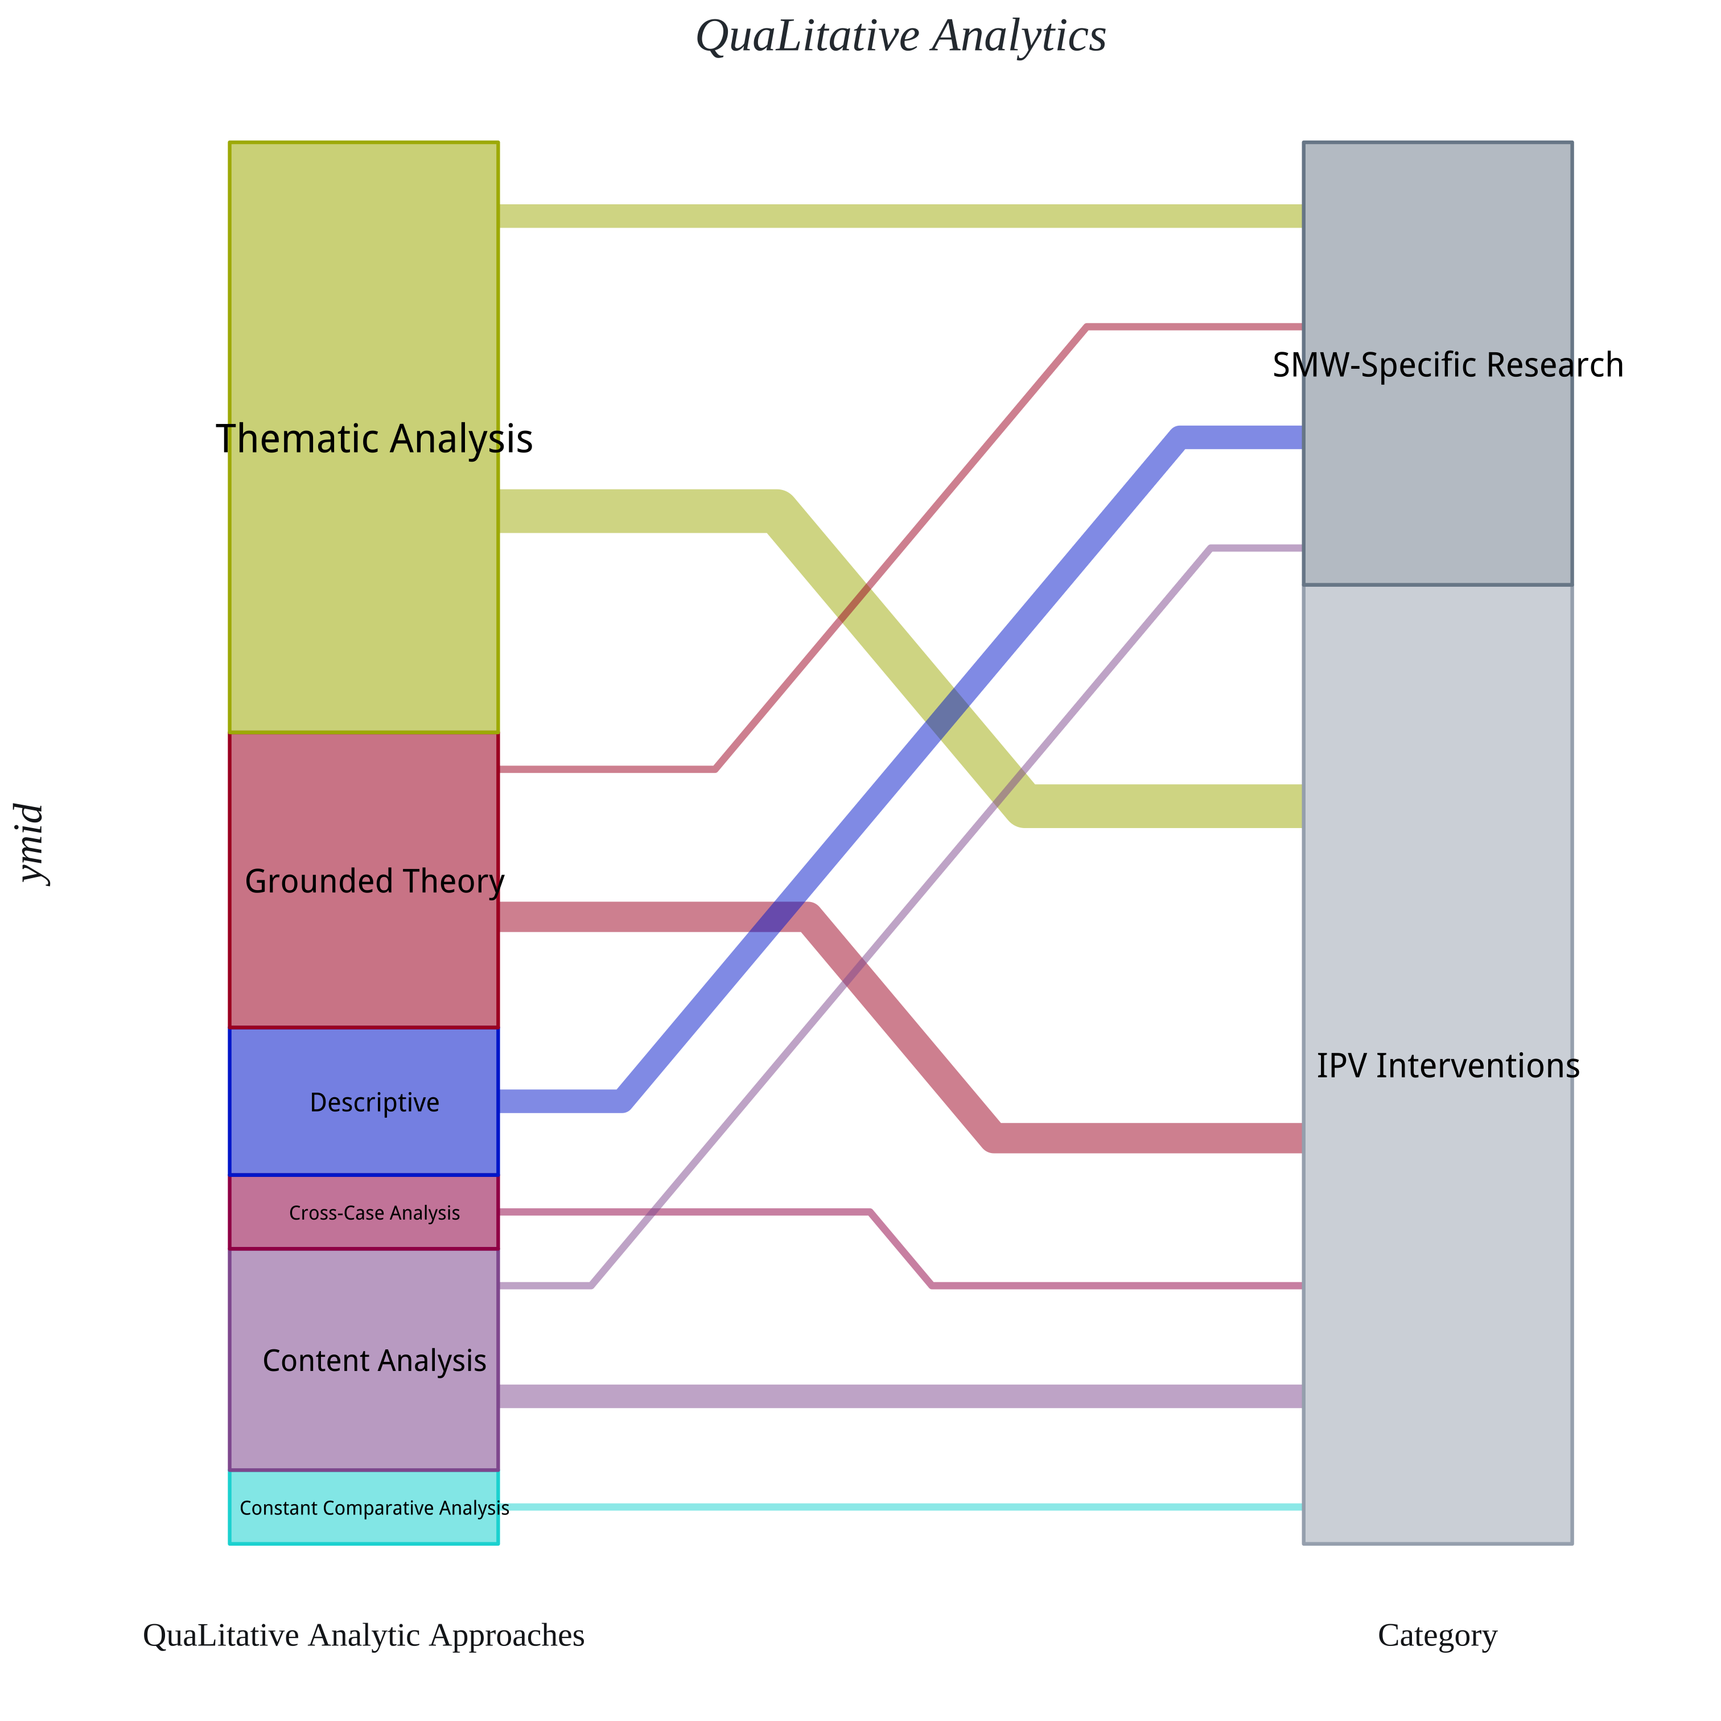

Figure 8: Qualitative Data Analytic Approaches Implemented among the Review Literature in Each Substantive Research Category

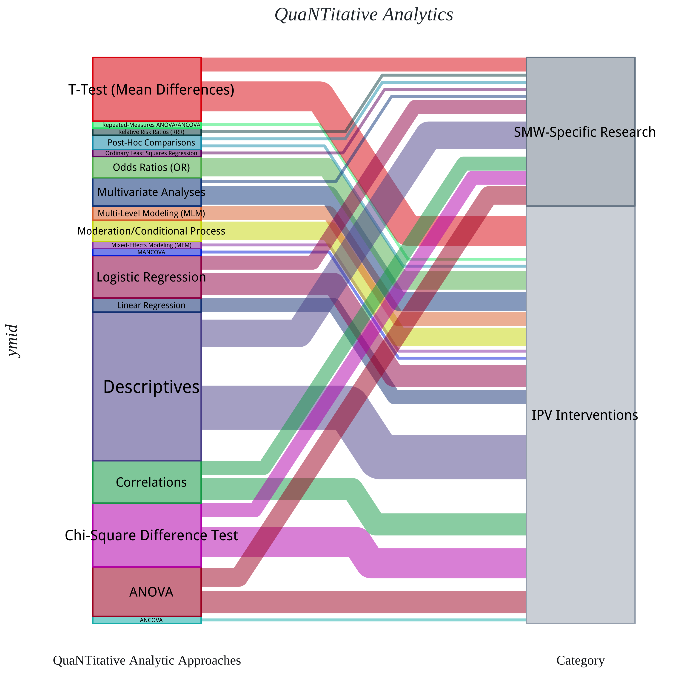

Figure 9: Quantitative Data Analytic Approaches Implemented among the Review Literature in Each Substantive Research Category

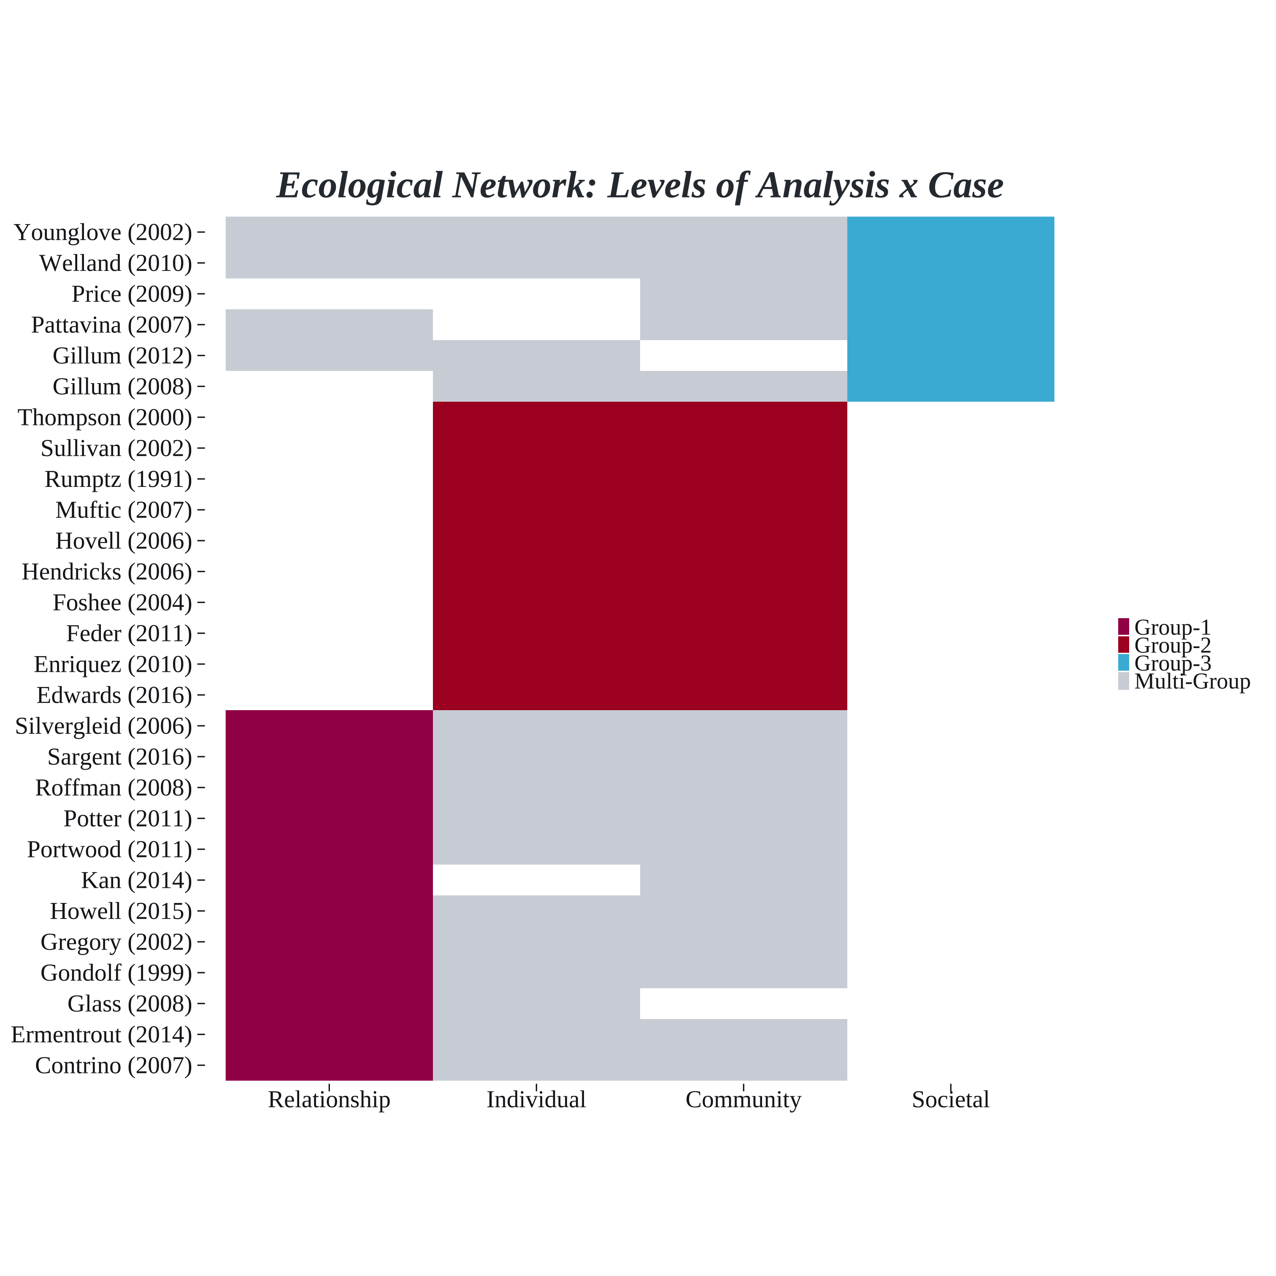

Figure 10: Ecological Network: Levels of Analysis. Group memberships derived from clustering algorithm which maximizes modularity across all possible partitions of the graph data in order to calculate the optimal cluster structure for the data (Brandes et al., 2008)

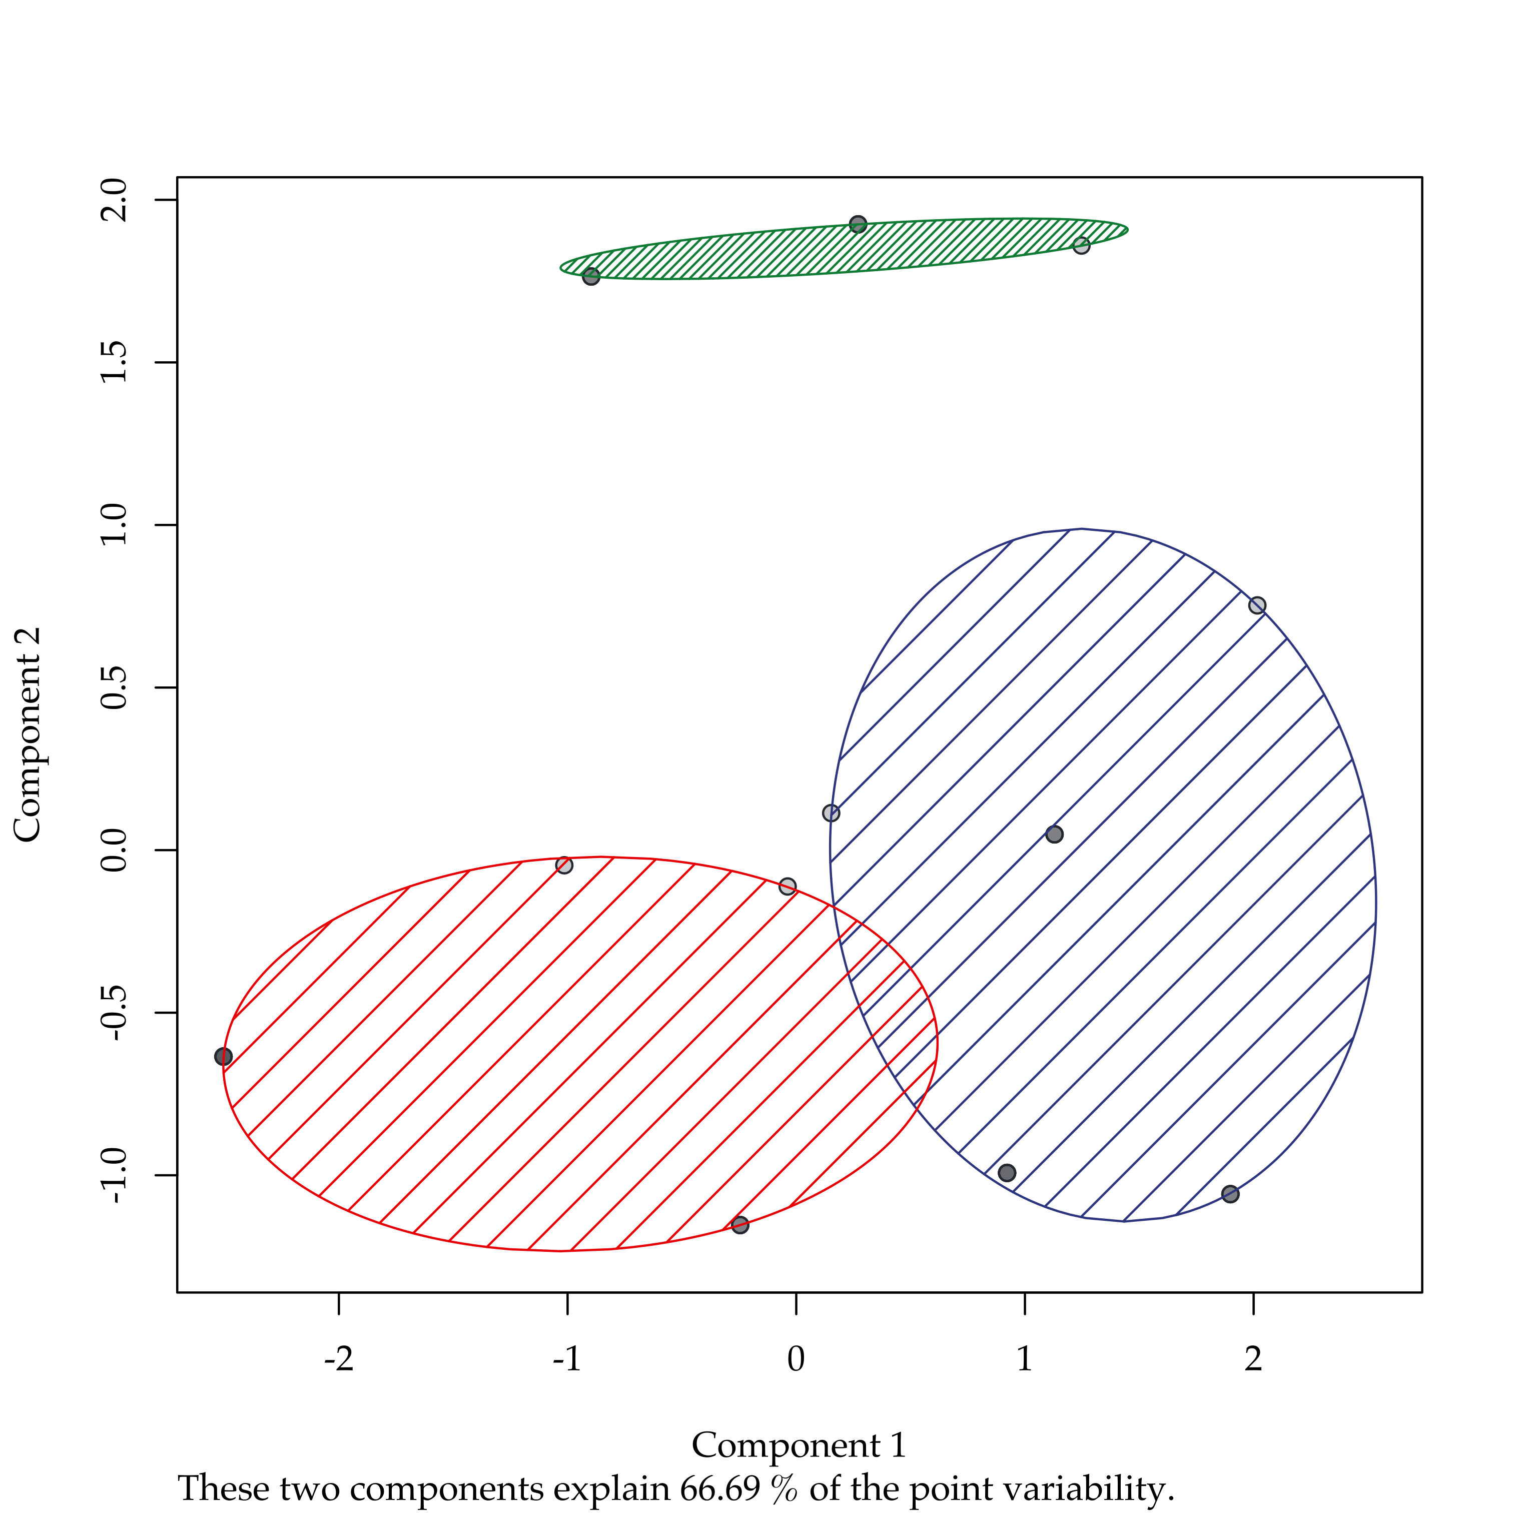

Figure 11: K-Means cluster analysis results visualization

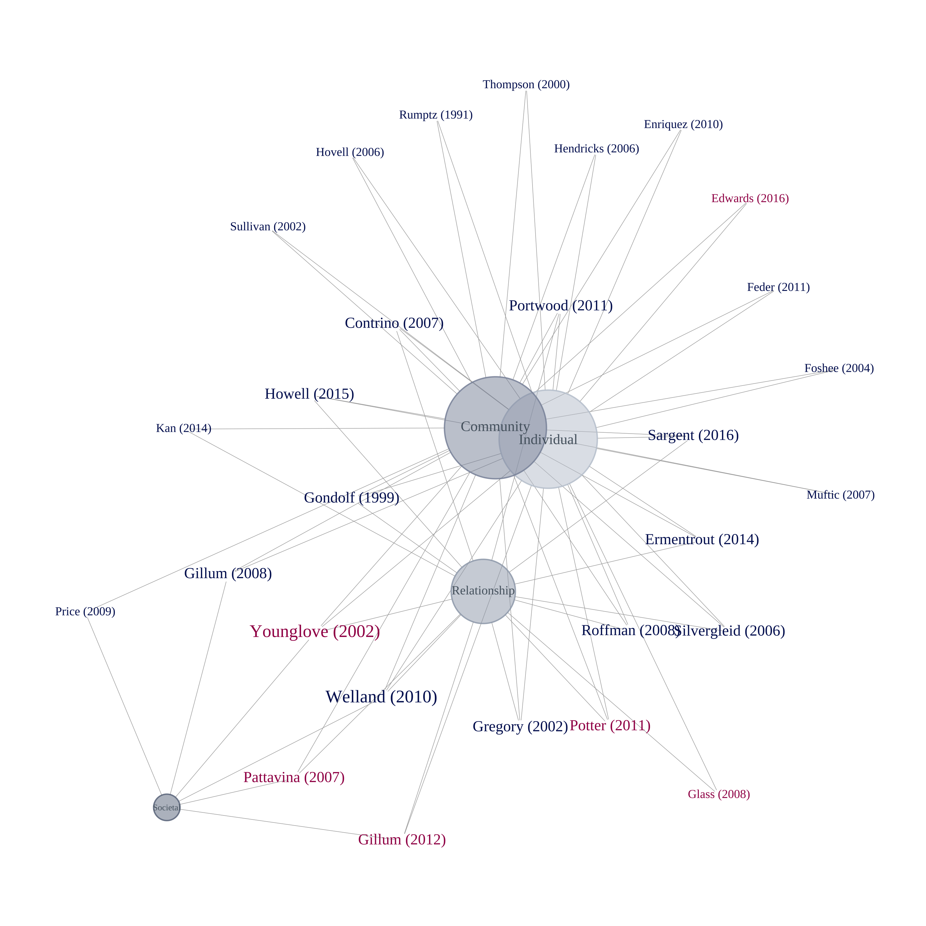

Figure 12: Network graph of the levels of analysis involved in the reviewed literature

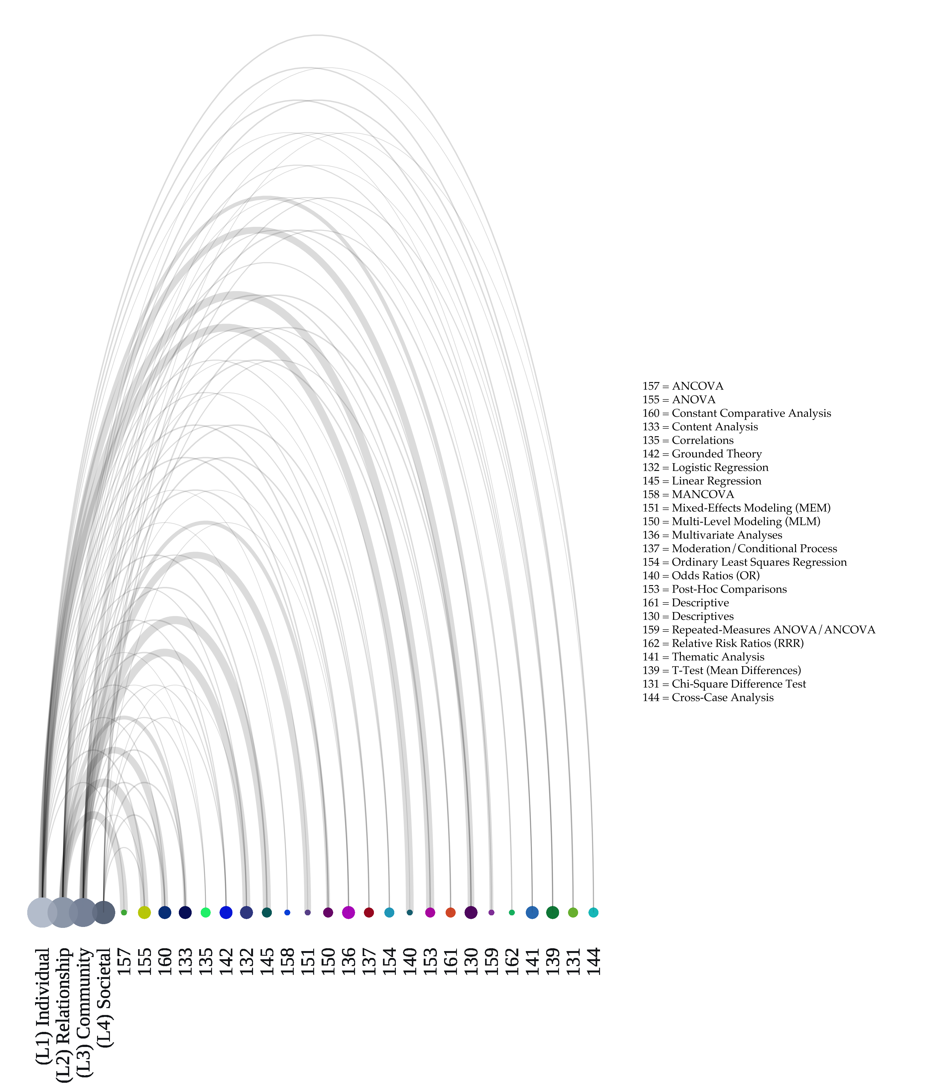

Figure 13: Network Diagram Showing Relations among Analytic Approaches (numbered graph nodes) used and Ecological Levels of Analysis (named graph nodes) Invovled among the Reviewed Literature:

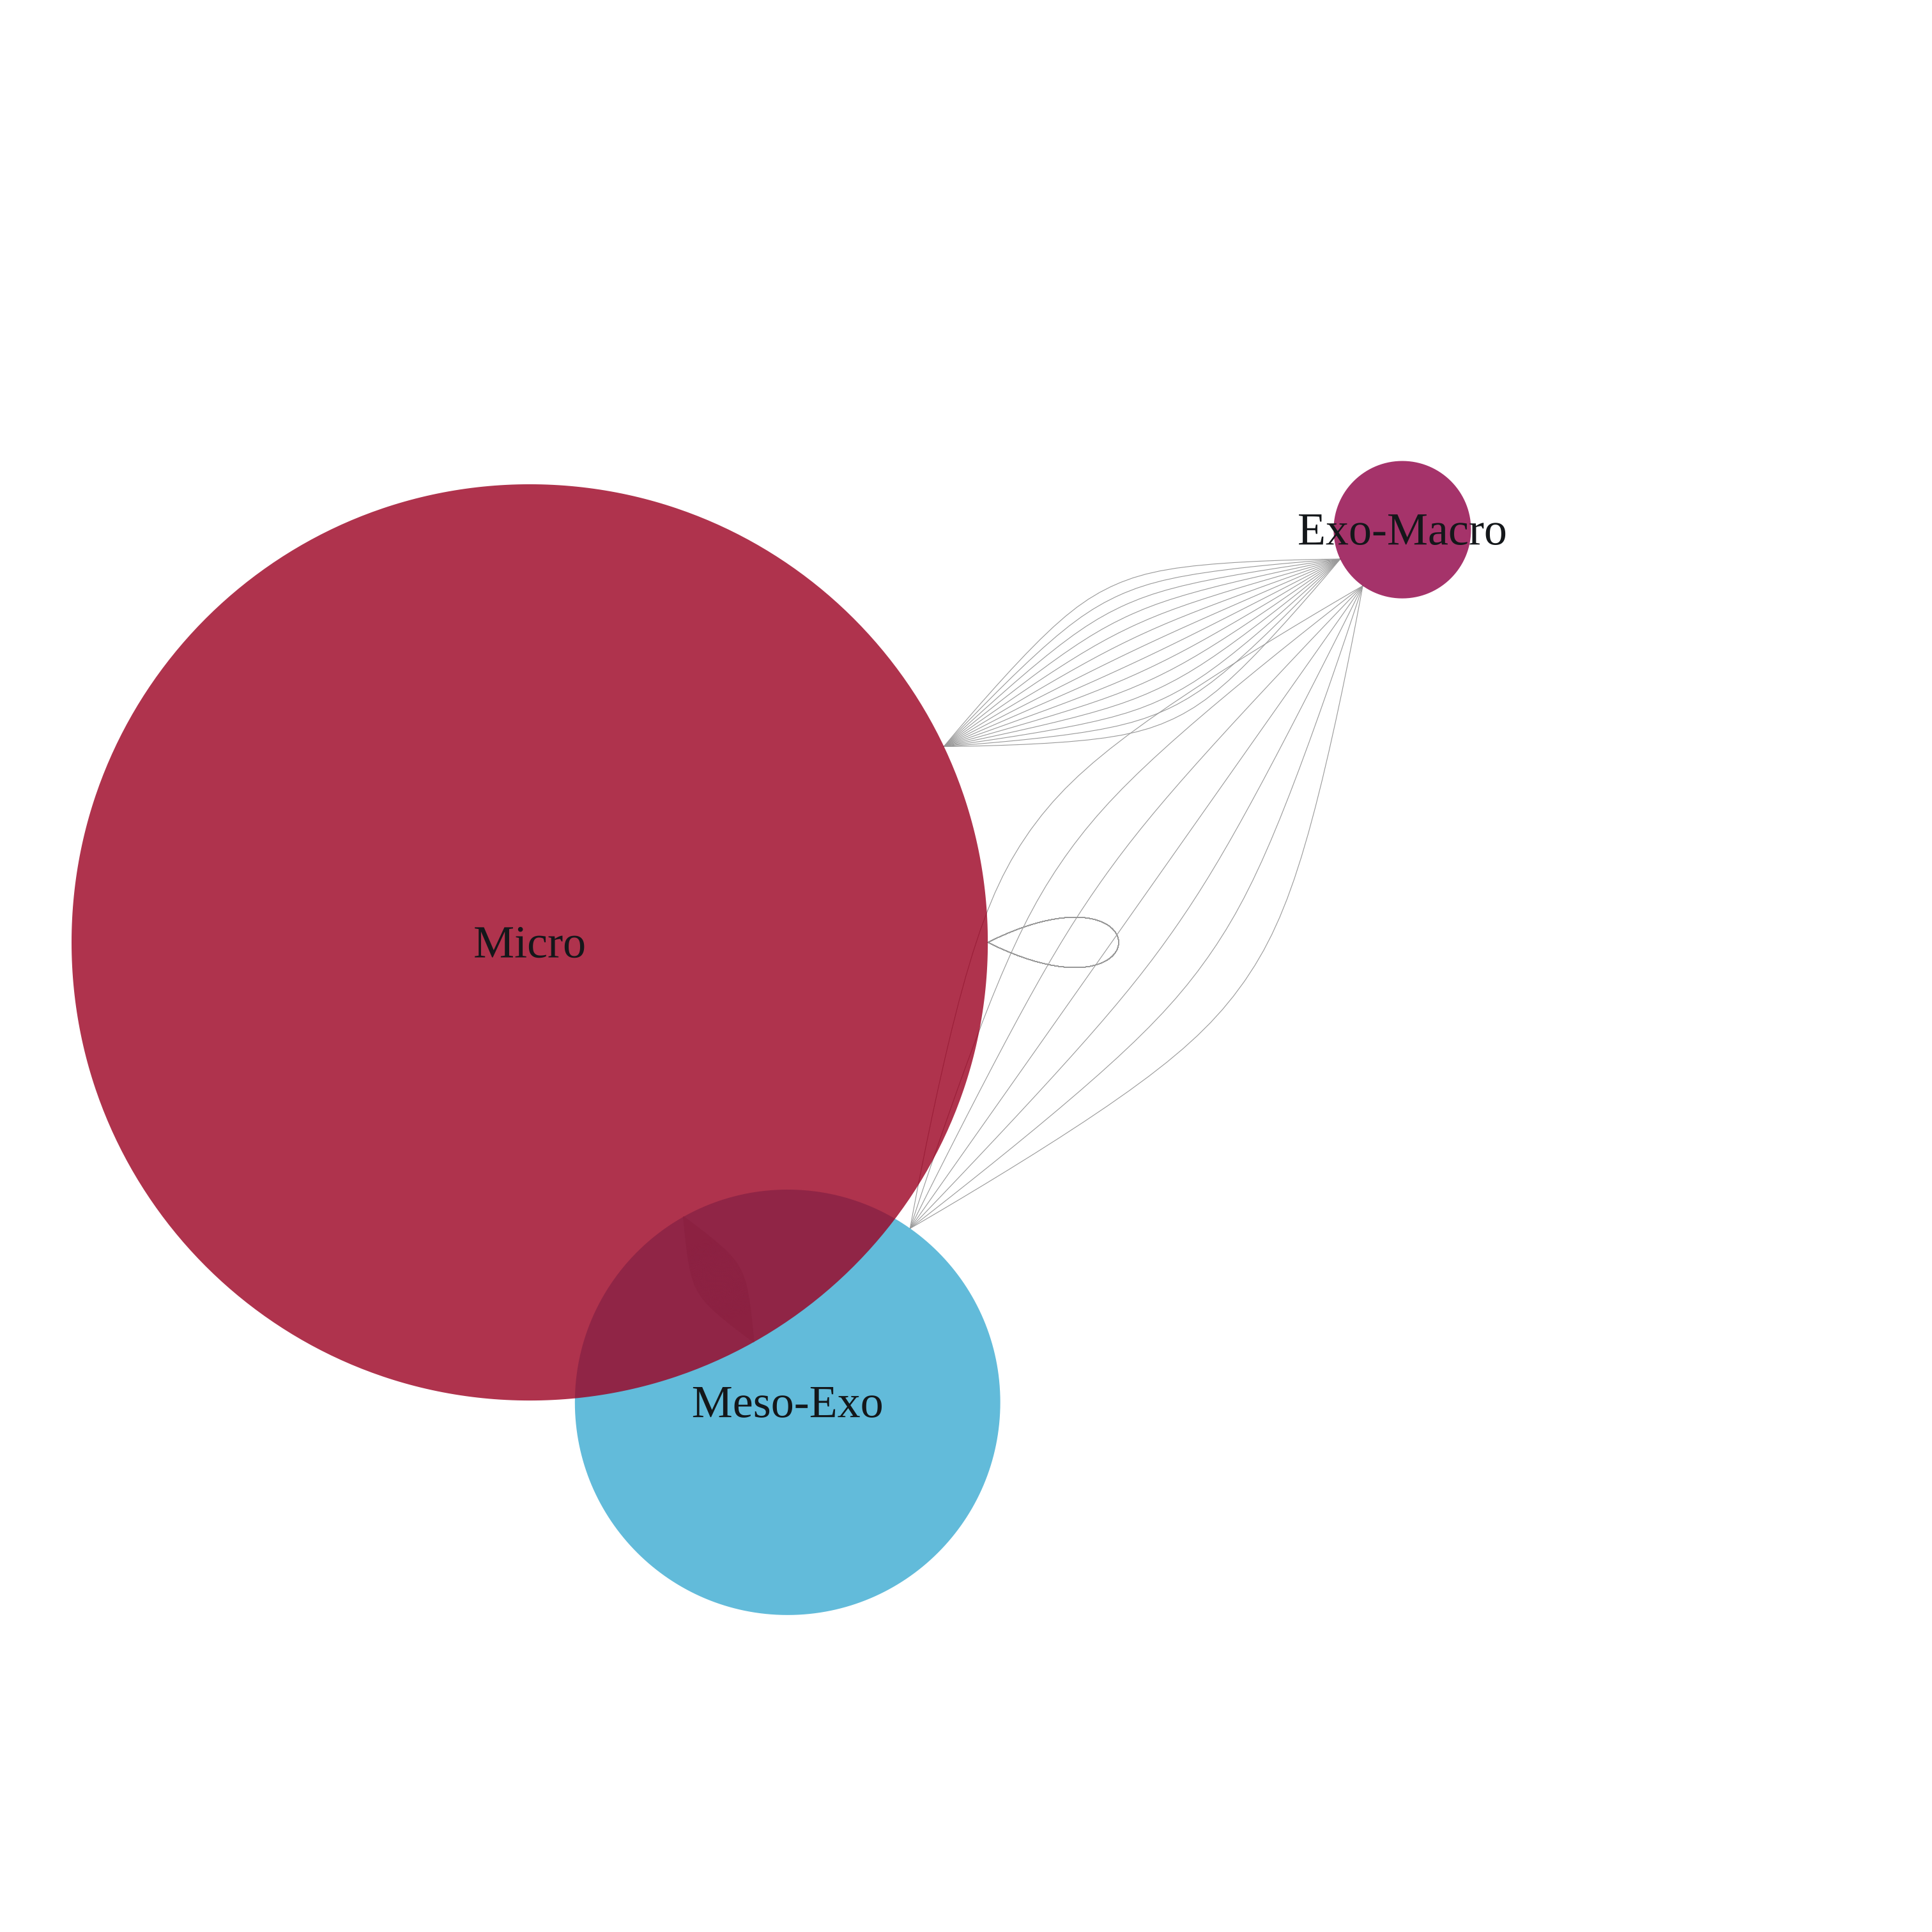

Figure 14: Network Visualization Of The Ecological Levels of Analysis (left) and Systems (right) Involved Across The Reviewed Literature

# References

Anderies; J., Janssen; M., & Ostrom; E. (2004). A framework to analyze the robustness of social-ecological systems from an institutional perspective. *Ecology and Society*, *9*, 18.

Anderson; V. A. (2016). Introduction to mixed methods approaches. In L. A. Jason & D. S. Glenwick (Eds.), *Introduction to community-based methodological approaches* (pp. 234–241). New York, NY: Oxford University Press.

Andrews; D., & Bonta; J. (1995). *Level of service inventory–Revised (lsi–R)*. Toronto, Canada: Multi- Health Systems.

Arias; E., Arce; R., & Vilariño; M. (2013). Batterer intervention programmes: A meta-analytic review of effectiveness. *Psychosocial Intervention*, *22*, 153–160.

Babcock; J., Armenti; N., Cannon; C., Lauve-Moon; K., Buttell; F., Ferreira; R., … Solano; I. (2016). Domestic violence perpetrator programs: A proposal for evidence-based standards in the united states. *Partner Abuse*, *7*, 355–460.

Baker; N., Buick; J., Kim; S., Moniz; S., & Nava; K. L. (2013). Lessons from examining same-sex intimate partner violence. *Sex Roles*, *69*, 182–192.

Balcazar; F. E., Taylor; R. R., Kielhofner; G. W., Tamley; K., Benziger; T., Carlin; N., & Johnson; S. (2004). Participatory action research: General principles and a study with a chronic health condition.

Barker; R. G. (1964). The ecological environment. In R. G. Barker & P. V. Gump (Eds.), *Big school, small school* (pp. pp. 4–10). Stanford, CA: Stanford University Press.

Barner; J. R., & Carney; M. M. (2011). Interventions for intimate partner violence: A historical review. *Journal of Family Violence*, *26*, 235–244.

Berkes; F., & Turner; N. J. (2006). Knowledge, learning and the evolution of conservation practice for social-ecological system resilience. *Human Ecology*, *34*, 479–494.

Boal; A. L., & Mankowski; E. S. (2014a). Barriers to compliance with oregon batterer intervention program standards. *Violence and Victims*, *29*, 607–619.

Boal; A. L., & Mankowski; E. S. (2014b). The impact of legislative standards on batterer intervention program practices and characteristics. *American Journal of Community Psychology*, *53*, 218–230.

Brandes; U., Delling; D., Gaertler; M., Gorke; R., Hoefer; M., & Nikoloski; Z. (2008). On modularity clustering. *IEEE Transactions on Knowledge and Data Engineering*, *20*, 172–188.

Bronfenbrenner; U. (1977). Toward an experimental ecology of human development. *American Psychologist*, *32*, 513.

Bronfenbrenner; U. (1979). *The ecology of human development: Experiments by nature and design*. Cambridge, MA: Harvard University Press.

Browning; C. R. (2002). The span of collective efficacy: Extending social disorganization theory to partner violence. *Journal of Marriage and Family*, *64*, 833–850.

Brydon-Miller; M., Greenwood; D., & Maguire; P. (2003). Why action research? *Action Research*, *1*, 9–28.

Campbell; J. C. (1986). Nursing assessment for risk of homicide with battered women. *Advances in Nursing Science*, *8*, 36–51.

Campbell; J. C. (1993). The Danger Assessment Instrument: Risk factors of homicide of and by battered women. *Questions and Answers in Lethal and Non-Lethal Violence*, *1*, 27–38.

Campbell; J. C., Webster; D. W., & Glass; N. (2009). The danger assessment validation of a lethality risk assessment instrument for intimate partner femicide. *Journal of Interpersonal Violence*, *24*, 653–674.

Campbell; J. C., Webster; D., Koziol-McLain; J., Block; C. R., Campbell; D., Curry; M. A., … others. (1985). A team of researchers studied the danger assessment and found that despite certain limitations, the tool can with some reliability identify women who may be at risk of being killed by an intimate partner. *Intimate Partner Violence*, *1993*.

Casler; K., Bickel; L., & Hackett; E. (2013). Separate but equal? A comparison of participants and data gathered via amazon’s mturk, social media, and face-to-face behavioral testing. *Computers in Human Behavior*, *29*, 2156–2160.

Centers for Disease Control and Prevention. (2013). *Taking action to prevent intimate partner violence and sexual violence: Creating statewide prevention plans*. Atlanta, GA: Centers for Disease Control; Prevention, Division of Violence Prevention.

Chandler; D., & Torbert; B. (2003). Transforming inquiry and action interweaving 27 flavors of action research. *Action Research*, *1*, 133–152.

Christens; B. D., Faust; V., Gaddis; J., Inzeo; P. T., Sarmiento; C. S., & Sparks; S. M. (2016). Action research. In L. A. Jason & D. S. Glenwick (Eds.), *Introduction to community-based methodological approaches* (pp. 243–251). New York, NY: Oxford University Press.

Connell; C. M. (2016). Introduction to quantitative methods. In L. A. Jason & D. S. Glenwick (Eds.), *Handbook of methodological approaches to community-based research: Qualitative, quantitative, and mixed methods* (pp. 121–131). New York, NY: Oxford University Press.

Contrino; K. M., Dermen; K. H., Nochajski; T. H., Wieczorek; W. F., & Navratil; P. K. (2007). Compliance and learning in an intervention program for partner-violent men. *Journal of Interpersonal Violence*, *22*, 1555–1566.

Dahlberg; L. L., & Krug; E. G. (2002). Violence: A global public health problem. In E. G. Krug, L. L. Dahlberg, J. A. Mercy, A. B. Zwi, & R. Lozano (Eds.), *World report on violence and health* (pp. 1–21). Geneva: World Health Organization.

Dahlberg; L. L., & Mercy; J. A. (2009). History of violence as a public health issue. *AMA Virtual Mentor*, *11*, 167–172. Retrieved from <http://virtualmentor.ama-assn.org/2009/02/mhst1-0902.html>

Dutton; D. G., & Corvo; K. (2006). Transforming a flawed policy: A call to revive psychology and science in domestic violence research and practice. *Aggression and Violent Behavior*, *11*, 457–483.

Dutton; D. G., & Corvo; K. (2007). The duluth model: A data-impervious paradigm and a failed strategy. *Aggression and Violent Behavior*, *12*, 658–667.

Eckhardt; C. I., Murphy; C. M., Whitaker; D. J., Sprunger; J., Dykstra; R., & Woodard; K. (2013). The effectiveness of intervention programs for perpetrators and victims of intimate partner violence. *Partner Abuse*, *4*, 196–231.

Edelen; M. O., McCaffrey; D. F., Marshall; G. N., & Jaycox; L. H. (2009). Measurement of teen dating violence attitudes an item response theory evaluation of differential item functioning according to gender. *Journal of Interpersonal Violence*, *24*, 1243–1263.

Edwards; K. M., Littleton; H. L., Sylaska; K. M., Crossman; A. L., & Craig; M. (2016). College campus community readiness to address intimate partner violence among LGBTQ+ young adults: A conceptual and empirical examination. *American Journal of Community Psychology*, *58*, 16–26.

Enriquez; M., Cheng; A.-L., Kelly; P. J., Witt; J., Coker; A. D., & Kashubeck-West; S. (2010). Development and feasibility of an hiv and ipv prevention intervention among low-income mothers receiving services in a missouri day care center. *Violence Against Women*, *16*, 560–578.

Ermentrout; D. M., Rizo; C. F., & Macy; R. J. (2014). “This is about me”: Feasibility findings from the children’s component of an ipv intervention for justice-involved families. *Violence Against Women*, *20*, 653–676.

Espino; S. L. R., & Trickett; E. J. (2008). The spirit of ecological inquiry and intervention research reports: A heuristic elaboration. *American Journal of Community Psychology*, *42*, 60–78.

Feder; L., & Wilson; D. B. (2005). A meta-analytic review of court-mandated batterer intervention programs: Can courts affect abusers’ behavior? *Journal of Experimental Criminology*, *1*, 239–262.

Feder; L., Niolon; P. H., Campbell; J., Wallinder; J., Nelson; R., & Larrouy; H. (2011). The need for experimental methodology in intimate partner violence: Finding programs that effectively prevent ipv. *Violence Against Women*, *17*, 340–358.

Fine; D. M. (1998). Violence against women act of 1994: The proper federal role in policing domestic violence. *Cornell L. Rev.*, *84*, 252–355.

Fine; M., Torre; M. E., Boudin; K., Bowen; I., Clark; J., Hylton; D., … others. (2003). Participatory action research: From within and beyond prison bars. In P. Camic, J. Rhodes, & L. Yardley (Eds.), *Qualitative research in psychology: Expanding perspectives in methodology and design* (pp. 179–198). Washington, DC, US: American Psychological Association.

Folke; C. (2006). Resilience: The emergence of a perspective for social-ecological systems analyses. *Global Environmental Change*, *16*, 253–267.

Forgey; E. (1965). Cluster analysis of multivariate data: Efficiency vs. interpretability of classification. *Biometrics*, *21*, 768–769.

Foshee; V. A., Bauman; K. E., Ennett; S. T., Linder; G. F., Benefield; T., & Suchindran; C. (2004). Assessing the long-term effects of the safe dates program and a booster in preventing and reducing adolescent dating violence victimization and perpetration. *American Journal of Public Health*, *94*, 619–624.

Friedman-Nimz; R., Altman; J., Cain; S., Korn; S., Karger; M. J., Witsch; M., … Weiss; M. (2006). Blending support and social action: The power of a gay-straight alliance and PrideWorks conference. *Prufrock Journal*, *17*, 258–264.

Fryer; D. (2008). Some questions about “the history of community psychology”. *Journal of Community Psychology*, *36*, 572–586.

Gelles; R. J. (2001). Standards for programs for men who batter? Not yet. *Journal of Aggression, Maltreatment & Trauma*, *5*, 11–20.

Gillum; T. L. (2008). The benefits of a culturally specific intimate partner violence intervention for african american survivors. *Violence Against Women*, *14*, 917–943.

Gillum; T. L., & DiFulvio; G. (2012). “There’s so much at stake”: Sexual minority youth discuss dating violence. *Violence Against Women*, *18*, 725–745.

Glass; N., Perrin; N., Hanson; G., Bloom; T., Gardner; E., & Campbell; J. C. (2008). Risk for reassault in abusive female same-sex relationships. *American Journal of Public Health*, *98*, 1021–1027.

Gondolf; E. W. (1999). A comparison of four batterer intervention systems: Do court referral, program length, and services matter? *Journal of Interpersonal Violence*, *14*, 41–61.

Gondolf; E. W. (2007). Theoretical and research support for the duluth model: A reply to dutton and corvo. *Aggression and Violent Behavior*, *12*, 644–657.

Gondolf; E. W., & Wernik; H. (2009). Clinician ratings of batterer treatment behaviors in predicting reassault. *Journal of Interpersonal Violence*, *24*, 1792–1815.

Gregory; C., & Erez; E. (2002). The effects of batterer intervention programs: The battered women’s perspectives. *Violence Against Women*, *8*, 206–232.

Hart; B. J. (1995, March). Coordinated community approaches to domestic violence. Paper Presented at the Strategic Planning Workshop on Violence Against Women, Washington, DC: National Institute of Justice. Retrieved from <http://www.ncdsv.org/images/Coordinated%20Community%20Approaches%20to%20DV.pdf>

Hartigan; J. A., & Wong; M. A. (1979). Algorithm as 136: A k-means clustering algorithm. *Journal of the Royal Statistical Society. Series C (Applied Statistics)*, *28*, 100–108.

Hegarty; K., Sheehan; M., & Schonfeld; C. (1999). A multidimensional definition of partner abuse: Development and preliminary validation of the composite abuse scale. *Journal of Family Violence*, *14*, 399–415.

Heise; L. L. (1998). Violence against women an integrated, ecological framework. *Violence Against Women*, *4*, 262–290.

Hendricks; B., Werner; T., Shipway; L., & Turinetti; G. J. (2006). Recidivism among spousal abusers: Predictions and program evaluation. *Journal of Interpersonal Violence*, *21*, 703–716.

Higgins; J., & Green; S. (Eds.). (2011). *Cochrane handbook for systematic reviews of interventions version 5.1.0 [updated march 2011]*. London, UK: The Cochrane Collaboration. Retrieved from <http://handbook.cochrane.org>

Hovell; M. F., Seid; A. G., & Liles; S. (2006). Evaluation of a police and social services domestic violence program: Empirical evidence needed to inform public health policies. *Violence Against Women*, *12*, 137–159.

Howell; K. H., Miller; L. E., Lilly; M. M., Burlaka; V., Grogan-Kaylor; A., & Graham-Bermann; S. (2015). Strengthening positive parenting through intervention: Evaluating the moms’ empowerment program for women experiencing intimate partner violence. *Journal of Interpersonal Violence*, *30*, 232–252.

Hughes; D. L., & DuMont; K. (2002). Using focus groups to facilitate culturally anchored research. In *Ecological research to promote social change* (pp. 257–289).

Ingram; D., & Franco; S. (2012). NCHS urban-rural classification scheme for counties. In *Vital and health statistics* (Vol. 2). Hyattsville, Maryland: National Center for Health Statistics, Centers for Disease Control; Prevention.

Jain; A. K., Murty; M. N., & Flynn; P. J. (1999). Data clustering: A review. *ACM Computing Surveys (CSUR)*, *31*, 264–323.

Jason; L. A., & Glenwick; D. S. (2016). Grounded theory. In L. A. Jason & D. S. Glenwick (Eds.), *Introduction to community-based methodological approaches* (pp. 1–10). New York, NY: Oxford University Press.

Kan; M. L., & Feinberg; M. E. (2014). Can a family-focused, transition-to-parenthood program prevent parent and partner aggression among couples with young children? *Violence and Victims*, *29*, 967–980.

Kelly; J. G., Snowden; L. R., & Munoz; R. F. (1977). Social and community interventions. *Annual Review of Psychology*, *28*, 323–361.

Kelly; J., Azelton; S., Lardon; C., Mock; L., Tandon; D., & Thomas; M. (2004). On community leadership: Stories about collaboration in action research. *American Journal of Community Psychology*, *33*, 205–216.

Kloos; B. (2005). Community science: Creating and alternative place to stand? *American Journal of Community Psychology*, *35*, 259–267.

Kloos; B., Hill; J., Thomas; E., Wandersman; A., & Elias; M. J. (2012). *Community psychology: Linking individuals and communities* (Third Edition). Belmont, CA: Wadsworth, Cengage Learning.

Kral; M. J., & Allen; J. (2016). Community-based participator action research. In L. A. Jason & D. S. Glenwick (Eds.), *Introduction to community-based methodological approaches* (pp. 254–262). New York, NY: Oxford University Press.

Krug; E. G., Dahlberg; L. L., Mercy; J. A., Zwi; A. B., & Lozano; R. (Eds.). (2002). *The world report on violence and health*. Geneva: World Health Organization.

Leech; N. L., & Onwuegbuzie; A. J. (2007). An array of qualitative data analysis tools: A call for data analysis triangulation. *School Psychology Quarterly*, *22*, 557.

LeGates; M. (2001). *In their time: A history of feminism in western society*. New York, NY: Routledge.

Lewis; R. J., Milletich; R. J., Derlega; V. J., & Padilla; M. A. (2014). Sexual minority stressors and psychological aggression in lesbian women’s intimate relationships: The mediating roles of rumination and relationship satisfaction. *Psychology of Women Quarterly*, *38*, 535–550.

Lounsbury; D. W., & Mitchell; S. G. (2009). Introduction to special issue on social ecological approaches to community health research and action. *American Journal of Community Psychology*, *44*, 213–220.

Luke; D. A. (2005). Getting the big picture in community science: Methods that capture context. *American Journal of Community Psychology*, *35*, 185.

Maguire; P. (1987). *Doing participatory research: A feminist approach*. Amherst, MA: Center for International Education, School of Education, University of Massachusetts.

Maton; K. I., Perkins; D. D., Altman; D. G., Gutierrez; L., Kelly; J. G., Rappaport; J., & Saegert; S. (2006). Community-based interdisciplinary research: Introduction to the special issue. *American Journal of Community Psychology*, *38*, 1–7.

Meyer; I. H. (1995). Minority stress and mental health in gay men. *Journal of Health and Social Behavior*, 38–56.

Meyer; I. H. (2003). Prejudice, social stress, and mental health in lesbian, gay, and bisexual populations: Conceptual issues and research evidence. *Psychological Bulletin*, *129*, 674.

Meyer; I. H. (2015). Resilience in the study of minority stress and health of sexual and gender minorities. *Psychology of Sexual Orientation and Gender Diversity*, *2*, 209.

Modi; M. N., Palmer; S., & Armstrong; A. (2014). The role of violence against women act in addressing intimate partner violence: A public health issue. *Journal of Women’s Health*, *23*, 253–259.

Moher; D., Liberati; A., Tetzlaff; J., Altman; D. G., & The PRISMA Group. (2009). Preferred reporting items for systematic reviews and meta-analyses: The PRISMA statement. *PLoS med*, *6*, e1000097. <http://doi.org/https://doi.org/10.1371/journal.pmed.1000097>

Mufti $\overset{´}{c}$; L. R., & Bouffard; J. A. (2007). An evaluation of gender differences in the implementation and impact of a comprehensive approach to domestic violence. *Violence Against Women*, *13*, 46–69.

National Center for Injury Prevention and Control. (2015). The Social-Ecological Model: A framework for prevention. Atlanta, GA: Centers for Disease Control and Prevention; Division of Violence and Injury Prevention. Retrieved from <https://www.cdc.gov/violenceprevention/pdf/sem_framewrk-a.pdf>

Noffke; S. E. (1997). Professional, personal, and political dimensions of action research. *Review of Research in Education*, 305–343.

Norris; F., Stevens; S., Pfefferbaum; B., Wyche; K., & Pfefferbaum; R. L. (2008). Community resilience as a metaphor, theory, set of capacities, and strategy for disaster readiness. *American Journal of Community Psychology*, *41*, 127–150.

Onwuegbuzie; A. J., & Weinbaum; R. K. (2017). A framework for using qualitative comparative analysis for the review of the literature. *The Qualitative Report*, *22*, 359–372.

Onwuegbuzie; A. J., Dickinson; W. B., Leech; N. L., & Zoran; A. G. (2009). A qualitative framework for collecting and analyzing data in focus group research. *International Journal of Qualitative Methods*, *8*, 1–21.

Pattavina; A., Hirschel; D., Buzawa; E., Faggiani; D., & Bentley; H. (2007). A comparison of the police response to heterosexual versus same-sex intimate partner violence. *Violence Against Women*, *13*, 374–394.

Pence; E. (1983). Duluth domestic abuse intervention project, the. *Hamline Rev.*, *6*, 247.

Portwood; S. G., Lambert; R. G., Abrams; L. P., & Nelson; E. B. (2011). An evaluation of the adults and children together (act) against violence parents raising safe kids program. *Journal of Primary Prevention*, *32*, 147–160.

Potter; S. J., & Stapleton; J. G. (2011). Bringing in the target audience in bystander social marketing materials for communities: Suggestions for practitioners. *Violence Against Women*, *17*, 797–812.

Potter; S. J., Moynihan; M. M., & Stapleton; J. G. (2011). Using social self-identification in social marketing materials aimed at reducing violence against women on campus. *Journal of Interpersonal Violence*, *26*, 971–990.

Potter; S. J., Moynihan; M. M., Stapleton; J. G., & Banyard; V. L. (2009). Empowering bystanders to prevent campus violence against women: A preliminary evaluation of a poster campaign. *Violence Against Women*, *15*, 106–121.

Potter; S. J., Stapleton; J. G., & Moynihan; M. M. (2008). Designing, implementing, and evaluating a media campaign illustrating the bystander role. *Journal of Prevention & Intervention in the Community*, *36*, 39–55.

Price; B. J., & Rosenbaum; A. (2009). Batterer intervention programs: A report from the field. *Violence and Victims*, *24*, 757–770.

Prilleltensky; I. (1997). Values, assumptions, and practices: Assessing the moral implications of psychological discourse and action. *American Psychologist*, *52*, 517.

Prilleltensky; I. (2001). Value-based praxis in community psychology: Moving toward social justice and social action. *American Journal of Community Psychology*, *29*, 747–778.

R Core Team. (2016). *R: A language and environment for statistical computing*. Vienna, Austria: R Foundation for Statistical Computing. Retrieved from <https://www.R-project.org/>

Rappaport; J. (1987). Terms of empowerment/exemplars of prevention: Toward a theory for community psychology. *American Journal of Community Psychology*, *15*, 121–148.

Riger; S. (1993). What’s wrong with empowerment. *American Journal of Community Psychology*, *21*, 279–292.

Roffman; R. A., Edleson; J. L., Neighbors; C., Mbilinyi; L., & Walker; D. (2008). The men’s domestic abuse check-up: A protocol for reaching the nonadjudicated and untreated man who batters and who abuses substances. *Violence Against Women*, *14*, 589–605.

Rumptz; M. H., Sullivan; C. M., Davidson; W. S., & Basta; J. (1991). An ecological approach to tracking battered women over time. *Violence and Victims*, *6*, 237–244.

Sarason; S. B. (1972). *The creation of settings and the future societies*. San Francisco, CA: Jossey-Bass.

Sargent; K. S., McDonald; R., Vu; N. L., & Jouriles; E. N. (2016). Evaluating an online program to help children exposed to domestic violence: Results of two randomized controlled trials. *Journal of Family Violence*, *31*, 647–654.

Seidman; E. (2012). An emerging action science of social settings. *American Journal of Community Psychology*, *50*, 1–16.

Senn; C. Y. (2005). You can change the world: Action, participatory, and activist research. In F. Schneider, J. Gruman, & L. Coutts (Eds.), *Applied social psychology: Understanding and addressing social problems* (pp. 355–373). Thousand Oaks, CA: SAGE Publications, Inc.

Silvergleid; C. S., & Mankowski; E. S. (2006). How batterer intervention programs work: Participant and facilitator accounts of processes of change. *Journal of Interpersonal Violence*, *21*, 139–159.

Steinbach; M., Karypis; G., Kumar; V., & others. (2000). A comparison of document clustering techniques. In *KDD workshop on text mining* (Vol. 400, pp. 525–526). Boston.

Stover; C. S. (2005). Domestic violence research what have we learned and where do we go from here? *Journal of Interpersonal Violence*, *20*, 448–454.

Stover; C. S., Meadows; A. L., & Kaufman; J. (2009). Interventions for intimate partner violence: Review and implications for evidence-based practice. *Professional Psychology: Research and Practice*, *40*, 223.

Sullivan; C. M., Bybee; D. I., & Allen; N. E. (2002). Findings from a community-based program for battered women and their children. *Journal of Interpersonal Violence*, *17*, 915–936.

Team; R. C., & worldwide. (2017). *The r stats package*. Retrieved from <http://www.r-project.org/>

The Society for Community Research and Action (SCRA). (2017). Other journals relevant to community psychology. Retrieved from <http://www.scra27.org/publications/other-journals-relevant-community-psychology/>

The White House, Office of the Vice President, & Biden; J. (2014). 1 is 2 many: Twenty years fighting violence against women and girls [Official U.S. White House report prepared by the Office of the Vice President to commemorate the 20th Anniversary of the Violence Against Women Act]. Washington, D.C., U.S.: Office of the Vice President, The White House.

Thompson; R. S., Rivara; F. P., Thompson; D. C., Barlow; W. E., Sugg; N. K., Maiuro; R. D., & Rubanowice; D. M. (2000). Identification and management of domestic violence: A randomized trial. *American Journal of Preventive Medicine*, *19*, 253–263.

Tolman; R., & Edleson; J. L. (1995). Intervention for men who batter: A review of research. *Understanding Partner Violence: Prevalence, Causes, Consequences, and Solutions*, *11*, 262–273.

Toro; P. A. (2005). Community psychology: Where do we go from here? *American Journal of Community Psychology*, *35*, 9–16.

Trickett; E. J. (2009a). Community psychology: Individuals and interventions in community context. *Annual Review of Psychology*, *60*, 395–419.

Trickett; E. J. (2009b). Multilevel community-based culturally situated interventions and community impact: An ecological perspective. *American Journal of Community Psychology*, *43*, 257–266.

Trickett; E. J. (2011). From “water boiling in a peruvian town” to “letting them die”: Culture, community intervention, and the metabolic balance between patience and zeal. *American Journal of Community Psychology*, *47*, 58–68.

Welland; C., & Ribner; N. (2010). Culturally specific treatment for partner-abusive latino men: A qualitative study to identify and implement program components. *Violence and Victims*, *25*, 799–813.

Whitaker; P. (2014). Linking community protective factors to intimate partner violence perpetration. *Violence Against Women*, *20*, 1338–1359.

Witte; T. H., Mulla; M. M., & Weaver; A. A. (2015). Perceived social norms for intimate partner violence in proximal and distal groups. *Violence and Victims*, *30*, 691–698.

Younglove; J., Kerr; M., & Vitello; C. (2002). Law enforcement officers’ perceptions of same sex domestic violence - reason for cautious optimism. *Journal of Interpersonal Violence*, *17*, 760–772.

1. <http://www.mincava.umn.edu/papers/gondolf/discharg.htm>